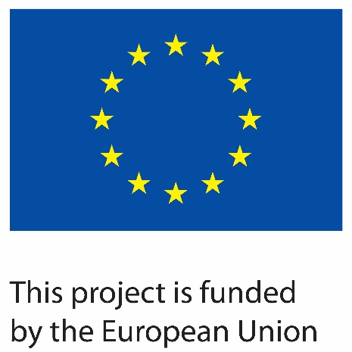 |  | 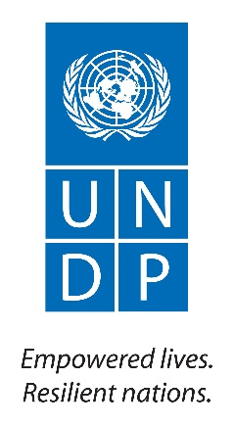

Contract number: ENPI/2014/354-587

Project Title: Support to Confidence Building Measures Starting date: 15 March 2015
Report end date: 31 December 2016
Implementing agency: UNDP Moldova
Country: Republic of Moldova

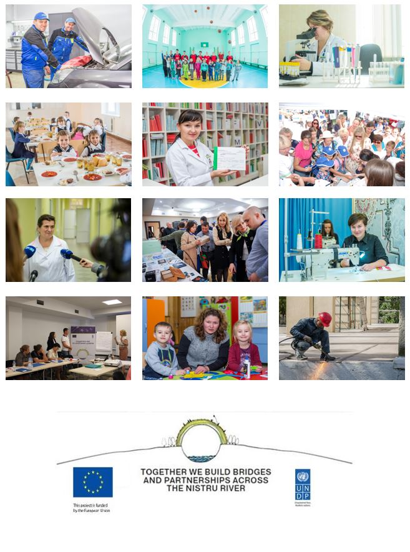

Table of Contents
I. SUMMARY 4
II. CONTEXT 6
III. PROGRESS UPDATE 8
3.1 Business Development and Employment Opportunities 9
IV. KEY RESULTS 11
4.1 Business Development and Employment Opportunities 11
Target 1 - At least 20 cross-river business exchanges and partnerships supported 12
Target 2 - 100 additional enterprises from both banks benefitting from business support services (20% women-led enterprises, 50% from Transnistrian region) 12
Target 3 - At least 60 new jobs additionally created, (at least 40% for women, at least 50% in Transnistrian region) 13
116 jobs were created (67% in the Transnistrian region, 45% for women) by 31 young entrepreneurs supported in the frame of 2 mirror Grants for Youth projects. 13
Target 4 - At least 2,500 women and men (50% women) benefiting from strengthened livelihoods 13
Target 5 - At least 10 consultants trained and certified to provide competitive services to beneficiaries on both banks 13
- 20 beneficiaries from both banks are currently being trained and coached as export consultants and at least 15 out of them will be certified in 2017; 13
More details and summary of each project are presented in Annex 3. 14
4.2 Empowered Communities and Infrastructure Support 14
V. RISK LOG 16
VI. MANAGEMENT ARRANGEMENTS 17
VII. MEDIA COVERAGE /VISIBILITY 18
VIII. FUTURE PLANS 19
IX. ANNEXES 20
Annex 1: Communication and Visibility Report 21
http://www.timpul.md/articol/30-de-tineri-de-pe-ambele-maluri-ale-nistrului-se-lanseaza-in-afaceri-cu-ajutorul-uniunii-europene--90827.html 24
http://tiraspol.ru/news/konferentsiya-molodyih-predprinimateley-business-bridges/ 25
Annex 3: List of Business Development and Employment Opportunities projects 46
I. Supporting Business-to-Business Activity 47
II. Stimulating Business Development Services 52
III. Promote a Culture of Entrepreneurship and Support Young Entrepreneurs 55
Annex 4: List of Community Infrastructure Projects 57
Sub-Project 14: “Overall renovation of the Rascov village Community Centre” (left bank) 67
Annex 4a: Capacity Building 78

SUMMARY

Title of the Programme: Increased opportunities and better living conditions across the Nistru/Dniestr River
Location: Republic of Moldova and its Transnistria region
Programme budget: €10 mil. provided by the European Union

Total duration | 36 months
Objectives | The overall objective of the programme is to contribute to an environment of trust and cooperation across the Nistru/Dniestr River generating new perspectives on shared interests and a shared future by people from both banks of the river while responding to their pressing development needs.  Specific objectives (outputs):  Output 1 (Business development and employment opportunities):  - Increased cross-river cooperation of economic actors leading to improved employment opportunities and livelihoods across the Nistru/Dniestr River.  Output 2 (Empowered communities and infrastructure support):  - Empowered local communities and actors from both sides to participate in collaborative projects addressing pressing development needs and improving critical community infrastructure.  The programme represents a framework for engaging in development interventions across the security zone on both sides of the Nistru/Dniestr River, in line with agreements reached in the 5+2 negotiation process. As such, it is comprised of a series of activities that will strengthen, regularize and intensify interaction between otherwise divided societies, aiming to establish this interaction as a norm.  It looks to deal strategically with barriers to cooperation experienced by all development cooperation actors working in Transnistria region of Moldova by building the trust towards such actions and broadening opportunities for engagement for a wide range of actors.  Additionally, it will provide support for improving critical community infrastructure, in line with agreements reached during the working groups and broader negotiation process.
Partner(s) | The Government of Moldova, the Bureau for Reintegration, de-facto local authorities from the Transnistrian region, business associations from Chisinau and Tiraspol (including Chambers of Commerce on both banks), regional/municipal authorities, community-based organizations, international, national and local NGOs active in the Transnistrian region and the security zone.
Target group(s) | - Economic actors including SMEs, Chambers of Commerce, business associations, etc. from both banks of the Nistru/Dniestr River;  - Communities and community-based organizations in the Transnistria region and the security zone;  - Statistics specialists on both banks;  - Vulnerable women and men in the target region.
Final beneficiaries | Citizens in the Republic of Moldova including the Transnistria region
Estimated results | For Output 1: Business development and employment opportunities  - At least 50 cross-river business exchanges and partnerships promoted between businesses and business associations leading to common understanding of opportunities, barriers and technical standards in the field of business development;  - At least 200 SMEs (including women led SMEs) involved in joint activities and received business support services contributing to increased professionalization and higher business standards on the left bank;  - New opportunities for business cooperation across the river and at least 150 new jobs and 5,000 new livelihoods for women and men;  - Consolidated local consultancy market providing improved services fostering local capacities to use the benefits provided by the DCFTA in terms of access to the EU market with at least 20 business consultants trained and/or certified;  - Improved culture of entrepreneurship and greater access to information and funding leads to the creation of 30 new businesses, integrated into existing cross-river platforms.  For Output 2: Empowered communities and infrastructure support  - At least 60 local actors have increased capacities for sustainable development and ensuring access of most vulnerable to public services by empowering communities;  - At least 30 social infrastructure projects supported in the security zone (on both banks of the river);  - About 100,000 women and men directly benefited from the implementation of the programme;  - Increased interaction between statisticians from Chisinau and Tiraspol leading to better compliancy with international standards (in at least 5 statistical areas) as a result of at least 5 learning activities targeting 30 professionals;  - Increased level of cooperation and trust across the river.
Main activities | The above is tackled through the following project components:  - Business Development and Employment Opportunities  Projects which promote the common interests of business actors from both banks in the context of EU integration will be implemented. This component will address comprehensively some of the key constraints faced by business and will focus heavily on creating sustainable cross-river business partnerships. Business to business interaction will be sustained through the facilitation of cooperation between business associations, supporting business cooperation networks, and building local capacities for export. Continuing the successful experience of previous phases of the programme, the business development services market will be further consolidated by bolstering the capacities of local private actors, business associations and consultants to provide certified services enabling the local business to capitalize on the existing opportunities, including those offered by the DCFTA. Additionally, a culture of entrepreneurship will be promoted energetically in the region, focussed mainly on enabling youth on both banks to become successful entrepreneurs.  Partnerships with civil society and businesses will be the main vehicle of the component implementation. Aiming to increase the cross-river cooperation, this component will also focus on contributing to enhance employment opportunities, and particularly supporting the creation of new jobs and livelihoods for women and men across the river.  - Empowered communities and infrastructure support  Support will be provided for projects oriented towards facilitation of the settlement and post-settlement period. Assistance could take various forms and cover areas like social infrastructure, environment, energy, transport and many others. Infrastructure projects from both banks of the Nistru/Dniestr river will be supported in a balanced manner as decided by the programme board.  Partnership with civil society organizations will be sought to enable and empower people from both banks to jointly participate in tackling community development needs, particularly the rehabilitation of social institutions and basic infrastructure, ranging from renovation of schools, kindergartens, or health centres. Additionally, the project will contribute to the capacity development of the beneficiary communities, and create/strengthen communication channels across the river.  Other activities would involve supporting the development of skills and knowledge of statisticians on both banks to produce qualitative and reliable statistical data and foster dialogue between experts in the field on both banks.

CONTEXT

The existence of the unrecognised Transnistrian region on the territory of the Republic of Moldova constitutes a serious challenge to Moldovan state-building efforts and socio-economic development. The inability of the Moldovan state to control a large section of its external border (452 km) or to exercise effective power over 12% of its internationally recognised territory cannot help but foster an impression of Moldovan statehood as “incomplete” and provisional in the eyes of both its citizens and external observers.

Peaceful settlement of the conflict and Transnistria’s reintegration has been one of the fundamental priorities of the authorities in Chisinau. The Governments consistently highlighted in their Governing Agendas the need to ensure a permanent dialogue with external partners and international organisations with a view to supporting the process of resolution of the conflict [], []. The set of actions proposed to be taken consist, inter alia, of impelling the sectoral working groups to promote confidence, promoting interaction between business communities on both banks of the Nistru River, implementing humanitarian, social and infrastructure projects in the region, as well as attracting assistance and expertise of foreign partners with a view to promoting the conflict resolution process. Additionally, in 2014 the Moldovan Parliament adopted a Declaration on Country reintegration in the context of Moldova’s European path.

Moldovan authorities hope that the European integration vector will increase the attractiveness of the Republic of Moldova for people from Transnistrian region. It relies in particular on the opportunities and benefits that are being provided to the Republic of Moldova through the Association Agreement, including the Deep and Comprehensive Free Trade Area and the liberalization of the visa regime with the European Union (EU). Figures over the last years indicate that the Transnistrian economy became more closely integrated with EU economies. According to Expert-Grup data as of September 2016, exports to the EU (70%) are nine times as high as exports to Russia (8%). The territory has benefited from the EU’s autonomous trade preferences, which made products from Transnistria (which are exported to the EU as Moldovan products) more competitive on European markets. An important achievement was registered in the application of the DCFTA in Transnistria. Chisinau authorities agreed to consider that the conditions for DCFTA application on the entirety of its territory were fulfilled, having committed to making special arrangements for implementation with Tiraspol directly. Besides trade, citizenship in Transnistria serves as indicator of the population preference. As of December 2016, out of 500,000 people living in the region, 300,000 hold a Moldovan passport. Around 75,000 of Moldovan passports in the region were biometric (and the number keeps growing), which opens the door for visa-free travel to the EU.

However, the effects of the events in the Eastern regions of Ukraine and loss of Crimea, led Ukraine to undertake measures to institute an intense control over the flow of persons and goods designated for export and import from the Transnistria region. Two new cross border cooperation agreements were signed between Moldova and Ukraine and are expected to enhance security through increasing transparency about the movement of vehicles and goods over the border. Against this background, in June 2016 were re-launched the negotiations within the 5+2 format. The process has been influenced by the political processes on both banks of Nistru and might get intensity in 2017, since the election processes ended in December 2016.

Throughout 2016, the Republic of Moldova faced turmoil in its political and economic systems. Against a background of political instability, a polarized society and an adverse external environment, Moldova faced big economic challenges in 2016. After the loss in 2015 of an eighth of GDP, due to a massive fraud in the banking sector, transparency, accountability, and corruption have emerged as crucial concerns. With higher public debt and damaged business confidence, the macroeconomic framework was severely damaged, while external budget support was halted until an IMF agreement is achieved. In November, a three-year arrangement with IMF opened the door for a financial support of US$178.7 million as a support the country’s economic and financial reform programme. Consequently, the EU transferred 45 million Euro as budget support and the World Bank approved the US$45 million Second Development Policy Operation for Moldova. November was also the months when, for the first time in the last twenty years, the President was elected by the citizens directly.

As regards the left bank, the Transnistrian region is facing an unprecedented economic crisis. According to the Regional Economic review, the economy of the Transnistrian region continued to worsen in 2016, even after a difficult economic year in 2015. In particular, the exports recorded a decline of 15.5% in January-August 2016, which was mainly caused by the decreasing competitiveness of the Transnistrian exporters. Nevertheless, the tendency to re-direct the trade flow continued: 81% of exports from the region were directed towards the right bank and the EU, e.g. to the Deep and Comprehensive Free Trade Area. The negative economic dynamics, coupled with the high macroeconomic, political and social uncertainties undermined the investment activity in the region, reducing the volume of investments in fixed capital by 14.3% in in January-August 2016. In addition, the reduction of the households’ income and remittances cooled down the demand in the region which, along with the shortage of foreign currency in the region, contributed to a significant reduction in imports.

On the other hand, there are some intensification of interaction between the two banks due to the fact that Transnistria’ Business is trying to marketplace on the right bank to export its goods to the European market. EU’s decision to allow Transnistria-based companies to continue to export within the DCFTA with Moldova at zero tariffs in 2016 brings more opportunities to local exporters, but depends on the willingness of the de facto administration to reform.

On the background of the overall context in the country, activities with a strong confidence building element are more than needed now. Dialogue and information sharing mechanisms further will be established to help connect institutions across the river, and support creation of platforms for communication and exchange of practices. Support will be provided for joint events and participation of mixed groups to national and international events, facilitating peer-to-peer learning and review; connecting communities across the river etc.

Activities facilitating direct people-to-people contacts will be prioritized. However, opportunities will be also sought to support the enhancement of an enabling environment within the divided communities. A particular focus will be maintained on projects that help to: promote culture of tolerance, facilitate dialogue within and between the divided communities including civil society-government contacts, address security and safety concerns of marginalized communities, contribute to good local governance, and strengthen community capacities including empowerment of women to play a more prominent role.

The objective of the SCBM Programme since its launch in 2009 has never been to reintegrate Moldova as a country, given that UNDP is not a party to the 5+2 conflict settlement process. The intervention’s rationale, as described in the Phase IV Project Document, is to have an impact on human development in a cross-sectorial dimension, bringing together issues related to crisis prevention and recovery, poverty reduction, local development and democratic governance practices. This is achieved through engaging the most vulnerable people in remote areas ensuring they are not excluded from development opportunities.

PROGRESS UPDATE

Despite a highly challenging year and overall sensitive regional context, the Programme achieved most of the targets set for the reported period and even exceeded most of the proposed objectives. This was much due to the experience acquired and lessons learnt during the implementation of previous phases of SCBM Programme.

Given that 2016 was the second year of SCBM IV, the pace of implementing activities got speed. Within the Empowered Communities and Infrastructure Support component, the high interest from eligible communities to implement social infrastructure projects generated an important number of project proposals. A total of 49 submissions were received during one joint competition for both banks where, for the first time, the same approach and rules of competition were applied for both banks. As a result of the evaluation, out of 11 new infrastructure projects that were planned to be selected, 8 projects were identified (reconstruction works are on track and due to be completed in 2017 (for detailed information about each sub-project see Annex 4)). Therefore, the selection process has been adjusted and a new selection approach was proposed and approved by the Board in August 2016. Hence, a round of bilateral consultations with main stakeholders was held, concluding with a workshop on short and long-term priorities, which generated a list of 20 project ideas to be considered by the Selection Committee in the beginning of 2017.

Within the Business Development and Employment Opportunities component, an array of activities has been implemented under the three main sub-components: Support Business-to-Business Activity, Stimulate Business Development Services (BDS), and Promote a Culture of Entrepreneurship and Support Young Entrepreneurs. While some of the activities have already been completed, further implementation of ongoing or planned projects under this component are exposed to higher risk due to an overall worsening of the economic situation on both banks of the Nistru River (for detailed information about each sub-project see Annex 3). The project team will further implement the activities under this component based on a careful risk mitigation and in consultation with the EU Delegation and Board members.

Progress to date: | - 51 cross-river business exchanges and partnerships supported;  - at least 203 enterprises from both banks benefitted from business support services;  - 31 newly created enterprises on both banks via the Grants for Youth Programme generated 116 new jobs (more than 45% for women, 58 in the Transnistrian region);  - More than 2700 people (51% women) benefitted from strengthened livelihoods;  - 28 community infrastructure projects under implementation;  - more than 62,000 direct beneficiaries of the selected social infrastructure projects;  - 50 local actors have improved capacities to identify relevant confidence building project ideas and elaborate social infrastructure project proposals;  - 42 statisticians and relevant specialists from both banks of the Nistru River have improved capacities and skills during a training on gender-related statistical data.

During the reporting period, four Programme Board meetings have been conducted (28 January, 19 May, 11 August, 5 November 2016), where 2015 annual reports, 2016 annual plans and quarterly reports have been approved, as well as funding of 8 infrastructure project proposals and grants for Business Cooperation Platforms, submitted by the Selection Committee. Minutes of the four Board Meetings are presented as Annex 5 and provide more information and details on the Programme implementation process.

Further key developments per component will be presented:

Business Development and Employment Opportunities

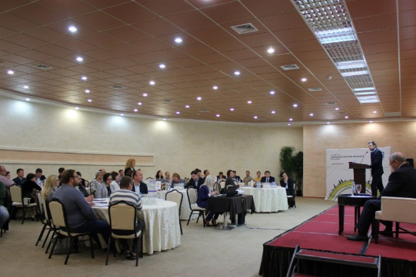
On the background of negative economic trends on both sides of the Nistru River, during the reporting period the Programme managed to address some of the key constraints faced by businesses and to focus on increasing sustainable partnerships between business development organisations from both banks as well as to contribute to enhanced employment opportunities, and support the creation of new jobs and livelihoods for women and men across the river. The operational targets set for 2016 have been fulfilled and even exceeded in all intervention areas establishing a solid foundation to tackle future interventions. Activities implemented during the reported period aimed to link-up and develop cooperation between existing business associations through joint participation at Business forums, study visits, participation at fair and exhibitions, supporting collaborative platforms between entrepreneurs, etc., thus resulting in 51 cross-river business exchanges and partnerships.
Joint Working Conference for young entrepreneurs. Tiraspol

In 2016, negative economic trends and structural issues led to a shared scepticism among business on both banks, and a temporary reluctance to invest in consulting/BDS, reducing short-term perspectives for growth in this market. However, building up on successful experience within the previous phases of the programme, support to SMEs in this area continued and 203 enterprises from both banks benefitted from business development services support.

Positive results were achieved by the Grants for Youth Programme, which is a continuation the Business Support for Youth project implemented within CBM III and has the goal contribute to the generation of employment, income, as well as to introduce entrepreneurial skills and mind-sets among young people. Based on Grants of up to 13,500 euros received in 2015, 31 newly created enterprises have already created 116 new jobs, out of which 58 are on the left bank and more than 45% are for women and have changed their own attitudes by becoming themselves strong examples of the benefits of cooperation to their peers.

A recent initiative supported by the programme, namely the implementation of Transnistrian Economic Review by Expert Group has proven to be successful by engaging stakeholders from both banks of the Nistru river in evidence-based discussions about the economic situation in the Transnistrian region. Three Transnistria Economic Briefs and one Regional Economic Review published during the reporting period were widely distributed and cited by the media, as well as were used for analytical purposes, including the EU Joint Analysis exercise (media references are provided in the Annex 1: Communication and Visibility Report).

As a result of the Grants Competition, organised to support the creation/strengthening of cross-river business platforms, 8 projects were approved by the Selection Committee. Within the framework of business platforms, more than 50 joint capacity building activities were organized allowing for more than 800 participants from both banks of the Nistru river to engage in joint work, networking and business interactions. Companies from both banks were enabled to promote together their products at common stands at fairs and expos in Moldova and abroad; are visiting each other to learn about new technologies and best practices, and are developing common approaches.

Overall, more than 2,700 women and men from both banks of the Nistru River have increased livelihoods as a result of projects implemented within this component.

  - Empowered Communities and Infrastructure Support

Projects implemented within this component aim to tap into the confidence building potential of the communities selected for the funding of social infrastructure objects. The infrastructure component has proved to be efficient and sustainable from the viewpoint of confidence building engaging members of communities and fostering cross-river cooperation.
During the reporting period, the project selection mechanism was updated according to previous approvals of the Programme Board, taking into consideration the lessons learnt during the previous year of implementation. For the first time, the selection of projects from both banks was integrated into one joint event. The SCBM Programme received and examined 49 infrastructure project proposals from 37 communities on both banks of the Nistru River covering areas such as education, culture, sports, health care, social services, etc. Following a thorough selection process, the Programme Board approved for funding 8 social infrastructure projects (2 projects on the right bank and 6 on the left bank of Nistru River), out of which 5 projects were conditionally approved. These include: renovation of 2 schools, 1 cultural centre, 1 sports centre, 2 air quality monitoring systems, 1 mobile service for palliative assistance and 1 social reintegration centre for youth. Out of 5 projects approved conditionally, 3 projects failed to comply with the requirements and were put on a standby list by the Board. Taking this into consideration, to ensure the selection of the remaining 6 social infrastructure projects out of the planned 11 projects, the selection process has been adjusted and a new approach was proposed and approved by the Board in August 2016. It consists of consultations with the main stakeholders from both banks of Nistru river, in order to come up with a list of new and strong ideas, to be analysed and proposed for approval to the Selection Committee. The final round of consultations materialized in a workshop where short-term and long-term project priorities have been brainstormed and a list of ideas in 5 areas has been generated.
Social infrastructure proposals main
thematic areas

Overall, 28 social infrastructure projects were in the process of implementation in 2016, which proved to be a challenging task. Currently, 15 reconstruction projects (9 on Right Bank/6 on the Left Bank) are completed (representing 50% of the overall target of the SCBM IV Programme). At the same time, 4 projects are in the process of reconstruction and 9 projects - in the inception phase. The impact of these projects materialized in 62.000 people from both banks benefiting from better conditions due to rehabilitated infrastructure, including around 380 new temporary and permanent jobs generated. Also, comparing with the previous year, the Programme succeeded to mobilize a higher local contribution which exceeds 3 million MDL (23% more than previous year).

A follow up assessment of projects implemented previously within the SCBM III programme was completed, being provided recommendations and conclusions. The findings from the report helped to improve the sustainability of previously implemented projects and ensure a better design for new projects.

Drawing up from the conclusions of previous SCBM reports, there is still need for additional assistance to the Local Public Administrations (LPAs) on both banks for the assessment of community needs, as well as improving the capacities in respect of planning, implementation, and ensuring sustainability of social infrastructure projects. To address these needs, a complex capacity development programme is currently being implemented by two consulting companies from each side of the Nistru River. At least 50 communities (19 from the right bank and 31 from the left bank) which previously had not benefitted from SCBM funding were assisted to identify relevant confidence building project ideas and submit their social infrastructure project proposals. Following the capacity gaps assessment reports and capacity development and confidence building action plans, 6 joint trainings were organized. A number of 12 communities either updated or developed their local development strategic plan.

In order to harness the existing confidence building potential of implemented infrastructural projects and enhance the cross-river collaboration between beneficiary communities and different actors across the river, the programme Board decided to establish specialized networks and partnerships (thematic platforms of collaboration). Given that all social infrastructure projects funded under the SCBM framework could be divided into five major activity fields – education, healthcare, sports, culture and environment protection – it was decided that the cross-river collaboration platforms will be organized around these particular domains as well. Based on the informal nature of the platforms, all institutions, which previously benefited from SCBM Programme support, will be considered potential members, while the platform membership will not be limited to beneficiary social institutions only, but may involve a larger number of potential community actors such as LPAs, local NGOs, local initiative groups etc. A platform should be a network of institutions from both banks having the same profile, allowing them to cooperate through building their capacity, joint implementation of thematic activities, local exchange visits and study tours. To support the platform members to apply this approach, a Small Grants Programme will be launched in 2017. It is expected that this initiative will lead to the establishment of a minimum of 30 cross-river partnerships until the end of the SCBM IV. The selected leaders of the platforms started the formation of the network, based on the developed methodology.

As regards the activities to support the development of skills and knowledge of statisticians on both banks of the Nistru River, more than 90 statisticians (72 women and 62 from the left bank) have built their capacities through trainings on: emerging practices and tools for SDGs nationalization, implementation of international standards/practices in statistics, producing comparable/reliable poverty data, defining statistical metadata, as well as on Big Data and data processing software. Additionally, within 4 analytical platforms, partners from both banks are currently developing evidence-based analytical papers on sustainable development, establishing mutual trust and a better understanding of statistical methodology.

KEY RESULTS

A snapshot of key achievements during the implementation period:

Business Development and Employment Opportunities

Programme Estimated Result: At least 50 cross-river business exchanges and partnerships promoted between businesses and business associations; at least 200 SMEs (including women led SMEs) involved in joint activities and received business support services; new opportunities for business cooperation across the river and at least 150 new jobs and 5,000 new livelihoods for women and men; consolidated local consultancy market providing improved services fostering local capacities to use the benefits provided by the DCFTA in terms of access to the EU market with at least 20 business consultants trained and/or certified; improved culture of entrepreneurship and greater access to information and funding leads to the creation of 30 new businesses, integrated into existing cross-river platforms.

2016 Targets and Key Results:

Target 1 - At least 20 cross-river business exchanges and partnerships supported
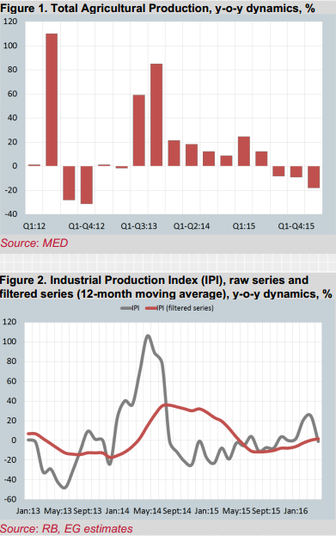
- A number of economic researches and forecasts, namely 3 Transnistria Economic Briefs and 1 Regional Economic Review of the Transnistrian Region, was carried out as well as a round table aiming at strengthening the understanding of the socio-economic processes in the Transnistrian region organized for representatives of diplomatic corps, international organizations, government organizations and media. All publications were widely distributed and cited by the media, as well as were used for analytical purposes, including the EU Joint Analysis exercise.
- 19 contracts and partnerships signed between business associations from both banks in order to create 8 business platforms; between associations and consulting companies with a view to promote products from both banks and to increase the organizational capacities (through trainings and workshops); as well as between private companies from both banks for the supply of raw materials;
- The business platforms promoted joint offers through common stands of products and services from both banks’ producers at 4 international and local fares;
- 9 study visits inbound and abroad to Lithuania, Poland, Romania, Ukraine and Belarus were organized to support the Business Service Providers from both banks to learn from international best practices and local success stories;
- 2 round tables were organized jointly by the Hospitality platform and the Association of Creative Labs, Arts and Crafts from the left bank, in order to identify common issues encountered by regional hoteliers and craftsmen;
- The members of business platforms and business associations as well as young entrepreneurs benefited from the possibilities offered by 17 conferences and workshops to improve their knowledge about specific issues of their area of activity;

Bottom line: 51 cross-river business exchanges and partnerships supported

Target 2 - 100 additional enterprises from both banks benefitting from business support services (20% women-led enterprises, 50% from Transnistrian region)
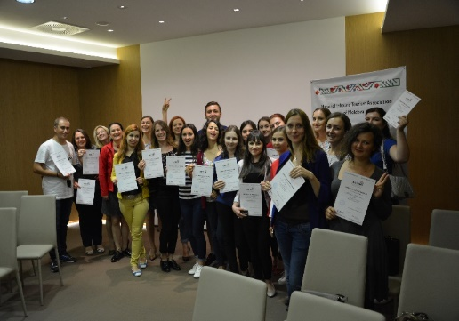
- A study on the Business Development Services market on both banks of the Nistru River was carried out and recommendations were provided for the further development of the sector. The results of the study served as the basis for targeted interventions in 2016 and will be taken into consideration while designing further initiatives;
The confidence building workshop for inbound travel agencies from both banks
- A feasibility study that assesses the opportunity to establish a business laboratory in Tiraspol was developed. The report provides strong arguments and will be further used while considering a decision to set-up the facility;
- 31 new enterprises created within the Grants for Youth Programme (16 from Transnistrian region) are receiving 14 months of continuous support through consultancy and coaching;
- Representatives of 101 companies, members of AgroInform, Moldova Fruct, ARDT and BizGates platforms, learned from their Romanian colleagues about best practices in ecological-intensive agriculture and in the development of hotelier services, with the goal to improve their competitiveness.
- Representatives of 71 companies are being continuously coached and trained within the 8 business platforms, improving skills and knowledge in their area of activity.

Bottom line: 203 additional enterprises from both banks have benefited from business support services

Target 3 - At least 60 new jobs additionally created, (at least 40% for women, at least 50% in Transnistrian region)

116 jobs were created (67% in the Transnistrian region, 45% for women) by 31 young entrepreneurs supported in the frame of 2 mirror Grants for Youth projects.

Bottom line: 116 jobs created (more than 45% for women, 67% in the Transnistrian region)

Target 4 - At least 2,500 women and men (50% women) benefiting from strengthened livelihoods
- At least 300 agricultural business women, 487 fruit producers, 75 berry producers and 500 farmers were assisted to enhance their sales capabilities, were trained on growing ecological products and environmentally friendly agricultural practices and were supported in establishing new contacts and trade links;
- Representatives of more than 520 companies benefited from consultancy services, study visits and coaching in the area of tourism, hospitality, ecological agriculture, marketing research, communication and sales, provided by the partner Business Associations;
- 40 beneficiaries are currently being trained as business and export consultants, and will receive internationally recognized certificates in 2017;
- 96 participants (37 women) improved their skills in preliminary data analysis, methods of data visualization, statistical analysis of data series, data panels, defining economic policies relevant for the Transnistrian region with the support of Expert Grup;
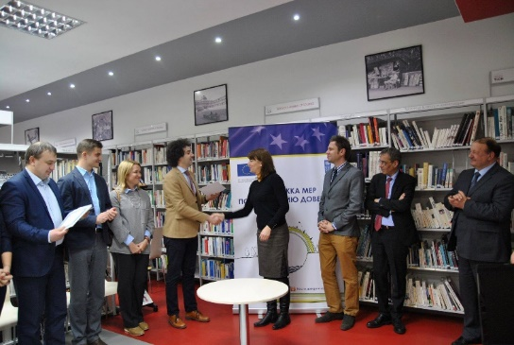
- 240 beneficiaries are being trained by the Chambers of Commerce and Industry from Chisinau and Tiraspol and will be certified in 2017 as managers, Energy Efficiency engineers, and bakers;
- 78 members of business associations benefited from consultancy and trainings to draft and implement their organizational development plans;
- Representatives of 52 companies benefitted from a capacity building event on brokerage and a business forum organized by the Moldo-Italian Chamber of Commerce and Industry, during which new contacts and networks were created;
- 30 representatives of the Chambers of Commerce and Industry from both banks improved their skills in marketing research and are able to jointly produce researches for both banks, this improving the business services provided by both institutions;
Award of certificates to the marketing research courses beneficiaries
- 226 men and women from both banks enhanced their capacity to successfully manage start-ups and existing companies;
- 48 private companies and Business Associations from both banks benefitted from the recommendations provided by Business Support Organizations from both banks and improved the range of their services.

Bottom line: At least 2,700 women and men benefitted from strengthened livelihoods

Target 5 - At least 10 consultants trained and certified to provide competitive services to beneficiaries on both banks
- 20 beneficiaries from both banks are currently being trained and coached as export consultants and at least 15 out of them will be certified in 2017;
- 20 beneficiaries from both banks are currently being trained and coached as business consultants
and at least 16 out of them will be certified in 2017.

Bottom line: 40 consultants trained and at least 31 consultants certified to provide competitive services to beneficiaries from both banks.

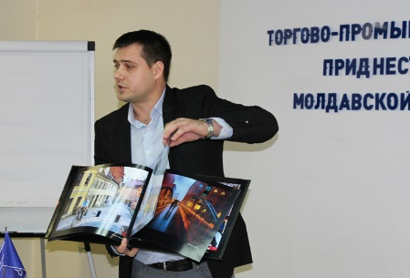
Target 6 - At least 10 new businesses additionally created as a result of an improved culture of entrepreneurship and greater access to information and funding and integrated in cross-river platforms
- 31 new businesses established by young entrepreneurs (16 women, 16 from the left bank) in the frame of the Grants for Youth project.

Bottom line: 31 new businesses were established as a result of the combination of advisory and financial assistance.
Grants for Youth Programme beneficiary

More details and summary of each project are presented in Annex 3.

Empowered Communities and Infrastructure Support

Programme Estimated Results: At least 60 local actors have increased capacities for sustainable development and ensuring access of most vulnerable to public services by empowering communities; at least 30 social infrastructure projects supported on both banks of the river; about 100,000 women and men directly benefited from the implementation of the programme; increased interaction between statisticians from Chisinau and Tiraspol leading to better compliancy with international standards (in at least 5 statistical areas) as a result of at least 5 learning activities targeting 30 professionals; increased level of cooperation and trust across the river.

2016 Targets and Key Results:

Target 1: Increased level of openness and trust toward development support received

- High interest in social infrastructure projects implementation from communities on both banks of the Nistru River. Regular communication with LPAs from eligible communities, consisting of site visits, meetings, pre-tender conferences, verbal and written communication was the basis for interaction with them and contributed to a higher openness for assistance. 37 communities from both banks submitted 49 social infrastructure project proposals aimed at addressing community development needs in areas of education, culture, sport, health care, social services, environment, etc.

Target 2: At least 30 local actors with improved capacity for implementing development projects

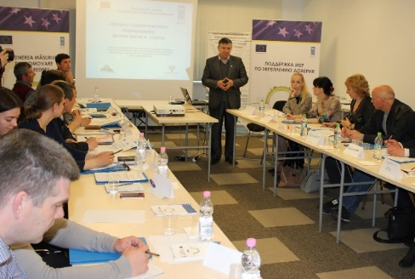
- Two consulting companies selected in 2015, Contact Centre responsible for capacity development activities in communities from the right bank and Interaction – for the left bank of the Nistru river, enhanced the capacity of at least 50 eligible communities, 19 from the right bank and 31 from the left bank;
- A joint plan for training and confidence building activities was developed. Hence, 12 Local Development Strategic Plans with confidence building elements incorporated were developed in communities from both banks, while coaching and mentoring helped them to start the implementation.
- In April, May and June 2016, six joint capacity building trainings were organized on Strategic planning, Fundraising and Communication – planning, as well as organizing information campaigns;
Representatives of LPAs during capacity
development exercises
- Additionally, representatives from four communities on the left bank attended local trainings on Basis of project preparation and planning and Mobilizing community resources to solve social problems;
- A total of 10 capacity gap assessments of newly selected projects, including 9 in the Transnistrian region, were carried out. It resulted in the identification of competence weaknesses of local partners. Interaction experts elaborated 4 community needs and capacity gaps assessment reports as well as capacity development and confidence building action plans for 4 communities from the left bank selected for the funding of social infrastructure objects;
- Exchange of experience/study visits to Varnita (Anenii Noi district) and Hagimus (Causeni district) villages were organized gathering 30 participants from 13 communities that were able to visit all projects implemented with EU funds in the community. The participants had the opportunity to interact, network and learn from the host communities about good practices of fundraising and project implementation.

Target 3: At least 11 social infrastructure projects initiated on both banks of the Nistru River (at least 70% in the Transnistrian region)

- One competition for the selection of social infrastructure projects carried out in 2016;
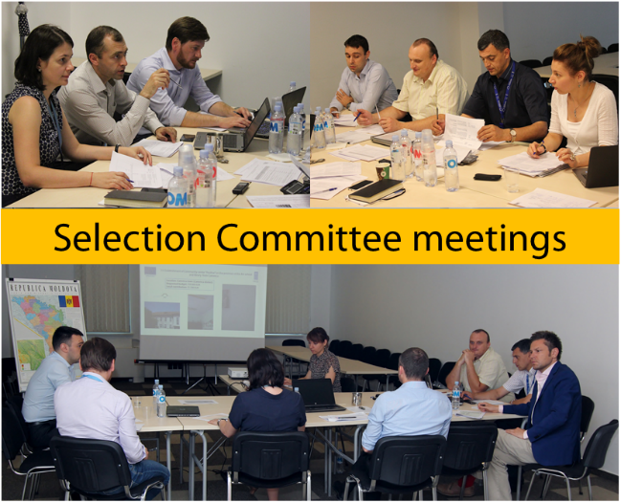
- A total of 49 project proposals submitted by 37 communities from both banks of the Nistru River examined by the Selection Committee;
- Over 25 field visits carried out by the Programme team to assess the technical condition of objects proposed for reconstruction;
- A total of 8 communities were selected for the funding of social infrastructure objects and will further benefit from extensive capacity development activities. 2 projects were selected for funding on the right bank and 6 on the left bank of Nistru River;
- Consultations with stakeholders carried out within the new selection modality and a list of 20 new project ideas identified;
- Rehabilitation works ongoing for 28 social infrastructure projects on both banks of the Nistru River.

Target 4: At least 30,000 women and men benefitting from improved services and small infrastructure, enjoying better access to basic community services

- Overall, 62,000 (52% women) direct beneficiaries of improved services provided by social infrastructure objects;
- Over 380 temporary jobs (11% women) and 10 permanent jobs (80% women) generated.

Target 5: At least 3 learning activities in at least 3 statistical areas implemented. Capacities of minimum 30 professionals from both banks increased.

- 90 statisticians (62 from the left banks and 72 women) jointly participated in 4 workshops, 6 seminars and one training and have improved their skills on data processing tools (SPSS), collecting of statistical data, implementation of SDGs, elaboration of statistical metadata and integration of ILO standards.

Target 6: At least 75% of the total number of projects implemented with a quality rating of satisfactory overall or higher

- Reconstruction of 28 social infrastructure objects ongoing. To ensure high quality of project implementation, the construction companies have been contracted following an open international, highly competitive selection process based on approved criteria;
- Additionally, two international experts are contracted to supervise and ensure the quality of technical documentation and the selection process of companies responsible for reconstruction.

More details and summary of each project are presented in Annex 4.

RISK LOG
Description of risk | Risk management actions
Volatile political and security environment, subject to unforeseen and sudden changes | The Programme team took into account the challenging political environment in the Republic of Moldova in 2016 by continuously analysing and monitoring the political processes. The implementation of the activities was planned and approached with caution, including the timing, visibility and presentation issues. Continuous consultations were conducted with the EU Delegation and Board members to ensure a wise approach to programme implementation. Additionally, the Programme team maintained working relationships with the key actors and implementing partners, emphasizing the non-political nature of the activities.
Activities may be delayed due to the regional context, and perception towards confidence building approach | The programme team ensured that the representatives of local administration are informed on an on-going basis about the aims and the activities planned, including inviting them to the events. Formalization of the participation of organisations from the Transnistrian region was kept to a minimum in order to avoid potential problems and remain non-contentious. Importance of confidence building approach was explained to beneficiaries and implementing partners and the activities were planned and implemented in an impartial manner, focusing on concrete improvements in people’s lives.
Lack of engagement on behalf of TN stakeholders | Prior consultations were in place to guarantee a buy-in on behalf of TN beneficiaries. Continuous engagement with key stakeholders has been ensured, as well as mobilisation of local resources to promote the local ownership of the results of the implemented action.
Limited interest from de facto authorities to implement joint confidence building activities | The activities planned to be implemented during SCBM IV are being constantly explained to the counterparts – technical level as well as de-facto administration.
Elections leading to change in priorities | The implementation team foreseen the political processes linked to the elections of the de-facto president of the Transnistrian region. The activities related to both components were planned to avoid overlapping with the elections held in the Transnistrian region in December 2016.  Additionally, the EU and UN/UNDP high level officials maintained continuous communication with key representatives of the de facto authorities in Tiraspol, notably with Mr Vitaly Ignatiev.  The programme team will meet the new key players in Tiraspol and will establish a working dialogue, pointing out the non-political status of the programme and its goals.
Different financial systems in the Transnistrian region | Financial flows to Transnistrian banks for TN NGOs and social institutions have facilitated delivery of activities.
Different regulation systems in the field of constructions on both sides of the Nistru/Dniestr river | Due consideration was provided to the most suitable and relevant implementation mechanisms relying on experience from previous phases of SCBM Programme. UNDP will use the granting modality for several projects to be implemented on the right bank, whereby local social institutions will be responsible for the construction standards. Social infrastructure projects implemented on the left bank will be funded via direct implementation under the supervision of a sub-contracted company responsible for the construction standards.

MANAGEMENT ARRANGEMENTS
Lessons learnt from previous phases and from the first year of implementation, as well as the need to implement the two components prompted a redesign of the Project’s Organisation Structure (see organigram infra). Throughout 2016, new members joined the Programme team.

SCBM IV Programme Board, which manages the programme at the highest level, comprised the representatives from the EU Delegation, UNDP, the Bureau for Reintegration, the Embassy of Sweden in Chisinau, the British Embassy in Chisinau, OSCE and the Swiss Agency for Development and Cooperation with a view to ensuring the efficient monitoring and evaluation of project results and maintain continuous cooperation between all project’s partners at all stages of project implementation.

The selection of and recommendations to the Programme Board for financing of community infrastructure projects was ensured by the Selection Committee. Four members representing the EU Delegation, the Bureau for Reintegration, SCBM Programme’s Portfolio Manager and SCBM Programme’s Coordinator, evaluated project proposals against the selection criteria and submitted to the Programme Board for approval 20 community infrastructure projects. The second year of SCBM IV Programme coincided with important Programme staff changes aiming to fit the restructured organisational chart.
PM team
Project Board
Senior Beneficiaries
Bureau for Reintegration, representative from civil society, representatives from communities

Executive UNDP
Senior Supplier
EU Delegation
Other development partners

Project Assurance
UNDP Moldova
Portfolio Manager
Project Support
Admin. & Finance Associate (1)
Procurement associate (1)
Project/Office assistant (1)
Drivers (2)
Project Organization Structure
National staff
Capacity development officer (1), business development officer (1), Infrastructure projects coordinators (2); Communications officer (1)
Programme Manager (1)

Business Development Project Manager (1)

Infrastructure Project Manager (1)
Short-term experts
National and international
(Engineers, finance/audit, communication in Transnistria region, monitoring etc.)
Given the increase in scope and responsibilities, with a view to ensuring a strong coordination and a smooth implementation of the programme, the position of Project Coordinator has been upgraded to the position of Programme Manager and announced for competition. Further, the recruitment process to hire a Programme Manager and a Business Development Project Manager (filling in the vacancy after the job transfer of the previous manager) was organised during the reporting period. These were filled in following external competitions and the newly recruited personnel took up their duties in August-September 2016.

MEDIA COVERAGE /VISIBILITY
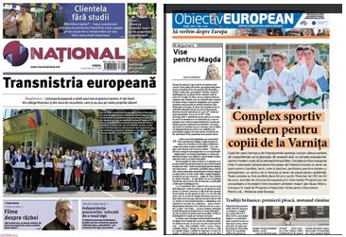
The SCBM Programme had an impressive visibility during 2016. Media monitoring reports show that it was the most covered project implemented by UNDP in April, June, July and October (monitoring started in April). The visibility potential of the implemented projects was entirely used. Over 20 public events were organized: inaugurations, forums, conferences, press tours.
Over 754 media clippings on the Programme achievements were published in media from both banks of the Nistru River, 31% out of them being favourable, other being neutral. Each article had at least one of the CBM key messages included. Reports indicate 64% SCBM references in media from the right bank and 36% from the left bank.

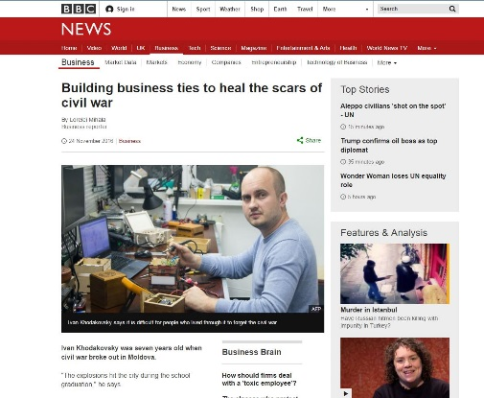
SCBM shared stories for national social campaigns. The story of Marina Tabuncic, grant beneficiary, was a part of the Publika TV social campaign Closer to People (Mai aproape de oameni), Angela Sobol shared her story for Moldova 1 TV special edition dedicated to Europe days in Moldova.

SCBM made use of methods offered by UNDP to promote achievements to the foreign public: the success story Learning to fit in published on Eurasia.undp.org or UN social media campaigns, such as #ShareHumanity. An accomplishment was the article Building business ties to heal the scars of civil war published on BBC.
SCBM on national newspapers cover pages

Articles about SCBM project impact were published on the cover-page or the Ziarul National newspaper and Obiectiv European supplement. A two-days training on informational campaigns for local leaders in the communities where infrastructure projects are implemented was organized. As a result – more informational activities about EU-funded CBM projects took place, such as joint painting contents in Gura Bicului or sport competitions in Serpeni and Varnita villages, all of them having a strong confidence-building and cross-river cooperation potential due to participation of teams from the left-bank communities.
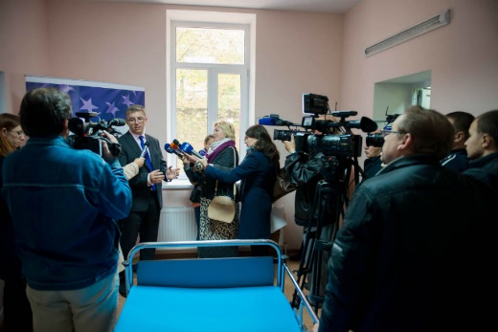
SCBM beneficiaries on BBC
An important achievement is the joint participation of media representatives from both banks of the Nistru at public events, such as inauguration of Rezina Infectious Disease Ward or the inauguration of Varnita educational and sports facilities.

Social media has been used as a cost-effective communication method. The number of followers on SCBM Facebook page and OK.RU group is constantly increasing. A video graphic gathering SCBM impact was developed and distributed on social media as well as presented at public events.
Inauguration of the Rezina Infectious
Disease Ward

Promotional and informational materials were updated as required in new SOP (Standard Operational Procedures) agreed by UNDP Moldova and EU Delegation in November 2016. An infographic with CBM achievements (2009 – 2016) was developed and distributed to the Programme’s partners, stakeholders and beneficiaries. Infrastructure objects were provided with informative banners and panels, including those from communities from the left bank, while the purchased equipment and furniture has stickers on.

The partners implementing projects were provided with assistance in order to ensure visibility as required by the SOP.

FUTURE PLANS

The following implementation period will be from 1 January to 31 December 2017 and coincides with a potential more stable political environment on both sides of the Nistru River, but aggravated by an economic recession, particularly on the left bank. This prompts additional efforts to coordinate the implementation of Programme’s activities with the donor, external partners, beneficiaries and implementers with a view to ensuring targets’ achievement.

During the second year of implementation of SCBM IV, several activities have been initiated that will generate increased cross-river cooperation and people-to-people interaction. Drawing up from the lessons learnt, upcoming confidence building activities will be tailor-made for each component striving to build trust between communities while demonstrating to the public at large that people can work together on and can draw joint benefits from issues that are of importance to the whole population of Moldova such as economic development, job creation, renovation of social infrastructure and various types of exchanges.

Key activities planned for each component are outlined below:

Business Development

- A number of 3 best cross-river partnership ideas will be selected for financing among the business associations participating in the project Cooperation and organizational development support for business associations on both banks of the Nistru River;
- Cross-river dialogue between 8 business platforms will be strengthened through the successful implementation of proposed action plans aiming offering an environment for networking, B2B and cross-river cooperation;
- At least 16 Business Consultants and 15 Export consultants from both banks of the Nistru river will be certified in order to develop jointly the local specialised business consultancy market;
- The consultancy market on both banks will be also consolidated through the certification of the beneficiaries of EUREM, Start-up and Baker courses;
- Two sub-projects on Creation of Job Opportunities through Business Support for Youth on both banks of the Nistru River will be continued through coaching that will allow young people to develop their own business and create additionally 40 new jobs;
- Young entrepreneurs from both banks will be further supported to improve their skills through the organization of a Summer School;
- A Forum of Young entrepreneurs from both banks will be carried out, serving as a platform for networking and sharing best experience.

Social Infrastructure component

- Complete 12 infrastructure projects out of the remaining 15 throughout 2017;
- Select and approve the remaining 6 infrastructure projects (4 for Transnistrian region and 2 on the right bank);
- The contracted consultancy companies will continue to provide capacity development and confidence building actions plans for all 30 social infrastructure object selected for funding and further activities and events (instruction events, joint activities, and study visits) will be carried out in 2017. Also, the two consulting companies will provide coaching and monitoring to the work/initiative groups from all 30 communities to ensure the successful implementation of the projects;
- 5 Thematic Platforms of collaboration will be fully functional and will create conditions for the cooperation of their members through building their capacity, joint implementation of thematic activities, local exchange visits and study tours. At least 30 cross-river partnerships will be established.
- The Small Grants Programme, aimed to support the implementation of activities within the Thematic Platforms will be launched. Up to 40 joint projects will be funded through this programme.
- 4 thematic data-based analytical papers, covering the following topics: resilient infrastructure, employment generation, development of sustainable cities and poverty reduction will be widely disseminated and debated.
- Organise learning activities for statisticians and relevant specialists from both banks to produce qualitative and reliable statistical data and foster dialogue between experts in the field. Self-learning methods will be applied using training materials developed for statistical professionals on both banks.

ANNEXES

- Communication and Visibility Report
- Quantitative and qualitative media assessment
- List of activities Business Development and Employment Opportunities
- List of Community Infrastructure Projects
- Minutes of the Board Meetings and decisions from 27 March, 17 June, and 22 October 2013 (hardcopy)
- Map of Community Infrastructure Projects (hardcopy)
- Regional Economic review: Transnistrian Region (hardcopy)

Annex 1: Communication and Visibility Report

Informational and promotional materials

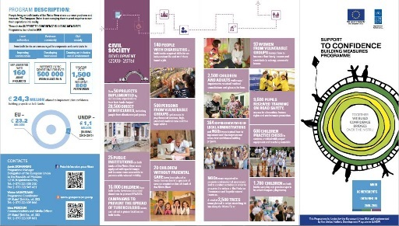
Impressive SCBM achievement since its launch in 2009 were gathered in a three language versions infographic both printed and electronic version.

A video graphic gathering SCBM impact was developed and distributed on social media as well as presented at public events.

All promotional materials are being updated to assure new visibility requirements of the donor – the European Union, outlined in Standard Operational Procedures.

The photo archive of the Programme was updated, important for providing better visual materials.
SCBM on social networks promoted
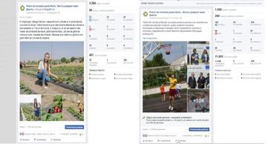
SCBM Programme uses social media as an effective and cost efficient tool to promote its achievements.

The number of followers on SCBM FB page and OK.RU group members is constantly increasing. Posts are written both in Russian and Romanian language, due to characteristic of target audience.

SCBM made use of UNDP Twitter channel to promote its achievement to external audience.

SCBM Programme participation at EU Day
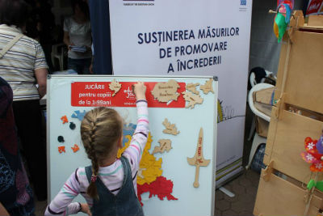
The Programme took active participation at public events, such as Europe Day in Chisinau, UN Caravane in Comrat, Youth Festival.

The visitors were informed about the CBM importance, Programme’s achievements and EU-role. Promotional and informational materials were distributed (t-shirts, bags, desk-calendars, leaflets etc.).

Europe Days, Chisinau, May 2016

Media and public opinion regularly informed

The SCBM Programme had an impressive visibility in media from both banks of the Nistru River during 2016 year. According to media monitoring reports SCBM was the most covered UNDP project in April, June, July and October (monitoring started in April).

Over 754 media clippings on the Programme’s achievements were published in media from both banks of the Nistru River, 31% out of them favourable, other neutral.
The story of Marina Tabuncic, grant beneficiary, was a part of the Publika TV social campaign Closer to People (Mai aproape de oameni), Angela Sobol shared her story for Moldova 1 TV special edition dedicated to Europe days in Moldova.

An accomplishment for the Programme was the article Building business ties to heal the scars of civil war published on BBC.

http://www.bbc.com/news/business-38063292

Press-releases drafted and disseminated to media on both banks as following:

- BUSINESS BRIDGES: 30 de tineri de pe ambele maluri ale Nistrului se lansează în afaceri cu ajutorul Uniunii Europene
- Granturi pentru intensificarea cooperării în domeniul afacerilor între malurile Nistrului
- Lideri locali de pe ambele maluri ale râului Nistru participă la instruiri comune de dezvoltare a localităților
- Pugiliști din Republica Moldova, România și Ucraina participă la Turneul Internațional de Box „Cupa Varnița 2016”
- Piața serviciilor de dezvoltare a afacerilor de pe ambele maluri ale râului Nistru are potențial care trebuie valorificat
- Восемь населенных пунктов в Приднестровье получат финансирование от ЕС на улучшение социальной инфраструктуры
- Finanțare europeană pentru modernizarea localităților de pe ambele maluri ale râului Nistru
- Peste 20 mii de locuitori ai orașului Dnestrovsk, stânga Nistrului, au acces la asistență medicală de calitate
- Suport european: Complex educațional-sportiv pentru tinerii din Varnița și Bender
- Agricultura ecologică va fi promovată în rândul fermierilor de pe ambele maluri ale râului Nistru
- Asociațiile de business de pe ambele maluri ale râului Nistru și-au prezentat planurile de dezvoltare strategică
- Oferta turistică în localitățile de pe ambele maluri ale râului Nistru se va diversifica
- Cu sprijinul UE, la Rezina a fost inaugurată cea mai modernă secție de tratare a bolilor contagioase
- Uniunea Europeană finanțează lucrările de renovare a trei școli din stânga Nistrului
- European standard creative centre for children from Dubasari, the left bank of Nistru
- Uniunea Europeană finanțează renovarea Casei de Cultură din satul Rașcov, stânga Nistrului
- Fermieri de pe ambele maluri ale râului Nistru participă la Expoziția Internațională „PRDOEXPO - 2016”
- Производители фруктов участвовали в Сорокском Фестивале Яблок

Success stories:
- Once divided by a river, communities in Moldova come together
- In Moldova, learning to fit in
- Поддержка от ЕС или как стать предпринимателем за шесть месяцев
- С помощью ЕС, молодая жительница Григориополя начала успешный бизнес в 21 год
- Жительница Тирасполя открыла ферму по выращиванию перепелов с помощью европейского гранта
- Turiștii vor avea posibilitatea să exploreze noi rute pe ambele maluri ale râului Nistru
- Европа протягивает руку помощи Приднестровью
- Cu ajutorul UE în doar jumătate de an a pus pe picioare o afacere profitabilă
- O tânără mămică din Tiraspol a creat o crescătorie de prepelițe cu ajutorul UE
- Au transformat vocația în afaceri

Relevant links:

- Uniunea Europeană finanțează lucrările de renovare a trei școli din stânga Nistrului

http://trm.md/en/regional/trei-scoli-din-stanga-nistrului-sunt-renovate-capital-din-bani-europeni/
TVR Moldova https://www.facebook.com/TVRMoldova/?fref=ts
http://tv7.md/ro/cotidian/cotidian-editie-integrala-ora-18-00-25-04/
https://tv.pgtrk.ru/show/41/42924
https://www.youtube.com/watch?v=U-OtdItddsI&list=PLuS6U5RiULLQIGjeDzczgP1hu5n1OEXat&index=12
http://rtr.md/peredachi/vesti-moldova
http://rtr.md/novosti/obshhestvo/tri-shkoly-na-levom-beregu-dnestra-otremontirovany-na-dengi-es
http://rtr.md/novosti/obshhestvo/evrosoyuz-profinansiruet-shkoly-v-pridnestrove
http://www.infotag.md/rebelion-en/222952/
http://www.ipn.md/en/societate/76194
http://novostipmr.ru/info/vesti/2016-04-v-ryade-shkol-pridnestrovya-pri-podderzhke-proon-osushhestvlyayutsya-remontnye-raboty/
http://novostipmr.com/ru/news/16-04-25/v-tryoh-shkolah-slobodzeyskogo-rayona-prodolzhayutsya-remonty-po
http://novostipmr.ru/video/tsv/2016-04-remont-ot-proon/
http://www.kp.md/daily/26523.4/3539318/
http://www.mediaimage.ro/WKY-PUR-TML/monitorizare/MOLDOVA/PNUD/central-en/27_04_16/254112.html
http://pan.md/pridnestrove/evrosoyuz-finansiruet-remont-treh-shkol-v-pridnestrove
http://www.timpul.md/articol/trei-coli-din-regiunea-transnistreana-renovate-cu-bani-europeni-91781.html
http://zugo.md/article/800-de-elevi-din-3-scoli-din-stanga-nistrului-vor-invata-in-institutii-renovate-din-banii-ue.htm
http://newsmaker.md/rus/novosti/tri-shkoly-v-pridnestrove-budut-otremontirovany-na-dengi-es-24442
http://agora.md/stiri/18541/uniunea-europeana-finanteaza-lucrarile-de-renovare-a-trei-scoli-din-stanga-nistrului
http://www.realitatea.md/trei-coli-din-stanga-nistrului-renovate-pe-bani-europeni-ue-a-acordat-cate-150-mii-de-euro-pentru-fiecare-institu-ie-foto-video_38220.html
http://www.publika.md/imbucurator-ue-finanteaza-lucrarile-de-renovare-a-trei-scoli-din-stanga-nistrului_2605001.html

http://www.ziarulnational.md/scoli-din-stanga-nistrului-renovate-din-bani-europeni/

http://www.vesti.md/?mod=news&id=58544

http://independent.md/ue-finanteaza-lucrarile-de-renovare-a-trei-scoli-din-stanga-nistrului/#.VyH503p8rEY

http://stirilocale.md/foto-uniunea-europeana-finanteaza-lucrarile-de-renovare-a-trei-scoli-din-stanga-nistrului.html

http://ru.interlic.md/2016-04-26/es-finansiruet-remont-treh-shkol-na-levom-beregu-dnestra-43725.html

http://www.politik.md/articles/social/ue-finanteaza-lucrarile-de-renovare-a-trei-scoli-din-stanga-nistrului/37049/

http://www.md.undp.org/content/moldova/en/home/presscentre/pressreleases/2016/04/22/uniunea-european-finan-eaz-lucr-rile-de-renovare-a-trei-coli-din-st-nga-nistrului-/

http://www.comunicate.md/index.php?task=articles&action=view&article_id=9415

http://provincial.md/fierbinte/scolile-din-nezavertailovca-hlinaia-si-chitcani-reparate-pe-bani-europeni

http://diez.md/2016/04/25/foto-ue-finanteaza-lucrarile-de-renovare-trei-scoli-din-stanga-nistrului-iata-care-sunt-acestea/

http://zugo.md/article/800-de-elevi-din-3-scoli-din-stanga-nistrului-vor-invata-in-institutii-renovate-din-banii-ue.htm

http://mediacentre.md/publikacii/1023-es-proon-remont-shkol-zabota-o-detyah.html
http://mediacentre.md/publikacii/1017-evrosoyuz-finansiruet-remont-treh-shkol-na-levom-beregu-dnestra.html

http://mirpmr.ru/evrosoyuz-finansiruet-remont-treh-shkol-na-levom-beregu-dnestra/

http://mirpmr.ru/es-proon-remont-shkol-zabota-o-detyah/

http://www.hotnews.md/articles/view.hot?id=34724

http://ngointeraction.org/main/ru/component/content/article/1-latest-news/3288-the-european-union-is

http://www.womenin.org/index.php/RU/glavnaya-2/9-news-a-events/165-evrosoyuz-finansiruet-remont-trekh-shkol-na-levom-beregu-dnestra

http://dr-ecology.blogspot.md/2016/04/blog-post_28.html

http://www.ngo-ardt.com/news/evrosoyuz-finansiruet-remont-treh-shkol-na-levom-b.html

- BUSINESS BRIDGES: 30 de tineri de pe ambele maluri ale Nistrului se lansează în afaceri cu ajutorul Uniunii Europene
http://trm.md/ro/economic/granturi-europene-pentru-afaceri-oferite-pentru-30-de-tineri/
http://www.realitatea.md/emisiuni/stirile-realitatea.html/85278
http://rtr.md/novosti/obshhestvo/molodezh-moldovy-poluchila-granty-ot-es-na-otkrytie-sobstvennogo-biznesa
http://www.agrotvmoldova.md/granturi-pentru-tineri
http://www.moldpres.md/news/2016/04/07/16002790
http://www.kp.md/daily/26516/3533181

http://www.timpul.md/articol/30-de-tineri-de-pe-ambele-maluri-ale-nistrului-se-lanseaza-in-afaceri-cu-ajutorul-uniunii-europene--90827.html
http://www.ziarulnational.md/granturi-de-circa-13-mii-de-euro-primite-de-tinerii-din-r-moldova-pentru-propriile-afaceri/
http://www.md.undp.org/content/moldova/en/home/presscentre/pressreleases/2016/04/07/business-bridges-30-de-tineri-de-pe-ambele-maluri-ale-nistrului-se-lanseaz-n-afaceri-cu-ajutorul-uniunii-europene/
http://comunicate.md/index.php?task=articles&action=view&article_id=9370
http://bani.md/sustinuti-sa-isi-creeze-propriile-afaceri-granturi-europene-de-pana-la-13500-de-euro-pentru-30-de-tineri-de-pe-cele-doua-maluri-ale-nistrului---72684.html
http://www.realitatea.md/s-au-lansat-in-afaceri-cu-ajutorul-uniunii-europene-30-de-tineri-de-pe-ambele-maluri-ale-nistrului-au-ob-inut-granturi_37318.html
http://agrobiznes.md/business-bridges-30-de-tineri-de-pe-ambele-maluri-ale-nistrului-se-lanseaza-in-afaceri-cu-ajutorul-ue.html
http://mybusiness.md/ro/categories/item/4510-startup-urile-podurilor-de-afaceri-de-pe-nistru
http://www.politik.md/articles/social/30-de-tineri-de-pe-ambele-maluri-ale-nistrului-se-lanseaza-in-afaceri-cu-ajutorul-ue/36823/
http://diez.md/2016/04/07/30-de-tineri-de-pe-ambele-maluri-ale-nistrului-se-lanseaza-afaceri-cu-ajutorul-uniunii-europene/
http://www.interlic.md/2016-04-08/30-de-tineri-de-pe-ambele-maluri-ale-nistrului-se-lanseaza-in-afaceri-cu-ajutorul-uniunii-europene-43527.html

http://infoeuropa.md/asistenta-europeana/uniunea-europeana-incurajeaza-tinerii-sa-lanseze-afaceri-in-moldova/

http://provincial.md/fierbinte/tineri-de-pe-ambele-maluri-ale-nistrului-au-obtinut-granturi-europene-pentru-a-si-crea-propriile-afaceri

http://tiraspol.ru/news/konferentsiya-molodyih-predprinimateley-business-bridges/
http://mirpmr.ru/business-bridges-30-molodyh-lyudej-s-oboih-beregov-dnestra-poluchili-evropejskie-granty-dlya-razvitiya-sobstvennogo-biznesa/

http://mediacentre.md/publikacii/1013-business-bridges-30-molodyh-lyudey-s-oboih-beregov-%20dnestra-poluchili-evropeyskie-granty-dlya-razvitiya-sobstvennogo-biznesa.html

http://budjakonline.md/novosti/obschestvo/2292-30-molodyh-lyudey-poluchili-evropeyskie-granty-na-summu-do-13-500-evro-na-otkrytie-sobstvennogo-biznesa.html

http://gagauzmedia.md/index.php?newsid=6818

Public events organized

During the reported period, 12 public events, such as conferences, official launches, forums and others were organized. Also, 12 field trips for media from both banks were carried out to infrastructure projects or grant beneficiaries.

An important achievement is the joint participation of media representatives from both banks of the Nistru at public events, such as inauguration of Rezina Infectious Disease Hospital or the inauguration of Varnita educational and sports facilities.

Media clippings on SCBM achievements.

- Foreign media
http://www.eurasia.undp.org/content/rbec/en/home/ourwork/democratic-governance-and-peacebuilding/successstories/once-divided-by-a-river--communities-in-moldova-come-together/
https://news.rambler.ru/europe/34671586-v-grigoriopole-poyavilas-novaya-klubnichnaya-ferma/
http://nv.ua/world/countries/polikliniki-pridnestrove-evrosojuz-177735.html
http://www.ukrinform.ru/rubric-world/2054523-evrosouz-profinansiroval-remont-polikliniki-v-pridnestrove.html
http://poslezavtra.com.ua/news/81415
- CBM achievements success stories
http://www.comunicate.md/index.php?task=articles&action=view&article_id=9190
http://mediacentre.md/thresektor/998-natalya-rayter-v-nashih-silah-izmenit-mir-k-luchshemu-i-podarit-rebenku-schastlivoe-detstvo.htm
http://mybusiness.md/otkrytie-biznesa/item/4509-startapy-biznes-mostov-cherez-dnestr
http://www.trm.md/ro/spatiul-public/spatiul-public-din-14-aprilie-2016/
http://mybusiness.md/ro/categories/item/4510-startup-urile-podurilor-de-afaceri-de-pe-nistru
https://undpmoldova.exposure.co/au-transformat-vocaia-in-afaceri
http://trm.md/ro/rapsodia-satului1/rapsodia-satului-emisiune-din-24-aprilie-2016/
Moldova 1 https://www.youtube.com/watch?v=kJ2p_j69pUc&feature=youtu.be&t=29m6s
http://ziarulnational.md/granturi-afaceri-in-transnistria-cu-bani-europeni/
- Contest for business associations from both banks of the Nistru River
http://www.ipn.md/ro/economie-business/74757
http://www.ipn.md/ru/economie-business/74757
http://www.ipn.md/en/economie-business/74757
http://www.moldpres.md/news/2016/02/19/16001443
http://www.timpul.md/articol/concurs-pentru-asociatiile-de-business-de-pe-ambele-maluri-ale-nistrului--88063.html
http://ong.md/index.php/news/4882/15/APEL-DE-PARTICIPARE-la-concursul-imbunata-irea-oportunita-ilor-i-serviciilor-disponibile-comunita-ilor-de-afaceri-de-pe-ambele-maluri-ale-raului-Nistru-prin-sus-inerea-Asocia-iilor-de-Business/d,detalii_stire
http://www.noi.md/md/news_id/79155
http://www.noi.md/ru/news_id/79155
http://jurnal.md/ro/economic/2016/2/19/ue-ofera-cate-55-de-mii-de-euro-pentru-proiecte-de-cooperare-intre-asociatiile-de-afaceri-de-pe-ambele-maluri-ale-nistrului/
http://bani.md/ue-ofera-granturi-pentru-intensificarea-cooperarii-in-domeniul-afacerilor-intre-malurile-nistrului---70346.html
http://www.trm.md/ro/social/ue-ofera-granturi-pentru-intensificarea-cooperarii-in-domeniul-afacerilor-intre-malurile-nistrului/
http://trm.md/en/social/ue-ofera-granturi-pentru-intensificarea-cooperarii-in-domeniul-afacerilor-intre-malurile-nistrului/
http://trm.md/ru/social/ue-ofera-granturi-pentru-intensificarea-cooperarii-in-domeniul-afacerilor-intre-malurile-nistrului/
http://www.interlic.md/2016-02-19/granturi-pentru-intensificarea-cooperarii-in-domeniul-afacerilor-intre-malurile-nistrului-42861.html
http://ru.interlic.md/2016-02-19/es-vydeljaet-granty-na-proekty-po-povysheniju-delovogo-sotrudnichestva-dvuh-beregov-dnestra-42874.html
http://www.realitatea.md/ue-ofera-granturi-pentru-intensificarea-cooperarii-in-domeniul-afacerilor-intre-malurile-nistrului_34838.html
http://curentul.md/business/granturi-pentru-intensificarea-cooperarii-in-domeniul-afacerilor-intre-malurile-nistrului.html
http://agrobiznes.md/granturi-de-pana-la-55-de-mii-de-euro-pentru-afaceri-comune-trans-riverane.html
http://www.ziarulnational.md/ajutor-de-la-ue-pentru-asociatiile-de-afaceri-de-pe-ambele-maluri-ale-nistrului/
http://diez.md/2016/02/19/uniunea-europeana-ofera-granturi-pana-la-55-000-euro-pentru-ambele-maluri-ale-nistrului/
http://mybusiness.md/component/k2/item/4282-granty-dlja-povyshenija-delovogo-sotrudnichestva-mezhdu-beregami-dnestra
- Grant beneficiaries Success Stories
Angela Sobol:
http://jurnaltv.md/ro/news/2016/3/2/afacere-gustoasa-la-varvareuca-10196281/
http://madein.md/news/producatorul-autohton/incepem-ziua-cu-fulgii-de-cereale-ronti-un-produs-sanatos-si-100-natural
Marina Tabuncic:
http://www.publika.md/ambitie-si-perseverenta-afacerea-de-succes-a-unei-tinere-de-doar-21-de-ani-din-ustia_2609431.html
http://www.mediaimage.ro/WKY-PUR-TML/monitorizare/MOLDOVA/PNUD/central-ro/30_04_16/newsletter.html
Ivan Hodakovsky:
http://mybusiness.md/categories/item/4556-nastol-nye-zarjadnye-ustrojstva-dlja-telefonov
http://madein.md/news/producatorul-autohton/incarcatoare-suvenire-pentru-telefoane-mobile
http://moldnova.eu/ro/afacere-unica-lume-unui-tanar-din-transnistria-pe-bani-europeni-si-cu-tehnologii-americane-1222.html/
http://mybusiness.md/novosti-biznesa/item/5316-derevyannye-mashinki-s-pitaniem-ot-solntsa-novye-igrushki-dlya-moldavskikh-detej
Denis Gumeniuk :
http://tiraspol.ru/news/obladatel-granta-nachal-proizvodstvo-fotoknig/
http://mirpmr.ru/obladatel-granta-nachal-proizvodstvo-fotoknig/
Cristina Boicu:
http://diez.md/2016/06/11/foto-cristina-boicu-tanara-care-initiat-o-afacere-100-ecologica-totul-este-mainile-voastre/
http://agrobiznes.md/foto-o-tanara-din-anenii-noi-a-pus-pe-roate-o-afacere-cu-legume-ecologice-in-sol-protejat.html
Dorin Tapu:
http://www.publika.md/antreprenor-la-18-ani-un-tanar-din-stefan-voda-si-a-deschis-o-afacere-de-succes_2674881.html
http://agrobiznes.md/foto-cu-un-grant-oferit-de-ue-a-devenit-antreprenor-la-numai-18-ani.html
Petru Bondari:
http://eco.md/index.php/home/rss/item/4757-aventura-care-%C3%AEnt%C4%83re%C5%9Fte-echipele
Lilia Verlan:
http://eco.md/index.php/home/rss/item/4879-afacere-inovatoare-%C5%9Fi-profitabil%C4%83-pe-bani-europeni
http://provincial.md/fierbinte/afacerea-unei-femei-de-la-dubasari-deschisa-cu-suportul-ue-o-ferma-de-sinsile-afla-detalii
http://agrobiznes.md/ferma-de-sinsile-afacerea-deschisa-cu-ajutorul-ue-de-catre-o-tanara-din-dubasari.html
Vitaly Kovali
http://mirpmr.ru/novaia-molochno-tovarnaia-ferma-ekonomicheskii-effekt-i-socialnaia-znachimost/
http://tiraspol.ru/news/novaya-molochno-tovarnaya-ferma-ekonomicheskiy-effekt-i-sotsialnaya-znachimost/
Adriana Buciuscanu:
http://www.prime.md/rom/news/social/item38760/
http://www.allmoldova.com/ro/project/evropa-dlya-moldovy-1/cum-sa-ti-lansezi-propria-afacere-aflindu-te-in-concediu-de-maternitate
http://europa-moldova.md/ru/dlya-luchshey-jizni/kak-otkryit-sobstvennoe-delo-nahodyas-v-dekrete
Marcela Moscovciuc :
http://bci.md/ro/news/infiintarea-brandului-si-atelierului-MAR-ALB.html
http://ea.md/designerul-marcela-moscovciuc-a-croit-iubirea-si-traditia-intr-o-splendida-colectie-vestimentara/
Alina Gligor:
http://bci.md/ro/news/inaugurarea-Cabinetului-de-Imagistica-Dentara-David-Dental-Scan.html
Pres tour to Svetlana Matcova – grant beneficiary:
http://mediacentre.md/publikacii/1090-zhitelnica-tiraspolya-otkryla-fermu-po-vyraschivaniyu-perepelov-s-pomoschyu-evropeyskogo-granta.html
http://newspmr.com/novosti-pmr/proizvodstvo/14929
http://dr-ecology.blogspot.md/2016/07/blog-post.html?view=timeslide
http://ngointeraction.org/main/ru/component/content/article/1-latest-news/3415-a-resident-of-t
http://www.perepelka.org.ua/pridn.htm
http://ngo-ardt.com/news/zhitelnitsa-tiraspolya-otkryla-fermu-po-vyraschiva.html
http://ngointeraction.org/main/ru/component/content/article/1-latest-news/3422-evrogrant-supported-t
https://tv.pgtrk.ru/news/20160711/46024
TSV TV https://www.youtube.com/watch?v=1zqHQg_DGIs
http://mediacentre.md/publikacii/1091-evrogrant-podderzhal-sozdanie-perepelinogo-biznesa-v-tiraspole.html
http://novostipmr.ru/video/tsv/2016-07-perepela/
http://newspmr.com/novosti-pmr/proizvodstvo/14944
http://ngo-ardt.com/news/evrogrant-podderzhal-sozdanie-perepelinogo-biznesa.html
http://pridnestrovie-daily.net/archives/12446
http://mirpmr.ru/perepelinyi-biznes/
http://gazeta.gospmr.org/?p=20669
https://www.youtube.com/watch?v=xvAMV49S3G8
http://www.allmoldova.com/ro/project/obektiv-evropa-1/o-tanara-mamica-din-tiraspol-a-creat-o-crescatorie-de-prepelite-cu-ajutorul-ue
http://stirilocale.md/o-tanara-mamica-din-tiraspol-a-creat-o-crescatorie-de-prepelite-cu-ajutorul-ue.html
http://agora.md/stiri/22572/o-tanara-mamica-din-tiraspol-a-creat-o-crescatorie-de-prepelite-cu-ajutorul-ue
http://esp.md/podrobnosti/2016/09/22/molodaya-mat-iz-tiraspolya-osnovala-perepelinuyu-fermu-pri-podderzhke-es
Petronela Verejan:
http://madein.md/news/producatorul-autohton/buniplap-perne-si-plapume-din-puf-fabricate-la-causeni
http://mybusiness.md/otkrytie-biznesa/item/5286-v-keushen-nachali-vypuskat-pukhovye-odeyala
http://hra.md/
Press tour to Vitaly Radulov grant beneficiary:
http://mirpmr.ru/v-grigoriopolskom-raione-poiavilas-novaia-svinovodcheskaia-ferma/
http://novostipmr.com/ru/news/16-07-07/v-grigoriopolskom-rayone-poyavilas-novaya-svinovodcheskaya-ferma
http://mirpmr.ru/novaia-svinovodcheskaia-ferma-v-grigoriopolskom-raione/
http://mirpmr.ru/zhitelnitsa-tiraspolya-otkryla-fermu-po-vyrashhivaniyu-perepelov-s-pomoshhyu-evropejskogo-granta/
http://www.womenin.org/index.php/RU/glavnaya-2/9-news-a-events/177-11-07-2016
http://vestipmr.info/articles/2016/07/08/razvitie-fermerstva-aktualno-i-dlya-pridnestrovya
http://novostipmr.com/ru/news/16-07-26/v-pridnestrove-prodolzhayut-otkryvatsya-novye-malye-predpriyatiya
https://tv.pgtrk.ru/news/20160725/46478
http://vestipmr.info/articles/2016/07/25/razvitie-fermerstva-v-pridnestrove-prodolzhaet-nabirat
http://novostipmr.ru/info/vesti/2016-07-razvitie-fermerstva-v-pridnestrove-prodolzhaet-nabirat-oboroty/
http://www.womenin.org/index.php/RU/glavnaya-2/9-news-a-events/181-27-07-2016
http://mediacentre.md/publikacii/1108-podderzhka-ot-es-ili-kak-stat-predprinimatelem-za-shest-mesyacev.html
http://dnestr.tv/5409-podderzhka-ot-es-ili-kak-stat-predprinimatelem-za-shest-mesyacev.html
http://pridnestrovie-daily.net/archives/12670
http://novostipmr.ru/paper/daily/2016-07-za-kachestvo-otvechaem/
http://novostipmr.ru/video/dnestr/2016-07-podderzhka-ot-es-ili-kak-stat-predprinimatelem-za-shest-mesyacev/
https://www.youtube.com/watch?v=6yGJV3jT39c
http://novostipmr.ru/video/dnestr/2016-07-razvitie-semejnogo-biznesa-po-vyrashhivaniyu-svinej-v-s-speya-grigoriopolskogo-rajona/
http://www.ngo-ardt.com/news/podderzhka-ot-es-ili-kak-stat-predprinimatelem-za-.html
http://newspmr.com/novosti-pmr/proizvodstvo/15004
http://mirpmr.ru/kak-stat-predprinimatelem/
http://ngointeraction.org/main/ru/component/content/article/1-latest-news/3439-support-from-the-eu
http://dr-ecology.blogspot.md/2016/07/blog-post_26.html?view=flipcard
Dniestr TV https://www.youtube.com/watch?time_continue=17&v=vaHi_5sd_o8
http://gazeta.gospmr.org/?p=21188
http://agrobiznes.md/foto-cu-ajutorul-ue-in-doar-jumatate-de-an-a-pus-pe-picioare-o-ferma-de-porci-profitabila.html
Press tour to Maria Sokolova grant beneficiary:
https://www.facebook.com/TVRMoldova/videos/1859786524249325/
http://mirpmr.ru/v-grigoriopole-poiavilas-novaia-klybnichnaia-ferma/
http://vestipmr.info/articles/2016/09/08/molodaya-predprinimatelnica-iz-grigoriopolya-razvivaet
http://novostipmr.com/ru/news/16-09-08/v-grigoriopole-poyavilas-novaya-klubnichnaya-ferma
http://novostipmr.ru/info/vesti/2016-09-molodaya-predprinimatelnica-iz-grigoriopolya-razvivaet-klubnichnyj-biznes/
http://www.womenin.org/index.php/RU/novosti/187-2016-09-12
http://www.realitatea.md/obiectiv-european-o-tanara-mamica-din-tiraspol-a-creat-o-crescatorie-de-prepeli-e-cu-ajutorul-ue_44867.html
http://mediacentre.md/publikacii/1121-s-pomoschyu-es-molodaya-zhitelnica-grigoriopolya-nachala-uspeshnyy-biznes-v-21-god.html
http://mirpmr.ru/s-pomoshhyu-es-molodaya-zhitelnitsa-grigoriopolya-nachala-uspeshnyj-biznes-v-21-god/
http://mirpmr.ru/klybnika-sokolovoi/
http://ngointeraction.org/main/ru/component/content/article/1-latest-news/3509-with-the-help-of
http://newspmr.com/novosti-pmr/proizvodstvo/15182
http://novostipmr.ru/paper/daily/2016-09-klubnichnoe-pole-mechta-sbylas/
http://pridnestrovie-daily.net/archives/13407
http://gazeta.gospmr.org/?p=22650
http://newspmr.com/novosti-pmr/proizvodstvo/15200
http://mediacentre.md/publikacii/1126-klubnichnyy-biznes-na-evropeyskie-sredstva-v-grigoriopole.html
http://ngo-ardt.com/news/klubnichnyy-biznes-na-evropeyskie-sredstva-v-grigo.html
http://dr-ecology.blogspot.md/2016/09/blog-post_19.html
Dniestr online TV http://dnestr.tv/5456-molodaya-predprinimatelnica-iz-grigoriopolya-razvivaet-klubnichnyy-biznes.html
https://www.youtube.com/watch?v=g55Wkx_tPHI
http://gazeta.gospmr.org/?p=23389
- BBC news in Moldova media
http://agora.md/stiri/25190/bbc-legaturile-comerciale-vindeca-cicatricile-razboiului-transnistrean
http://ea.md/antreprenoarea-angela-sobol-si-designerul-marcela-moscovciuc-pe-paginile-publicatiei-bbc/
- Conference with the participation of grant beneficiaries from both banks of the Nistru River:
http://mirpmr.ru/konferenciia-molodyh-predprinimatelei/
http://novostipmr.com/ru/news/16-10-20/v-tiraspole-prohodit-konferenciya-uchastnikov-proekta-biznes
- Capacity Building
http://www.comunicate.md/index.php?task=articles&action=view&article_id=9386
- Infrastructure component
http://www.publika.md/cozi-imense-la-centrul-medical-din-varnita-numar-mare-de-pacienti-din-stanga-nistrului_2562511.html
Prime TV http://www.mediaimage.ro/WKY-PUR-TML/monitorizare/MOLDOVA/PNUD/central-ro/17_03_16/newsletter.html
Rezina Hospital Infectious Disease Ward refurbishment http://trm.md/ro/vector-european/vector-european-emisiune-din-4-aprilie-2016/
http://ru.publika.md/infekcionnoe-otdelenie-rezinskoy-rayonnoy-bolnicy-otkryli-posle-remonta-_1872811.html
http://www.mediaimage.ro/WKY-PUR-TML/monitorizare/MOLDOVA/PNUD/central-ro/15_06_16/newsletter.html
http://www.cuvintul.md/article/Localitatile-de-pe-ambele-maluri-ale-Nistrului-se-modernizeaza-cu-resurse-europene/
Hirbovat bridge http://stirilocale.md/foto-milioane-de-lei-de-la-europeni-pentru-constructia-unui-pod-rutier-la-harbovat.html
- Cross River collaboration
http://www.noi.md/md/print/news_id/82645
http://www.zdg.md/stiri/stiri-sociale/pugilisti-din-r-moldova-romania-si-ucraina-participa-la-turneul-international-de-box-cupa-varnita-2016
http://varnita.md/pugilistii-din-republica-moldova-romania-si-ucraina-la-turneul-international-box-cupa-varnita-2016
http://varnita.md/turneul-international-de-box-cupa-varnita-2016-a-intrunit-120-de-sportivi-juniori-din-republica-moldova-romania-si-ucraina
http://zugo.md/article/foto---prima-editie-a-turneului-international-de-box--cupa-varnita-2016--a-reunit-120-de-sportivi-juniori-din-moldova--romania-si-ucraina.htm
- Expert Group reports
http://www.timpul.md/articol/situaia-economica-din-regiunea-transnistreana-mai-grava-decat-cea-din-dreapta-nistrului-91539.html
http://unimedia.info/stiri/situatia-economica-din-regiunea-transnistreana--mai-grava-decat-cea-din-dreapta-nistrului-113554.html http://evzmd.md/economic/267-economie/39660-situa
http://bani.md/situatia-economica-din-regiunea-transnistreana--mai-grava-decat-cea-din-dreapta-nistrului-care-sunt-cauzele-acestui-proces--in-opinia-expertgrup---73388.html
http://www.ipn.md/ru/integrare-europeana/76114
http://www.ipn.md/ro/integrare-europeana/76114
http://www.ipn.md/en/integrare-europeana/76114
http://agrobiznes.md/expert-grup-regiunea-transnistreana-are-grave-probleme-economice.html
http://rtr.md/novosti/ekonomika/specialisty-expert-grup-rekomenduyut-pridnestrovyu-oslabit-kurs-rublya
http://www.infotag.md/rebellion/222783/
http://www.ziarulnational.md/situatia-economica-din-regiunea-transnistreana-mai-grava-decat-cea-din-dreapta-nistrului/
http://www.mediaimage.ro/WKY-PUR-TML/monitorizare/MOLDOVA/PNUD/central-ro/22_04_16/253992.html
http://www.hotnews.md/articles/view.hot?id=35481
http://rtr.md/ro/stiri/economie/criza-economica-din-regiunea-transnistreana-este-agravata-de-decizii-politice-apreciaza-expertii
http://news.click.md/story/criza-economica-din-regiunea-transnistreana-agravata-de-decizii-313672
http://abcnews.md/criza-economica-din-regiunea-transnistreana-agravata-de-decizii-politice/
http://www.realitatea.md/expert-grup-de-i-economia-din-stanga-nistrului-s-a-redus-cu-20prc-in-2015-aceasta-nu-da-semne-de-revenire-criza-se-adance-te_41158.html
http://bani.md/expertgrup--criza-din-regiunea-transnistreana-se-adanceste---76230.html
http://www.timpul.md/articol/expert-criza-economica-din-regiunea-transnistreana-agravata-de-decizii-politice-94328.html
http://rtr.md/ro/stiri/economie/expert-grup-desi-economia-din-stanga-nistrului-s-a-redus-cu-20-in-2015-aceasta-nu-da-semne-de-revenire
http://www.timpul.md/articol/expert-group-un-nou-an-de-criza-economica-pentru-regiunea-transnistreana-%E2%80%93-recesiune-de-6-in-2016--95739.html
http://bani.md/expertii-prognozeaza-pentru-anul-acesta-o-scadere-de-56prc--a-economiei-transnistriei-5-riscuri-cu-care-se-va-confrunta-regiunea-in-urmatorii-23-ani---77482.html
http://www.ipn.md/ro/dosar-transnistrean/77984
http://www.ipn.md/ru/dosar-transnistrean/77984
http://www.ipn.md/en/dosar-transnistrean/77984
http://mbc.md/rom/news/economy/expert-grup-prognoziruet-ekonomicheskij-spad-v-pridnestrove-na-6/
http://mbc.md/rus/news/economy/expert-grup-prognoziruet-ekonomicheskij-spad-v-pridnestrove-na-6/
http://diez.md/2016/07/27/studiu-estimari-2016-regiunea-transnistreana-se-afla-recesiune-economica-de-6/
http://jurnal.md/ro/economic/2016/7/27/un-nou-an-de-criza-economica-pentru-regiunea-transnistreana-recesiune-de-6-in-2016-raport/
http://www.businessclass.md/others/eksperti_v-2016-godu-pridnestrovje-zhdet-prodolzhenie-ekonomicheskogo-krizisa/
Moldova 1 http://www.mediaimage.ro/WKY-PUR-TML/monitorizare/MOLDOVA/PNUD/central-ro/28_07_16/newsletter.html
- Development of business associations
http://www.realitatea.md/studiu--companiile-din-moldova-nu-au-cultura-de-a-plati-pentru-servicii-de-dezvoltare-a-afacerilor_38119.html
http://www.realitatea.md/studiu--companiile-din-moldova-nu-au-cultura-de-a-plati-pentru-servicii-de-dezvoltare-a-afacerilor_38119.html
http://www.ipn.md/ru/dosar-transnistrean/76156
http://www.ipn.md/ro/dosar-transnistrean/76156
http://www.ipn.md/en/dosar-transnistrean/76156
http://agrobiznes.md/propuneri-pentru-dezvoltarea-afacerilor-de-pe-ambele-maluri-ale-nistrului.html
http://www.hotnews.md/articles/view.hot?id=34693
http://evzmd.md/economic/267-economie/39774-propuneri-pentru-dezvoltarea-afacerilor-de-pe-ambele-maluri-ale-nistrului.html
http://www.beltsymd.ru/2016/04/23/economy/predlozheniya-po-razvitiyu-biznesa-s-oboix-beregov-dnestra
- New infrastructure projects announcement
http://mediacentre.md/publikacii/1036-evropeyskiy-soyuz-profinansiruet-proekty-po-uluchsheniyu-socialnoy-infrastruktury-v-vosmi-naselennyh-punktah-levogo-berega-dnestra.html
http://vestipmr.info/articles/2016/05/12/socialnaya-infrastruktura-8-naselennyh-punktov-pridnestrovya
http://mirpmr.ru/evropejskij-soyuz-profinansiruet-proekty-po-uluchsheniyu-sotsialnoj-infrastruktury-v-vosmi-naselennyh-punktah-levogo-berega-dnestra/
http://dr-ecology.blogspot.md/2016/05/blog-post_13.html
http://www.ngo-ardt.com/news/evropeyskiy-soyuz-profinansiruet-proekty-po-uluchs.html
http://mediacentre.md/publikacii/1040-vosem-naselennyh-punktov-v-pridnestrove-poluchat-finansirovanie-ot-es-na-uluchshenie-socialnoy-infrastruktury.html
http://mirpmr.ru/vosem-naselennyh-punktov-v-pridnestrove-poluchat-finansirovanie-ot-es-na-uluchshenie-sotsialnoj-infrastruktury/
http://dr-ecology.blogspot.md/2016/05/blog-post_19.html?view=flipcard
http://www.womenin.org/index.php/RU/glavnaya-2/9-news-a-events/168-19-05-2016
http://www.kp.md/daily/26534.4/3550695/
http://www.realitatea.md/finantare-europeana-pentru-modernizarea-localitatilor-de-pe-ambele-maluri-ale-nistrului--vor-fi-oferite-cate-150-mii-euro-pentru-proiect_40184.html
http://www.radiochisinau.md/localitatile_de_pe_ambele_maluri_ale_raului_nistru_pot_obtine_finantare_de_la_ue-34189
http://www.comunicate.md/index.php?task=articles&action=view&article_id=9486
http://news.click.md/item/finantare-europeana-pentru-modernizarea-localitatilor-de-pe-ambe-ca88a25981277d82e54792d8c6d1a8c0
http://zugo.md/article/concurs-pentru-localitatile-de-pe-ambele-maluri-ale-raului-nistru--castiga-150-000-de-euro-per-proiect.htm
http://independent.md/finantare-europeana-in-valoare-de-150-000-de-euro-pentru-modernizarea-localitatilor-din-republica-moldova/
http://www.evzmd.md/economic/267-economie/41564-localitatile-de-pe-ambele-maluri-ale-raului-nistru-pot-obtine-suport-financiar-european-vezi-aici-pentru-ce.html
http://www.timpul.md/articol/localitatile-de-pe-ambele-maluri-ale-raului-nistru-pot-obtine-finantare-de-la-ue--93652.html
http://diez.md/2016/06/03/localitatile-de-pe-ambele-maluri-ale-nistrului-pot-castiga-150-000-de-euro-pentru-modernizarea-infrastructurii/
http://www.noi.md/md/news_id/85464#close
http://www.noi.md/ru/news_id/85464#close
http://ipn.md/ro/economie-business/76944
http://ipn.md/ru/economie-business/76944
http://ipn.md/en/economie-business/76944
https://point.md/ru/novosti/ekonomika/naselennie-punkti-s-oboih-beregov-dnestra-mogut-poluchitj-finansirovanie-ot-es
http://evzmd.md/economic/267-economie/41564-localitatile-de-pe-ambele-maluri-ale-raului-nistru-pot-obtine-suport-financiar-european-vezi-aici-pentru-ce.html
http://news.click.md/story/localitatile-de-pe-ambele-maluri-ale-raului-nistru-pot-obtine-fi-307160
http://independent.md/finantare-europeana-in-valoare-de-150-000-de-euro-pentru-modernizarea-localitatilor-din-republica-moldova/#.V6rvEzV8rEY
http://www.allmoldova.com/ru/news/ies-profinansiruiet-v-2016-ghodu-proiekty-po-modiernizatsii-nasieliennykh-punktov-na-oboikh-bierieghakh-dniestra
http://www.moldpres.md/news/2016/06/04/16004479
http://www.moldpres.md/ru/news/2016/06/04/16004479
http://www.moldpres.md/en/news/2016/06/04/16004479
http://curentul.md/social/finantare-europeana-pentru-modernizarea-localitatilor-de-pe-ambele-maluri-ale-raului-nistru.html
http://www.infotag.md/rebelion-ro/225200/
http://www.infotag.md/rebellion/225191/
http://www.infotag.md/rebelion-en/225209/
http://www.mediaimage.ro/WKY-PUR-TML/monitorizare/MOLDOVA/PNUD/central-ro/10_06_16/255873.html
- Press tour to Dubasari Creative Centre for children:
http://mirpmr.ru/sovremennyj-dvorets-detsko-yunosheskogo-tvorchestva-dlya-detej-iz-dubossar/
https://tv.pgtrk.ru/news/20160623/45504
http://mediacentre.md/publikacii/1069-sovremennyy-dvorec-detsko-yunosheskogo-tvorchestva-dlya-detey-iz-dubossar.html
http://tiraspol.me/index.php?action=pmrnews;id=44898
http://dr-ecology.blogspot.md/2016/06/blog-post_23.html?view=timeslide
http://womenin.org/index.php/RU/glavnaya-2/9-news-a-events/171-27-06-2016
http://www.md.undp.org/content/moldova/ro/home/presscentre/articles/2016/06/22/centru-de-crea-ie-la-standarde-europene-pentru-copiii-din-dub-sari-st-nga-nistrului/
http://www.md.undp.org/content/moldova/en/home/presscentre/articles/2016/06/22/centru-de-crea-ie-la-standarde-europene-pentru-copiii-din-dub-sari-st-nga-nistrului/
http://vestipmr.info/articles/2016/06/24/remont-dvorca-detsko-yunosheskogo-tvorchestva-provoditsya-v
http://www.ngo-ardt.com/news/sovremennyy-dvorets-detsko-yunosheskogo-tvorchestv.html
http://newspmr.com/novosti-pmr/vesti-s-mest/14864
http://novostipmr.com/ru/news/16-06-24/rekonstrukciya-ddyut-v-dubossarah-podhodit-k-zaversheniyu
http://novostipmr.ru/info/novo/2016-06-rekonstrukciya-ddyut-v-dubossarax-podxodit-k-zaversheniyu/
http://www.dubossary.ru/news.php?extend.5237
http://mirpmr.ru/programma-doveriia/
http://mirpmr.ru/rekonstrykciia-ddut-v-dybossarah-podhodit-k-zaversheniu/
http://pridnestrovie-daily.net/archives/12195
http://newspmr.com/novosti-pmr/vesti-s-mest/14884
http://mirpmr.ru/es-sozdaet-komfortnye-usloviya-dlya-vospitannikov-ddyut-v-dubossarah/
http://mirpmr.ru/es-sozdaet-v-dybossarah/
http://www.womenin.org/index.php/RU/glavnaya-2/9-news-a-events/174-29-06-2016
http://mediacentre.md/publikacii/1076-es-sozdaet-komfortnye-usloviya-dlya-vospitannikov-ddyut-v-dubossarah.html
http://ngointeraction.org/main/ru/component/content/article/1-latest-news/3400-eu-creates-a-comfortable
http://agora.md/stiri/20778/video--140-de-mii-de-euro-din-partea-ue-pentru-centrul-de-creatie-din-dubasari
http://trm.md/ru/regional/centrul-de-crea-tie-din-dubasari-renovat-in-premiera-dupa-65-de-ani-de-la-darea-in-exploatare/
http://www.ipn.md/ro/societate/77737
http://www.ipn.md/ru/societate/77737
http://www.ipn.md/en/societate/77737
http://www.politik.md/articles/social/centru-de-creatie-la-standarde-europene-pentru-copiii-din-stanga-nistrului/38105/
http://www.infotag.md/m9_culture/227765/
http://www.infotag.md/culture-ro/227779//
http://www.noi.md/md/news_id/87777#close
http://www.noi.md/ru/news_id/87777
http://europa-moldova.md/pentru-o-viata-mai-buna/video-140-de-mii-de-euro-din-partea-ue-pentru-centrul-de-creatie-din-dubasari
http://provincial.md/la-raion/centrul-de-creatie-din-dubasari-renovat-pe-bani-europeni-iata-de-ce-vor-beneficia-sute-de-copii-foto
http://zugo.md/article/sute-de-copii-din-moldova-isi-vor-dezvolta-aptitudinile-intr-un-centru-de-creatie-la-standarte-europene.htm
http://trm.md/en/regional/centrul-de-crea-tie-din-dubasari-renovat-in-premiera-dupa-65-de-ani-de-la-darea-in-exploatare/
- Varnita inauguration
http://www.comunicate.md/index.php?task=articles&action=view&article_id=9525
http://provincial.md/la-raion/un-complex-educational-sportiv-nou-pentru-locuitorii-ambelor-maluri-ale-raului-nistru
http://diez.md/2016/06/24/la-varnita-va-fi-inaugurat-un-complex-educational-sportiv-pentru-locuitorii-ambelor-maluri-ale-nistrului/
http://www.noi.md/md/news_id/86717
http://www.noi.md/ru/news_id/86717
http://mirpmr.ru/pomoshh-ot-es-sportivno-obrazovatelnyj-kompleks-dlya-detej-iz-varnitsy-i-bender/
http://mediacentre.md/publikacii/1072-pomosch-ot-es-sportivno-obrazovatelnyy-kompleks-dlya-detey-iz-varnicy-i-bender.html
http://www.womenin.org/index.php/RU/glavnaya-2/9-news-a-events/172-28-06-2016
http://ngointeraction.org/main/ru/component/content/article/1-latest-news/3402-aid-from-the-european
Jurnal, Prime, Publika, Moldova 1 http://www.mediaimage.ro/WKY-PUR-TML/monitorizare/MOLDOVA/PNUD/central-ro/28_06_16/newsletter.html
https://point.md/ru/novosti/obschestvo/kuljturno-sportivnij-kompleks-v-varnice-otkrilsya-posle-rekonstrukcii
http://trm.md/ru/regional/un-complex-educational-sportiv-a-fost-inaugurat-la-varnita/
http://www.comunicate.md/index.php?task=articles&action=view&article_id=9529
http://www.interlic.md/2016-06-27/suport-european-complex-educa-ionalsportiv-pentru-tinerii-din-varni-a-i-bender-44500.html
http://www.ipn.md/en/societate/77400
http://www.ipn.md/ru/societate/77400
http://www.ipn.md/ro/societate/77400
http://www.timpul.md/articol/complexul-cultural-sportiv-din-varnita-a-fost-inaugurat-dupa-renovare--94525.html
http://www.politik.md/articles/social/complex-educational-sportiv-pentru-tinerii-din-varnita-si-bender-din-bani-ai-ue/37910/
http://www.realitatea.md/la-varnita-a-avut-loc-inaugurarea-unui-complexul-sportiv-in-valoare-de-150-de-mii-de-euro--proiectul-a-fost-realizat-cu-suportul-ue--foto-_41462.html
http://www.allmoldova.com/ru/news/sportivno-obrazovatiel-nyi-komplieks-dlia-zhitieliei-s-oboikh-bierieghov-dniestra
http://provincial.md/proaspat/la-varnita-a-fost-inaugurat-un-complex-sportiv-bugetul-proiectului-150-000-euro
http://newspmr.com/novosti-pmr/obshhestvo/14876
http://www.ngo-ardt.com/news/pomosch-ot-es-sportivno-obrazovatelnyy-kompleks-dl.html
http://dr-ecology.blogspot.md/2016/06/blog-post_28.html
http://mirpmr.ru/pomosh-ot-es/
http://www.canal3.md/ro/news/veste-buna-complexul-sportiv-din-satul-varnita-renovat
http://jurnaltv.md/ro/news/2016/6/27/complexul-sportiv-din-varni-a-renovat-10225159/
http://varnita.md/suport-european-complex-educational-sportiv-pentru-tinerii-din-varnita-si-bender
http://diez.md/2016/06/28/foto-tinerii-din-varnita-si-bender-vor-merge-la-un-complex-educational-sportiv-construit-din-bani-europeni/
http://www.eurotv.md/stire-filip-a-remarcat-o-abordare-mai-larga-in-reglementarea-transnistreana
http://ngo-ardt.com/news/es-proon--ukreplenie-doveriya---s-pomoschyu-sporti.html
http://newspmr.com/novosti-moldovy/14905
http://www.ngo-ardt.com/news/es-proon--ukreplenie-doveriya---s-pomoschyu-sporti.html
http://mediacentre.md/publikacii/1089-es-proon-ukreplenie-doveriya-s-pomoschyu-sportivno-obrazovatelnogo-kompleksa.html
http://dnestr.tv/5396-v-sele-varnica-posle-remonta-otkrylsya-uchebno-sportivnyy-kompleks.html
http://ngointeraction.org/main/ru/component/content/article/1-latest-news/3407-eu-undp-building-trust-
http://womenin.org/index.php/RU/glavnaya-2/9-news-a-events/175-04-07-2016
http://mirpmr.ru/es-proon-ukreplenie-doveriya-s-pomoshhyu-sportivno-obrazovatelnogo-kompleksa/
http://www.mediaimage.ro/WKY-PUR-TML/monitorizare/MOLDOVA/PNUD/central-ro/22_07_16/newsletter.html#RENOVAREA%20INFRASTRUCTURII%20SOCIALE180998

- Business platforms
Ecological agriculture:
http://ipn.md/ro/economie-business/77654
http://ipn.md/ru/economie-business/77654
http://ipn.md/en/economie-business/77654
http://www.timpul.md/articol/agricultura-ecologica-va-fi-promovata-in-randul-fermierilor-de-pe-ambele-maluri-ale-nistrului--94982.html
http://agrobiznes.md/foto-patru-asociatii-din-falesti-si-slobozia-au-creat-o-platforma-de-promovare-a-agriculturii-ecologice.html
http://www.radiochisinau.md/pnud_moldova_program_de_promovare_a_agriculturii_ecologice_in_randul_fermierilor-35486
https://point.md/ru/novosti/ekonomika/ekologicheskoe-zemledelie-budet-prodvigatjsya-sredi-fermerov-na-oboih-beregah-dnestra
http://www.mediaimage.ro/WKY-PUR-TML/monitorizare/MOLDOVA/PNUD/central-ro/09_07_16/newsletter.html#DEZVOLTAREA%20AFACERILOR180384
http://provincial.md/la-raion/patru-asociatii-de-pe-ambele-maluri-ale-raului-nistrului-au-creat-o-platforma-de-cooperare
http://mirpmr.ru/seminar-prakticheskoe-zaniatie-sozdanie-i-effektivnoe-ispolzovanie-orehovyh-plantacii/
http://www.agrotvmoldova.md/noi-oportunitati-pentru-dezvoltarea-pomiculturii
Tourism partnership to be launched between Nistru banks:
http://novostipmr.com/ru/news/16-08-16/razvitie-turizma-v-pridnestrove-obsudili-v-tiraspole-s-uchastiem
http://mirpmr.ru/turisticheskoe-predlozhenie-na-oboih-beregah-dnestra-stanet-raznoobraznee/
http://mediacentre.md/publikacii/1114-turisticheskoe-predlozhenie-na-oboih-beregah-dnestra-stanet-raznoobraznee.html
http://vestipmr.info/articles/2016/08/16/startoval-proekt-po-razvitiyu-turisticheskogo-biznesa-v
http://novostipmr.ru/info/vesti/2016-08-startoval-proekt-po-razvitiyu-turisticheskogo-biznesa-v-pridnestrove/
http://ngo-ardt.com/news/16-avgusta-2016-g-v-gtiraspole-sostoyalas-konferen.html
http://independent.md/parteneriat-pentru-diversificarea-ofertei-turistice-localitatile-de-pe-ambele-maluri-ale-nistrului/
http://diez.md/2016/08/17/oferta-turistica-localitatile-de-pe-ambele-maluri-ale-raului-nistru-se-va-diversifica/
www.timpul.md/articol/parteneriat-turistic-pe-doua-maluri-de-nistru--96537.html
http://trm.md/ro/vacante/doua-asocia-tii-de-turism-de-pe-ambele-maluri-ale-nistrului-au-stabilit-un-parteneriat/
http://ipn.md/ro/societate/78371
http://ipn.md/ru/societate/78371
http://ipn.md/en/societate/78371
http://www.ngo-ardt.com/news/zayavka-na-uchastie-v-proekte-konsolidatsiya-turis.html
http://mirpmr.ru/razvitie-tyrizma-v-pridnestrove-obsydili-v-tiraspole-s-ychastiem-predstavitelei-mejdynarodnyh-organizacii/
http://www.womenin.org/index.php/RU/glavnaya-2/9-news-a-events/183-2016-08-17
http://ngo-ardt.com/news/es-sodeystvuet-rasshireniyu-turisticheskogo-sotrud.html
http://mirpmr.ru/tyristicheskoe-partnerstvo/
http://ngointeraction.org/main/ru/component/content/article/1-latest-news/3480-the-tourist-offer
www.allmoldova.com/ro/news/parteneriat-pentru-diversificarea-ofertei-turistice-in-localitatile-de-pe-ambele-maluri-ale-nistrului
http://evzmd.md/actualitate/social/285-social/46012-parteneriat-turistic-pe-ambele-maluri-ale-raului-nistrului.html
http://www.womenin.org/index.php/RU/glavnaya-2/9-news-a-events/182-2016-08-19
http://pridnestrovie-daily.net/archives/13039
http://mirpmr.ru/es-sodejstvuet-rasshireniyu-turisticheskogo-sotrudnichestva-mezhdu-dvumya-beregami-dnestra/
http://novostipmr.ru/paper/daily/2016-08-dobro-pozhalovat-v-pridnestrove/
http://newspmr.com/novosti-pmr/biznes/15124
http://dr-ecology.blogspot.md/2016/08/blog-post_71.html
http://ngointeraction.org/main/ru/component/content/article/1-latest-news/3476-eu-promotes-the-ex
http://www.noi.md/md/news_id/89626
http://www.noi.md/ru/news_id/89626
http://mirpmr.ru/tyrizm-dvyh-beregov/
http://mediacentre.md/publikacii/1117-es-sodeystvuet-rasshireniyu-turisticheskogo-sotrudnichestva-mezhdu-dvumya-beregami-dnestra.html
http://gazeta.gospmr.org/?p=21903
http://www.ngo-ardt.com/news/es-sodeystvuet-rasshireniyu-turisticheskogo-sotrud.html
Empowering women in agriculture:
http://mirpmr.ru/seminar-prakticheskoe-zaniatie-vyrashivanie-vinograda/
Training to be provided to berry-growing farmers from both banks:
http://www.moldovenii.md/md/news/view/section/542/id/24307
http://www.ipn.md/ro/economie/78494
http://www.ipn.md/en/economie/78494
http://www.ipn.md/ru/economie/78494
http://evzmd.md/actualitate/social/285-social/46359-fermieri-de-pe-ambele-maluri-ale-raului-nistru-sunt-ajuta
http://rtr.md/novosti/biznes/fermery-specializiruyushhiesya-na-vyrashhivanii-yagod-poluchayut-pomoshh-dlya-razvitiya-biznesa
http://www.allmoldova.com/ro/news/ue-va-finanta-proiecte-individuale-pentru-cultivarea-pomusoarelor-in-r-moldova
http://agrobiznes.md/instruiri-pentru-producatorii-de-pomusoare-de-pe-ambele-maluri-ale-nistrului.html
http://mediacentre.md/publikacii/1156-evropeyskiy-opyt-dlya-proizvoditeley-yagod-s-oboih-beregov-dnestra.html
http://mirpmr.ru/evropeiskii-opyt/
Joint participation of the fruits producers from both banks at the Soroca Apple Festival:
http://mediacentre.md/publikacii/1139-proizvoditeli-fruktov-uchastvovali-v-sorokskom-festivale-yablok.html
http://mirpmr.ru/festival-iablok/
http://mirpmr.ru/sadovody-pridnestrovia-predstavili-svou-prodykciu-na-festivale-iabloka/
Participation of the entrepreneurs from both banks at the Moldo-Italian business forum:
http://rtr.md/ro/stiri/afaceri/peste-100-de-antreprenori-la-primul-forum-de-afaceri-moldo-italian
http://infoprut.ro/45468-forum-de-afaceri-cu-antreprenori-italieni-la-chisinau-agricultura-2016.html
http://www.timpul.md/articol/forum-de-afaceri-cu-antreprenori-italieni-la-chiinau-agricultura-2016-99127.html
http://m.trm.md/ro/mnews/?id=5619982
http://agora.md/stiri/23403/la-chisinau-se-va-desfasura-primul-forum-de-afaceri-moldo-italian-agricultura-2016
http://www.timpul.md/articol/afaceri-cu-italienii-99141.html
http://curentul.md/stiri/agricultorii-de-pe-ambele-maluri-ale-nistrului-isi-pot-intensifica-colaborarea-comerciala-cu-oamenii-de-afaceri-din-italia.html
http://stirimd.net/?p=10615
http://www.agrotvmoldova.md/forum-de-afaceri-moldo-italian-agricultura-2016
http://agrobiznes.md/la-chisinau-se-va-desfasura-primul-forum-de-afaceri-moldo-italian-agricultura-2016.html
http://rtr.md/novosti/biznes/v-kishineve-projdet-pervyj-moldo-italyanskij-biznes-forum
http://www.noi.md/md/print/news_id/92627
http://www.noi.md/ru/news_id/92627
http://www.aipa.gov.md/ro/content/aipa-participat-%C3%AEn-cadrul-forumului-de-afaceri-moldo-italian-%E2%80%9Dagricultura-2016%E2%80%9D
http://moldavianews.ru/v-kishineve-proidet-pervyi-moldo-italianskii-biznes-forym/#
http://pan.md/drugie/v-kishineve-proydet-pervyiy-moldo-italyanskiy-biznes-forum
http://www.trud7.md/index.php?r=19&s=3111&l=2
http://www.moldova.org/ru/20-%D0%BE%D0%BA%D1%82%D1%8F%D0%B1%D1%80%D1%8F-%D0%BF%D1%80%D0%BE%D0%B9%D0%B4%D0%B5%D1%82-%D0%BF%D0%B5%D1%80%D0%B2%D1%8B%D0%B9-%D0%BC%D0%BE%D0%BB%D0%B4%D0%BE-%D0%B8%D1%82%D0%B0%D0%BB%D1%8C%D1%8F%D0%BD/
Moldova 1 http://www.mediaimage.ro/WKY-PUR-TML/monitorizare/MOLDOVA/PNUD/central-ro/21_10_16/newsletter.html
http://curentul.md/stiri/antreprenorii-din-moldova-si-italia-au-participat-la-primul-forum-de-afaceri-moldo-italian-agricultura-2016.html
Hoteliers platform:
http://accolada-ngo.blogspot.md/2016/10/blog-post.html
http://womenin.org/index.php/RU/novosti/190-2016-10-20
http://ngointeraction.org/main/ru/component/content/article/1-latest-news/3563-promotion-of-service
http://vestipmr.info/articles/2016/10/18/prodvizhenie-gostinichnyh-uslug-v-socsetyah-obsudili-v
http://newspmr.com/novosti-moldovy/15333
http://mirpmr.ru/gostinichnyi-biznes/
http://mediacentre.md/publikacii/1144-prodvizhenie-uslug-v-seti-vernoe-reshenie-dlya-razvitiya-gostinichnogo-biznesa.html
Capacity building on consulting services:
http://www.realitatea.md/circa-100-de-agenti-economici-de-pe-ambele-maluri-ale-nistrului-vor-face-cursuri-profesioale-de-bucatar-cofetar-si-management--in-cadrul-unui-proiect-lansat-de-cci--video-_42509.html
http://www.moldpres.md/news/2016/07/19/16005833
http://www.moldpres.md/ru/news/2016/07/19/16005833
http://www.moldpres.md/en/news/2016/07/19/16005833
http://www.hotnews.md/articles/view.hot?id=35885
http://www.beltsymd.ru/2016/07/20/daily/proekt-po-sblizheniyu-dvux-beregov-dnestra-seminary-i-praktiki
http://www.noi.md/md/news_id/88076
http://www.infotag.md/m9_economics/228005//
http://www.infotag.md/economics-ro/228017//
http://www.infotag.md/economics-en/228067//
Capacity building for export specialists from both banks:
http://www.noi.md/md/news_id/94140#close
http://www.noi.md/ru/news_id/94140
http://oficial.md/economie/cci-desfasoara-un-training-pentru-intreprinzatori-incepatori-si-tineri-care-doresc-sa-initieze-propria-afacere
http://bani.md/intreprinzatorii-incepatori-din-moldova-invata-cum-se-initiaza-o-afacere-ce-informatii-au-aflat-tinerii---83513.html
http://provincial.md/fierbinte/la-filiala-tighina-a-cci-circa-30-de-incepatori-instruiti-in-initierea-propriilor-afaceri
http://www.moldpres.md/ru/news/2016/11/29/16009494
http://www.moldpres.md/news/2016/11/29/16009494
http://www.realitatea.md/circa-30-de-tineri-i-intreprinzatori-incepatori-din-moldova-inva-a-cum-sa-dezvolte-o-afacere_49024.html
http://moldovanews.md/30112016/economika/139715.htm
New touristic routes on both banks of the Nistru River:
http://mediacentre.md/publikacii/1147-na-dvuh-beregah-dnestra-poyavyatsya-novye-turisticheskie-marshruty.html
http://dr-ecology.blogspot.md/2016/10/blog-post_22.html
http://vestipmr.info/articles/2016/10/24/novyy-turisticheskiy-marshrut-otkryli-v-respublike
http://rtr.md/ro/stiri/societate/doua-asociatii-de-turism-din-chisinau-si-tiraspol-si-au-unit-eforturile-turistii-vor-putea-explora-noi-rute-pe-ambele-maluri-ale-raului-nistru
http://diez.md/2016/10/26/foto-turistii-vor-avea-posibilitatea-sa-exploreze-noi-rute-pe-ambele-maluri-ale-raului-nistru/
http://zugo.md/article/foto---8-trasee-ce-cuprind-30-de-obiective-turistice-de-pe-ambele-maluri-ale-nistrului-vor-fi-disponibile-vizitatorilor_15425.htm
http://moldpres.md/news/2016/10/26/16008454
http://moldpres.md/ru/news/2016/10/26/16008454
http://moldpres.md/en/news/2016/10/26/16008454
http://www.hotnews.md/articles/view.hot?id=37709
http://www.moldovenii.md/md/news/view/section/15/id/25385
https://point.md/ru/novosti/obschestvo/vosemj-novih-turisticheskih-marshrutov-budet-otkrito-po-obe-storoni-dnestra-1/
http://www.noi.md/md/news_id/93158
http://www.noi.md/ru/news_id/93158
http://antrim.md/noi-atractii-turistice-descoperite-pe-ambele-maluri-ale-raului-nistru/
http://www.ngo-ardt.com/news/na-dvuh-beregah-dnestra-poyavyatsya-novye-turistic.html
http://pridnestrovie-daily.net/archives/14276
http://novostipmr.ru/paper/daily/2016-10-luchshe-net-rodnogo-kraya/
http://www.realitatea.md/chisinau-si-tiraspol-si-au-unit-fortele-pentru-a-promova-turismul-intern--afla-obiectivele-incluse-in-cele-opt-trasee-turistice-noi--foto-_47792.html
http://bani.md/noi-trasee-turistice-in-republica-moldova-afla-ce-locuri-frumoase-mai-poti-vizita-galerie-foto---81922.html
http://trm.md/ru/moldovenii-in-lume/fructe-de-pe-ambele-maluri-ale-nistrului-promovate-la-o-expozi-tie-interna-tionala-la-minsk/
Participation of farmers from both banks at PRODEXPO exhibition:
http://www.agrotvmoldova.md/fermierii-moldoveni-la-prodexpo-2016
http://www.allmoldova.com/ru/news/fiermiery-oboikh-bierieghov-dniestra-prodvighaiut-svoiu-produktsiiu-na-miezhdunarodnoi-vystavkie
http://agrobiznes.md/fermieri-de-pe-ambele-maluri-ale-raului-nistru-participa-la-expozitia-internationala-prodexpo-2016.html
http://moldpres.md/news/2016/11/08/16008906
http://moldpres.md/ru/news/2016/11/08/16008906
http://moldpres.md/en/news/2016/11/08/16008906
http://www.ziarulnational.md/fermieri-de-pe-ambele-maluri-ale-nistru-si-au-dat-mana-la-expozitia-internationala-prodexpo-2016/
http://rtr.md/ro/stiri/economie/fermieri-de-pe-ambele-maluri-ale-nistrului-impreuna-la-o-expozitie-in-belarus
http://infoprut.ro/45709-fermieri-de-pe-ambele-maluri-ale-nistrului-stand-comun-la-minsk.html
http://www.moldovenii.md/md/news/view/section/542/id/25621
http://www.moldovenii.md/ru/news/view/section/542/id/25621
http://www.noi.md/md/news_id/93967#close
http://www.noi.md/ru/news_id/93967
http://www.infotag.md/rebellion/234418/
http://www.infotag.md/rebelion-ro/234426/
http://www.infotag.md/rebelion-en/234434/
http://mirpmr.ru/fermery-s-oboih-beregov-dnestra-prinimayut-uchastie-v-mezhdunarodnoj-vystavke-prdoexpo-2016/
http://moldova9.com/2016/11/08/fermierii-de-pe-ambele-maluri-ale-nistrului-la-targul-international-de-la-minsk/
https://ecoportal.md/index.php?route=information/articles&article_id=2194&lang=ro
http://mirpmr.ru/fermerskoe-sotrydnichestvo/
Energy efficiency trainings for specialists from both banks of the Nistru River:
Moldova 1 http://www.mediaimage.ro/WKY-PUR-TML/monitorizare/MOLDOVA/PNUD/central-ro/16_11_16/newsletter.html
http://www.realitatea.md/speciali-ti-autohtoni-vor-fi-instrui-i-in-domeniul-eficien-ei-energetice-in-cadrul-unui-proiect-lansat-cu-suportul-ue_48355.html
http://www.chamber.md/ro/home/10-nout%C4%83%C8%9Bi/nout%C4%83%C8%9Bi-cci/2159-cu-suportul-ue,-speciali%C8%99ti-autohtoni-sunt-instrui%C8%9Bi-%C3%AEn-domeniul-eficien%C8%9Bei-energetice
http://www.noi.md/md/news_id/94368#close
http://www.noi.md/ru/news_id/94368
http://trm.md/ro/social/instruiri-in-domeniul-eficientei-energetice-pentru-locuitorii-de-pe-ambele-maluri-ale-nistrului/
http://www.chamber.md/ro/home/10-nout%C4%83%C8%9Bi/nout%C4%83%C8%9Bi-cci/2156-invita%C8%9Bie-pentru-pres%C4%83-lansarea-instruirilor-%C3%AEn-domeniul-eficien%C8%9Bei-energetice,-finan%C8%9Bate-de-ue
Study visit to Romania for hoteliers from both banks:
http://mediacentre.md/publikacii/1158-otelery-s-oboih-beregov-dnestra-perenimayut-opyt-kolleg-iz-rumynii.html
http://www.womenin.org/index.php/RU/novosti/196-2016-11-24
http://newspmr.com/novosti-moldovy/15495
http://dr-ecology.blogspot.md/2016/11/blog-post_67.html
http://ngointeraction.org/main/ru/prioriteti/3621-a-famil
http://mirpmr.ru/otelery-s-oboih-beregov-dnestra-perenimayut-opyt-kolleg-iz-rumynii/
- Business school
http://bstiraspol.org/index.php?option=com_content&view=article&id=356:2016-07-14-05-52-02&catid=21&Itemid=7
http://bstiraspol.org/index.php?option=com_content&view=article&id=365:2016-09-20-11-13-29&catid=21:2010-08-12-21-10-37&Itemid=348
http://mirpmr.ru/v-tiraspole-startoval-kyrs-dlia-nachinaushih-predprinimatelei/
http://tiraspol.ru/news/brending-sozdanie-i-upravlenie-brendom/
http://tiraspol.ru/news/vstrechi-s-uspeshnyimi-predprinimatelyami/
http://tiraspol.ru/news/v-biznes-shkole-govorili-o-primenenii-informatsionnyih-tehnologiy-v-biznese/
- Dnestrovsk outpatient clinic inauguration:
http://www.md.undp.org/content/moldova/ro/home/presscentre/pressreleases/2016/07/20/peste-20-mii-de-locuitori-ai-ora-ului-dnestrovsk-st-nga-nistrului-au-acces-la-asisten-medical-de-calitate/
http://www.md.undp.org/content/moldova/en/home/presscentre/pressreleases/2016/07/20/peste-20-mii-de-locuitori-ai-ora-ului-dnestrovsk-st-nga-nistrului-au-acces-la-asisten-medical-de-calitate/
http://mediacentre.md/publikacii/1092-bolee-20-tysyach-zhiteley-levoberezhnogo-goroda-dnestrovsk-poluchili-dostup-k-kachestvennomu-medicinskomu-obsluzhivaniyu.html
http://novostipmr.com/ru/news/16-07-20/v-dnestrovske-posle-remonta-otkrylas-gorodskaya-poliklinika
http://vestipmr.info/articles/2016/07/20/otremontirovannyy-korpus-dnestrovskoy-gorbolnicy-gotov
http://minzdrav.gospmr.org/node/1750
http://www.womenin.org/index.php/RU/glavnaya-2/9-news-a-events/179-21-07-2016
http://ngointeraction.org/main/ru/component/content/article/1-latest-news/3434-more-than-20-th
http://www.noi.md/md/news_id/88170
http://www.noi.md/ru/news_id/88170
http://www.politik.md/articles/transnistria/locuitorii-unui-oras-din-stanga-nistrului-au-acces-la-asistenta-medicala-de-calitate-din-bani-ai-ue/38191/
http://www.realitatea.md/policlinica-renovata_42652.html
http://www.hotnews.md/articles/view.hot?id=35919
http://provincial.md/fierbinte/standarde-si-practici-moderne-la-policlinica-din-orasul-dnestrovsk-implementate-pe-bani-europeni
http://www.jc.md/ue-continua-sa-finanteze-institutiile-medicale-din-stanga-nistrului/
http://trm.md/ru/regional/policlinica-din-dnestrovsk-a-fost-inaugurata-dupa-renovare/
https://tv.pgtrk.ru/news/20160721/46426
http://radio.pgtrk.ru/news/220716/v-dnestrovske-posle-remonta-otkrylas-gorodskaya-poliklinika
http://www.allmoldova.com/ru/news/ies-profinansiroval-riemont-polikliniki-v-lievobieriezhnom-rieghionie
http://mirpmr.ru/v-dnestrovske-posle-remonta-otkrylas-gorodskaia-poliklinika-2/
http://www.tirasadmin.org/new/2016-07-21/12188
http://newspmr.com/novosti-pmr/zdravooxranenie/14983
http://dr-ecology.blogspot.md/2016/07/20.html?view=timeslide
Obiectiv European/Jurnal de Chisinau http://www.mediaimage.ro/WKY-PUR-TML/monitorizare/MOLDOVA/PNUD/central-en/22_07_16/257382.html
http://gottstat.com/news/2039155/
Moldova 1 http://www.mediaimage.ro/WKY-PUR-TML/monitorizare/MOLDOVA/PNUD/central-ro/22_07_16/newsletter.html#OCROTIREA%20SANATATII180933
http://gazeta.gospmr.org/?p=20864
http://newspmr.com/novosti-pmr/zdravooxranenie/14995
http://mirpmr.ru/v-dnestrovske-otkryli-vosstanovlennuyu-s-pomoshhyu-evropejskogo-soyuza-polikliniku/
https://tv.pgtrk.ru/news/20160724/46464
http://gazeta.gospmr.org/?p=20913
http://agora.md/stiri/21579/foto--video--cum-arata-acum-spitatul-din-dnestrovsk--dupa-ce-a-fost-renovat-cu-bani-europeni
- Press tour to Rascov cultural hall
http://mirpmr.ru/dom-kultury-dlya-bolee-chem-dvuh-tysyach-zhitelej-sela-rashkovo-remontiruetsya-za-sredstva-evropejskogo-soyuza/
http://www.womenin.org/index.php/RU/glavnaya-2/9-news-a-events/184-2016-08-26
http://mediacentre.md/publikacii/1118-dom-kultury-dlya-bolee-chem-dvuh-tysyach-zhiteley-sela-rashkovo-remontiruetsya-za-sredstva-evropeyskogo-soyuza.html
http://vestipmr.info/articles/2016/08/26/remontnye-raboty-polnym-hodom-idut-v-rashkovskom-dome
http://novostipmr.ru/info/vesti/2016-08-remontnye-raboty-polnym-xodom-idut-v-rashkovskom-dome-kultury/
http://ngointeraction.org/main/ru/component/content/article/1-latest-news/3489-house-of-culture-for
http://vestimd.ru/index.php?option=com_content&view=article&id=37472:dom-kulturi-v-rashkovo&catid=50:sodrujestvo&Itemid=152
http://newspmr.com/novosti-pmr/vesti-s-mest/15154
http://pridnestrovie-daily.net/archives/13225
http://novostipmr.ru/paper/daily/2016-08-i-vnov-zazhgutsya-ogni/
http://ecolife-dubossary.ru/?p=2698
http://mirpmr.ru/es-rekonstruiruet-dom-kultury-v-odnom-iz-starejshih-sel-pridnestrovya/
http://mediacentre.md/publikacii/1120-es-rekonstruiruet-dom-kultury-v-odnom-iz-stareyshih-sel-pridnestrovya.html
http://newspmr.com/novosti-pmr/vesti-s-mest/15170
http://www.womenin.org/index.php/RU/novosti/186-2016-09-01
http://ngointeraction.org/main/ru/component/content/article/1-latest-news/3499-eu-reconstructs-th
http://moldpres.md/news/2016/09/01/16006948
http://provincial.md/la-noi-in-sat/casa-de-cultura-din-satul-rascov-in-reparatie-capitala-pe-bani-europeni
http://trm.md/ro/regional/investi-ie-europeana-in-stanga-nistrului/
http://curentul.md/cultura/ue-finanteaza-renovarea-unei-case-de-cultura-din-stinga-nistrului.html
http://evzmd.md/actualitate/din-tara/296-din-tara/46928-uniunea-europeana-finan
http://diez.md/2016/09/02/casa-de-cultura-din-satul-rascov-va-fi-renovata-cu-sprijinul-financiar-al-ue/
Moldova 1 http://www.mediaimage.ro/WKY-PUR-TML/monitorizare/MOLDOVA/PNUD/central-ro/03_09_16/newsletter.html#RENOVAREA%20INFRASTRUCTURII%20SOCIALE182567
http://www.ziarulnational.md/cum-a-bucurat-uniunea-europeana-locuitorii-dintr-un-sat-din-transnistria/
http://stirilocale.md/casa-de-cultura-din-satul-rascov-va-fi-renovata-pe-bani-europeni.html
http://diez.md/2016/09/05/foto-o-tanara-mamica-din-tiraspol-creat-o-crescatorie-de-prepelite-cu-ajutorul-ue/
http://agora.md/stiri/22206/video--200-de-mii-de-euro-pentru-renovarea-casei-de-cultura-din-satul-rascov--stanga-nistrului
- Rezina Infectious Disease Ward inauguration:
Moldova 1 http://www.mediaimage.ro/WKY-PUR-TML/monitorizare/MOLDOVA/PNUD/central-ro/13_10_16/newsletter.html
http://www.comunicate.md/index.php?task=articles&action=view&article_id=9668
http://www.womenin.org/index.php/RU/novosti/189-2016-10-14
www.ipn.md/ru/societate/79593
http://www.ipn.md/ro/societate/79593
http://www.ipn.md/en/societate/79593
http://www.cuvintul.md/article/Gratie-UE-Rezina-are-inca-o-institutie-medicala-moderna/
http://www.allmoldova.com/ro/news/a-fost-data-in-exploatare-cea-mai-moderna-institutie-publica-de-tratare-a-bolilor-contagioase-din-tara
http://www.allmoldova.com/ro/news/conditii-mai-bune-pentru-bolnavi
http://diez.md/2016/10/13/europa-pentru-moldova-la-rezina-fost-inaugurata-cea-mai-moderna-sectie-de-tratare-bolilor-contagioase/
http://provincial.md/fierbinte/o-institutie-medicala-moderna-inaugurata-la-rezina-si-va-presta-servicii-pe-ambele-maluri-ale-nistrului
http://www.ziarulnational.md/la-rezina-a-fost-inaugurata-cea-mai-moderna-sectie-de-tratare-a-bolilor-contagioase-cine-a-alocat-160-de-mii-de-euro/
http://moldpres.md/news/2016/10/13/16008129
http://moldpres.md/ru/news/2016/10/13/16008129
http://news.click.md/story/institutie-medicala-moderna-la-rezina-va-presta-servicii-locuito-340597
http://www.europalibera.org/a/28050247.html
http://www.allmoldova.com/ru/news/v-riezinie-vviedieno-v-ekspluatatsiiu-mieduchriezhdieniie-dlia-priedostavlieniia-uslugh-zhitieliam-oboikh-bierieghov-dniestra
http://mirpmr.ru/pri-podderzhke-es-v-gorode-rezina-sdano-v-ekspluatatsiyu-samoe-sovremennoe-otdelenie-lecheniya-infektsionnyh-zabolevanij/
http://ru.interlic.md/2016-10-13/v-rezine-vvedeno-v-ekspluataciju-meduchrezhdenie-dlja-predostavlenija-uslug-zhiteljam-oboih-beregov--45798.html
http://newspmr.com/novosti-moldovy/15311
http://dr-ecology.blogspot.md/2016/10/blog-post_13.html
http://mirpmr.ru/infekcionnaia-bezopasnost/
http://mediacentre.md/publikacii/1143-pri-podderzhke-es-v-gorode-rezina-sdano-v-ekspluataciyu-samoe-sovremennoe-otdelenie-lecheniya-infekcionnyh-zabolevaniy.html
http://stirilocale.md/la-rezina-a-fost-inaugurata-cea-mai-moderna-sectie-de-tratare-a-bolilor-contagioase.html

Annex 2: Quantitative and qualitative media assessment (January – November 2016)

This assessment looked at all reports in the printed media, online media and TV broadcasting referring to the SCBM Programme during January – November 2016.

To carry out the assessment, all journalistic materials that referred to the SCBM programme were selected.
The assessment includes the following segments:
- quantitative: volume of broadcasting
- qualitative: materials were granted tones depending on how they referred to the SCBM activity.
The journalistic tone is a measure of the journalistic bias in reflecting events related to the subject of the assessment. A three-tone grid, as follows, was used:
- neutral – the journalist reflects the company in the news in an objective manner
- favourable – the journalist expresses his/her appreciation towards the company/event, which, as such, is favourable for the company
- negative – the journalist expresses his/her disagreement with the actions of the company/event which, as such, is negative for the company.
The qualitative assessment also includes a top of the most reflected subjects concerning the SCBM activity.

General observations

During January – November 2016, a total of 721 materials were identified in the media on both banks of Nistru, referring to the activity of SCBM, where the European Union’s participation was mentioned.

64% of the total of 721 assessed materials were issued by the media outlets from the right bank. Thus, 36% come from the left bank media sources. This proves to be a very good indicator taking into consideration the fact that the number of media outlets on the right bank is significantly higher.

During 2016, most of the journalistic materials were broadcasted in July – 157, followed by June with 121 articles/news and April, with 142 materials of interest.

 | Online | Print | TV |  |  | Total
 |  |  |  |  |  | 7
January | 7
February | 17 |  |  |  |  | 17
March | 3 |  | 10 |  |  | 13
April | 114 | 3 | 25 |  |  | 142
May | 22 | 3 | 2 |  |  | 27
June | 103 | 1 | 17 |  |  | 121
July | 123 | 14 | 20 |  |  | 157
August | 71 | 6 | 3 |  |  | 81
September | 39 |  | 3 |  |  | 42
October | 73 |  | 8 |  |  | 81
November | 32 |  | 2 |  |  | 33
Total | 604 | 27 | 90 |  |  | 721

Throughout the assessed period, most of the recorded journalistic materials came from online sources (604), both on the right bank (378 and on the left bank (226).

In the media from both banks of Nistru, SCBM is promoted mostly via online sources. TV channels on the right bank reflected the activities of SCBM most actively, compared to the TV outlets from the left bank. In the printed media the situation is opposite – the media on the left bank was considerably more focused on reporting on subjects of interest. At the same time, the amount of reporting in the printed media and TV is almost equal in the media on the left bank of Nistru.

86 media sources on the right bank reported on the SCBM activities, while the media on the left bank counted 41 distinct sources.

The ipn.md website posted most of the news on SCBM among the right bank media. TV channels PUBLIKA and TVM1 reported on the program very actively.

Left bank media channels, which advertised SCBM most actively were the web-sites mirpmr.ru, ngo-ardt.com, newspmr.com, ngointeraction.org, women.in. PGTRK was the channel with the highest number of reports.

Media sources / right bank |  |  |  | Media sources/ left bank
 |  |  |  | mirpmr.ru | 51
ipn.md | 33
PUBLIKA | 26 |  |  | ngo-ardt.com | 25
TVM1 | 25 |  |  | novostipmr.ru | 24
mediacentre.md | 23 |  |  | newspmr.com | 18
noi.md | 22 |  |  | ngointeraction.org | 17
trm.md | 22 |  |  | womenin.org | 16
moldpres.md | 19 |  |  | dr-ecology.blogspot.md | 15
infotag.md | 15 |  |  | PGTRK - TV | 11
diez.md | 14 |  |  | vestipmr.info | 10
realitatea.md | 14 |  |  | tiraspol.ru | 8
timpul.md | 14 |  |  | Адэвэрул Нистрян | 7
allmoldova.com | 13 |  |  | DNESTR TV | 5
rtr.md | 11 |  |  | pridnestrovie-daily.net | 5
agrobiznes.md | 10 |  |  | Приднестровье | 5
interlic.md | 9 |  |  | TCB | 4
provincial.md | 9 |  |  | bstiraspol.org | 2
europalibera.org | 8 |  |  | gazeta.gospmr.org | 2
ziarulnational.md | 8 |  |  | mediacentre.md | 2
agora.md | 7 |  |  | pgtrk.ru | 2
comunicate.md | 7 |  |  | profvesti.org | 2
evzmd.md | 7 |  |  | Гомiт | 2
bani.md | 6 |  |  | Человек и его права | 2
hotnews.md | 6 |  |  | accolada-ngo.blogspot.md | 1
TV7 | 6 |  |  | dubossary.ru | 1
curentul.md | 5 |  |  | ecolife-dubossary.ru | 1
politik.md | 5 |  |  | go-ardt.com | 1
stirilocale.md | 5 |  |  | gottstat.com | 1
zugo.md | 5 |  |  | gov-pmr.org | 1
chamber.md | 4 |  |  | minzdrav.gospmr.org | 1
independent.md | 4 |  |  | moldavianews.ru | 1
mbc.md | 4 |  |  | nv.ua | 1
moldovenii.md | 4 |  |  | perepelka.org.ua | 1
mybusiness.md | 4 |  |  | poisk-pmr.ru | 1
PRIME | 4 |  |  | poslezavtra.com.ua | 1
publika.md | 4 |  |  | tirasadmin.org | 1
AGRO TV | 3 |  |  | ukrinform.ru | 1
bci.md | 3 |  |  | vestimd.ru | 1
JURNAL TV | 3 |  |  | Гомiн | 1
jurnal.md | 3 |  |  | Днестровская правда | 1
news.click.md | 3 |  |  | Заря Приднестровья | 1
point.md | 3 |  |  | Профсоюзные Вести | 1 | 10
varnita.md | 3 |  |  | Слободзейские вести | 1

226 articles/news were favourable about SCBM, which is 31% of the total media volume. The ratio of favourable materials is much higher in the media sources on the left bank, compared to the media on the right bank of Nistru

 | Right bank | Left bank |  | Total
 |  |  |  | 499
Neutral | 343 | 156
Favourable | 122 | 100 |  | 222
Negative
Total | 465 | 256 |  | 721

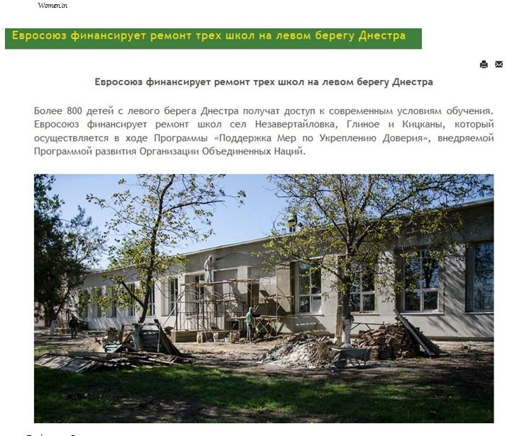
The most advertised topic was: „The European Union finances renovation works in three schools on the left of Nistru” with 67 media reports on both banks of Nistru.

Rating of the subjects:

Subjects | Right Left  bank bank |  | TOTAL
The European Union finances renovation works in three schools on the left of Nistru | 47 | 20
 |  |  | 67
A project designed to improve tourism on both banks of Nistru is implemented with EU support | 18 | 30 | 48
The European Union finances infrastructure projects on the left bank of Nistru | 33 | 12 | 45
Handicrafts centre at European standards for children in Dubasari, left of Nistru | 22 | 22 | 44
30 young people on both banks of Nistru start businesses with the European Union support |  |  | 40
 | 32 | 8
Educational-sports facilities for children in Varnita and Bender | 26 | 14 | 40
Dnestrovsk hospital was renovated with EU support | 15 | 23 | 38
A house of culture from the village Rascov on the left of Nistru shall be renovated from Western funds | 13 | 20 | 33
The most modern ward for treating communicable diseases was inaugurated in Rezina with the EU support
 | 28 | 4 | 32
Thanks to an EU grant, a quail farm was established in Tiraspol | 10 | 21 | 31
EU support or how to become a businessman in six months | 13 | 16 | 29
Business forum with Italian entrepreneurs in Chisinau: “Agriculture 2016” | 24 | 1 | 25
Expert-Grup: The economy of the Transnistrian region in a severe situation | 25 |  | 25
Farmers on both banks of Nistru participate at the international exhibition “PRODEXPO – 2016” | 21 | 2 | 23
Grants for scaling up business cooperation between the two banks of Nistru | 22 |  | 22
Strawberry farm was established in Grigoriopol | 3 | 18 | 21
Tourists will be able to explore new routes on both banks of Nistru | 14 | 3 | 17
Huge lines became a norm for the staff of the Health Centre in Varnita, Anenii Noi district |  |  | 10
 | 10
Experts: Economic crisis in the Transnistrian region is worsened by political decisions | 9 |  | 9
Assistance for farmers specialised in growing berries | 8 |  | 8
Pig farm in Grigoriopol was established thanks to EU support | 2 | 6 | 8
Proposals for developing businesses on both banks of Nistru | 7 |  | 7
Tourism can and must be promoted via internet |  | 7 | 7
Ambition and perseverance! Successful business of a 21-year-old lady from Ustia | 6 |  | 6
CCI from Tiraspol and the UNDP monitor the implementation of funded projects |  | 6 | 6

Annex 3: List of Business Development and Employment Opportunities projects
Number of Sub-Projects: 21
Total budget committed for sub-projects: 1,962,609 EUR

- Supporting Business-to-Business Activity
Sub-project 1: Assessment of export support services available to SMEs on both banks of the Nistru River
Implemented by: National consultant on Export Support Services Georgeta Mincu
Main Objectives: To carry out an assessment of export support services available to SMEs on both banks of the Nistru River with a view to identify specific needs and provide recommendations on how to address them
Budget: 6.601 EUR
Implementation period: June 2015 – March 2016
Beneficiaries: business communities, small and medium enterprises, analysts, researchers, practitioners from both banks of Nistru River
Main activities/results:
- Needs Assessment report for export support services has been drafted. The narrative includes an analysis of the state of play of trading activities on both banks, a description of the general export environment, outlines of existing support instruments for export promotion and development and recommendations for actions and measures for the internationalization of Business Associations and SMEs aiming at enhancing the export development capacities.

Sustainability: the results of the study provides inputs for the development of initiatives focused on increasing the capacities of Business Associations to support SME to trade internationally by developing export support services;
Current Status: completed

Subproject 2: Transnistrian Economic Review: Engaging stakeholders from both banks of the Nistru River in evidence-based discussions about the economic situation in the Transnistrian region
Implemented by: Independent Analytical Centre Expert-Grup
Main Objectives: Carrying out economic research and forecast about the economic situation of the Transnistrian region and engaging the stakeholders from both banks of Nistru River in discussions based on robust economic and statistical evidence
Budget: 60.011 EUR
Implementation period: October 2015 – October 2016
Beneficiaries: direct – 23 workshop participants, including 14 women and 73 participants at the round table presentation, including 23 women. Indirect beneficiaries - around 5000 people from both banks, including CSO, academia, private sector and media representatives from the Transnistrian region and from the rest of the country who are interested in the region.
Main activities:
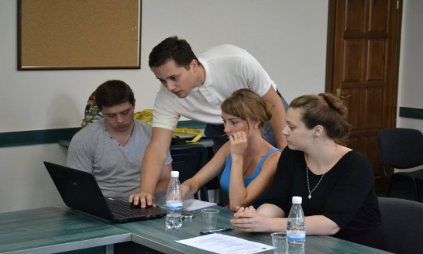
- 3 Transnistria Economic Briefs and 1 Regional Economic Review published. Both publications were widely distributed and cited by the media.
Expert Grup workshop on statistics
- A workshop on Statistics and a round table on the Economic growth analysis in Transnistria region organized with the aim of building the capacity of attendees in the field of evidence-based policy analysis and advocacy. The events were attended by 64 representatives of diplomatic corps, international organizations, government and academia.
Sustainability: 23 economic experts from the Transnistrian region improved their knowledge and capacities to promote evidence-based policy making; 73 participants at the round table improved their knowledge, this enabling them to use the acquired information and tools in their activity. The participants agreed to organize similar activities in the future, including in the Transnistrian region.
Current Status: completed

Sub-project 3: Cooperation and organizational development support for business associations on both banks of the Nistru River
Implemented by: Alternative Internationale de Dezvoltare (right bank) in partnership with Consulting Centre Yahont (left bank)
Main Objectives: To improve the opportunities and services available for business communities on both banks of the Nistru River by supporting BAs in their organizational development, their capacities for B2B and cross-river cooperation, as well as their ability to network and share knowledge, experience and best practices
Budget: 172,724 EUR
Implementation period: December 2015 - November 2017
Beneficiaries: 10 BAs from both banks. Indirect beneficiaries – the BA members, business communities, small and medium businesses from both banks of Nistru river
Main activities:
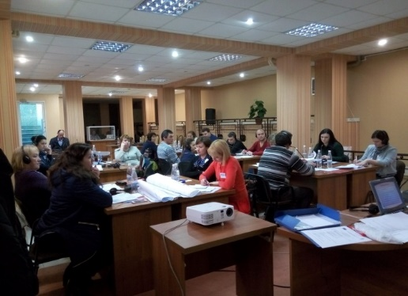
- 10 business associations assisted to draft organizational development plans, based on which they received 10 grants of 5000 USD each to implement the approved ODPs.
Representatives of BAs participating in the seminar on partnerships
- joint professional/technical trainings for BAs from both banks improved their knowledge of strategic planning, results-based management, management of human resources and fundraising, as well as establishment and maintaining of partnerships.
- a Study tour to Lithuania during which 12 associations’ representatives learned about Lithuanian BDS providers, as well as established new contacts with a perspective of future partnerships.
- a joint mid-term conference helped 45 participants (23 women) to understand the role and importance of BAs in the development of the business communities.

Sustainability: a network of BAs from both banks created during the implementation of this project. The established cooperation between BAs will ensure further durability of project results.
Current Status: on-going

Sub-project 4: Strengthening B2B Cooperation through Business Platforms of both banks of the Nistru river
Implemented by: 18 business associations listed below
Main Objectives: to improve the opportunities for business communities on both banks of the Nistru River by offering an environment for networking, B2B and cross-river cooperation, share knowledge, experience and learn best practices for increasing their competitiveness on foreign markets.
Budget: 393,203 EUR
Implementation period: January 2016 – November 2017
Main activities: As a result of an open tender for Creating cross-river business platforms, or strengthening the existing ones, 8 projects were approved by the Selection Committee out of 53 applications received. Within the framework of business platforms activities, more than 50 capacity building activities were organized, that allowed for more than 800 participants from both banks of the Nistru river to engage in joint work, networking and business interactions. Companies from both banks were enabled to promote together their products at common stands at fairs and expos in Moldova and abroad, are learning from each other about new technologies and best practices and are developing common approaches.
Sustainability: a network of cross-river cooperation platforms was created during the implementation of this project. The established cooperation between created platforms will ensure further durability of project results.
Current Status: ongoing
Sub-project 4.1: Cooperation Platform of fruit growers on both sides of Nistru river
Implemented by: Association Moldova Fruct, in partnership with Dnestrovschii Fruct, Tiraspol.
Budget: 51,680 EUR
Implementation period: June 2016 - October 2017
Beneficiaries: direct – 175 members of both associations and other 458 fruit producers from both banks. Indirect beneficiaries – business communities, small and medium-sized agricultural businesses from both banks of Nistru river
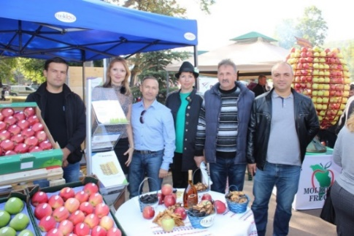
Main activities:
Moldova Fruct and Dnestrovschii Fruct at Festivalul Marului in Soroca
- joint trainings on integrated protection and management of pesticides, cherry trees pruning, needed treatments against diseases and pests, the safety of food products as well as business development attended by 78 farmers (13 women).
- joint study visits to Stefan-Voda on the intensive technology production of cherries and to Anenii Noi on the value chain of plums.
- joint participation with common stands at fairs in Belarus and Moldova;
- joint participation in the “Fruit business in Moldova” conference in order to learn about the latest market trends and innovations in the technology of fruit production and processing as well as to promote fruits export to EU markets.

Sustainability: The established cooperation between the members of the platform will ensure further durability of project results.
Current Status: on-going
Sub-project 4.2: Business Bridge Platform - revival of business confidence on the banks of the river Nistru
Implemented by: The Moldo-Italian Chamber of Commerce and Industry in partnership with the Chamber of Commerce and Industry from Tiraspol.
Budget: 45,000 EUR
Implementation period: June 15, 2016 - October 30, 2017
Beneficiaries: direct - at least 16 companies from the left bank, 29 companies from the right bank and 8 Italian companies. Indirect beneficiaries - experts representing NGOs and public organizations, business communities from both banks.
Main activities:
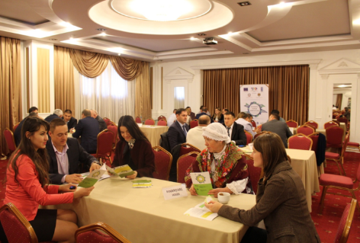
- a mentorship programme which includes assistance for drafting project proposals launched, benefiting 8 companies from both banks;
Brokerage event organized by the Moldo-Italian CCI
- a workshop carried out with the goal to promote the idea of business associations in agriculture among 70 entrepreneurs from both banks of Nistru and Italy.
- A brokerage event with 7 different thematic round tables was organized. The participants had the opportunity to present their projects and create new business links.

Sustainability: The established cooperation between BAs will ensure further durability of project results.
Current Status: on-going
Sub-project 4.3: Integrated platform for berry value chain development (BERRYDEV)
Implemented by: Bizgates Agency for Sustainable Social-Economic Development in partnership with the Association Berries of Moldova and the Association of Small Farmers Belyi Most
Budget: 51,525 EUR
Implementation period: June 15, 2016 - September 30, 2017
Beneficiaries: direct – 75 members of both associations. Indirect beneficiaries – business communities, small and medium agricultural businesses from both banks.
Main activities:
- assistance and consultancy to platform members, in accessing local retailers;
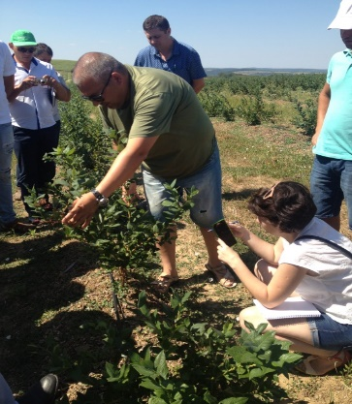
- participation of producers from both banks at international conferences (Fresh Retail Producers and Exporters from Moldova Conference, Commercial Berry Production International Conference), during which the participants were exposed to world’s best production, post-harvest handling and marketing practices presented by leading Dutch, Polish, Belarus and Ukrainian experts;
Visit to a Blueberry plantation
- a new sales platform is under development;
- study visits organized to the right bank berry growers as well as to Ukrainian producers, in order to make acquainted 29 platform members (10 women) with best practices of multiple berry crops and the berry seedlings production.

Sustainability: The BERRYDEV platform created new connections between its members from both banks and international experts to ensure the access to new technologies for berries producers. The established cooperation will ensure further durability of project results.
Current Status: on-going
Sub-project 4.4: Development of the tourism business on both banks of Nistru river through the establishment of sustainable partnerships
Implemented by: National association of inbound tourism ANTRIM (right bank), in partnership with ARDT (left bank)
Budget: 44,286 EUR
Implementation period: June 15, 2016 - October 30, 2017
Beneficiaries: direct –members of both associations, travel agencies, wineries, providers of services or products (women artisans, rural residents, rural guesthouses owners, handicraft centres, etc.) from both banks. Indirect beneficiaries: visitors, tourists, tour guides, translators, others
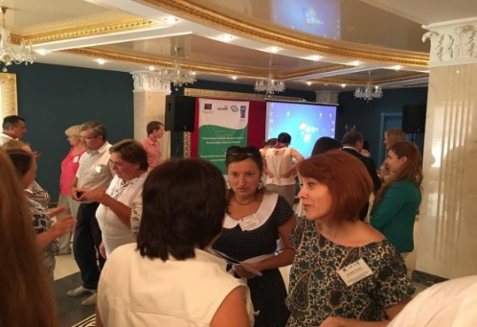
Main activities:
A networking event within the tourism platform
- participation of 32 representatives of travel agencies (65% women) in 2 study visits organized on both banks in order to assess 32 new touristic sites;
- participation in capacity building and networking events of 44 professionals from both banks (19 men, 25 women), as well as in the Global Conference of wine tourism in Georgia. The events offered the participants from both banks the possibility to improve their knowledge and establish new business contacts;
- an info-tour organized to familiarize the mass media and travel agencies with joint itineraries that include 11 touristic sites from both banks. The new touristic sites are being promoted through media and travel agencies offers.
Sustainability: The platform has improved the confidence among touristic service providers from both sides of the Nistru River through direct interaction and exchange of experience on the workshops and study visits. The continuity of this platform is insured by new touristic products, that include sites from both banks and an info-centre to be open in Chisinau, which will promote common touristic offers.
Current Status: on-going
Sub-project 4.5: Development of a sustainable cooperation platform of women agricultural entrepreneurs from both banks of Nistru River
Implemented by: Federation of agricultural producers AGROINFORM in partnership with the Chamber of Commerce and Industry from Tiraspol
Budget: 52,785 EUR
Implementation period: June 15, 2016 - August 31, 2017
Beneficiaries: direct –business women from both banks and women from the regional communities. Indirect beneficiaries – business communities, small and medium agricultural businesses from both banks
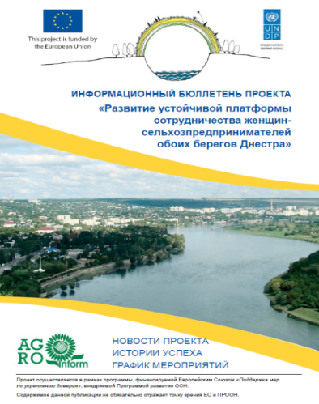
Main activities:
Newsletter for agricultural women entrepreneurs
- two agriculture business women associations undergo the registration procedure;
- capacity building activities organized for 46 participants (41 women) from both banks on growing stone-fruits and growing grapes;
- study and exchange visits for 59 women from both banks to farms in Slobozia and Falesti districts allowed the participants to improve their knowledge on soil preparation before planting, seedling, processing varieties of nuts and grapes;
- a project newsletter published, with more than 300 women entrepreneurs in agriculture from the right and left banks as direct beneficiaries.
Sustainability: The established cooperation between the representatives of agriculture associations will ensure further durability of project results.
Current Status: on-going
Sub-project 4.6: Development of a hospitality industry consortium on both banks of Nistru river
Implemented by: Agency for Regional Development ARDT (left bank) in partnership with the National Hotel and Restaurant Association of the Republic of Moldova
Budget: 49,773 EUR
Implementation period: June 15, 2016 - June 15, 2017
Beneficiaries: direct – 60 hoteliers from both banks and 30 staff members. Indirect beneficiaries - 10 inbound tourism agencies, 20 suppliers of hospitality services and goods from both banks, as well as tourists.
Main activities:
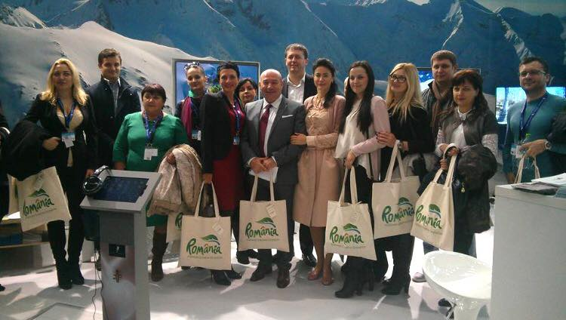
- a networking and a capacity building event attended by 77 representatives (49 women) of the hospitality industry from both banks, who had the opportunity to learn about effective management, promotion of hotel services and promotion of hotel services via the Internet and social networks.
Study tour of hoteliers to Romania
- a study tour to Romania organized for 15 hoteliers (11 women) from both banks, including the visit to the Tourism Exhibition.

Sustainability: The hospitality and tourism platform members will mutually promote such products as itineraries that include touristic sites and hotel offers from both banks. The info-centre opened in Tiraspol and the one to be opened in Chisinau will support the development of incoming tourism through joint offers. The established cooperation between platform members will ensure further durability of project results.
Current Status: on-going
Sub-project 4.7: Through communication and cooperation to a better life
Implemented by: Association CUTEZATORUL, Falesti in partnership with Association Vitality, Tiraspol and Association of Small Farmers Belyi Most, Chitcani, Slobozia
Budget: 49,560 EUR
Implementation period: June 15, 2016 - October 09, 2017
Beneficiaries: direct –12 trainers in the field of organic farming from both banks, 180 farmers from both banks, 13 specialized NGOs from both banks. Indirect beneficiaries - 500 farmers and agricultural producers from both sides, consumers of organic products, three scientific institutions from both banks.

Main activities:
- 14 NGOs and 12 trainers from both banks created a cross-river network of comunication and cooperation with a view to improve their capacity and sustainability;
- an information campaign organized, along with 500 leaflets published and distributed and the eco-agro.org web-site created to promote the cooperation within the business platform;
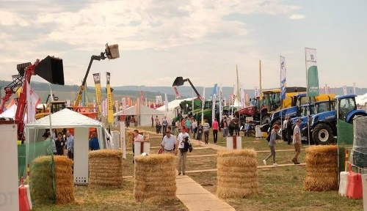
- networking and capacity building events on organic farming, how to initiate and develop start-ups and create networks of NGOs was attended by 34 representatives of platform partners, farmers, agricultural entrepreneurs, civil society and scientific institutions, from both banks;
Moldovan Farmers at an Agricultural fair in Romania
- A study tour was organized for 17 participants from both banks (6 women) to an organic farm and to Lungu Trifesti Agricultural fair, both in Ezureni, Iasi, Romania;
Sustainability: The established cooperation between the associations will ensure further durability of project results.
Current Status: on-going
Sub-project 4.8: Cross-river partnership on marketing research
Implemented by: the Chamber of Commerce and Industry France-Moldavie in partnership with the Chamber of Commerce and Industry from Tiraspol
Budget: 48,594 EUR
Implementation period: August 01, 2016 - October 30, 2017
Beneficiaries: direct – 23 representatives of both Chambers of Commerce, 7 employees of Magenta Consulting, 50 members of both Chambers of Commerce. Indirect beneficiaries - 80 exporters from the right bank, 50 exporters from the left bank.
Main activities:
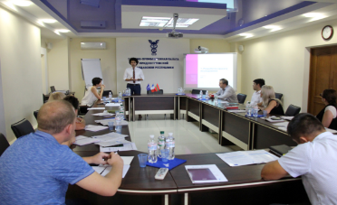
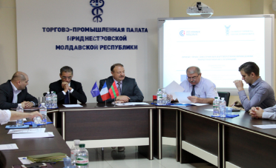
- 10 training sessions organized;
Training on marketing at the CCI Tiraspol
- two practical pilot studies on consumer preferences and on advertising currently carried out.

Sustainability: The platform members will provide joint marketing research services to customers from both banks, ensuring the confidence building through continuous collaboration for the upcoming projects. Both organizations have improved their skills and developed own services portfolio. The established cooperation between the two BAs will ensure further durability of project results.
Current Status: on-going

Sub-project 5: Trainings for BAs and CSOs from both banks of the Nistru river to support joint development initiatives
Implemented by: The Chamber of Commerce and Industry of the Republic of Moldova in partnership with the Agency for Regional Development from the Transnistrian region (ARDT)
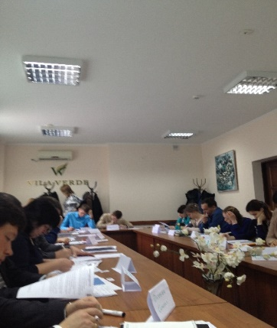
Budget: 9,314 EUR
Training on project writing
Implementation period: February 2016 - April 2016
Beneficiaries: direct – 55 applicants for cross river partnerships. Indirect – BAs and NGO from both banks of Nistru river
Main activities:
- Two training courses on partnership building and project design attended by 55 participants from both banks (27 from the left bank). The participants learned about the benefits of joint efforts and the way to ensure the commitment for this.

Sustainability: During the trainings, new connections and partnership were established, facilitating future joint projects.
Current Status: completed
- Stimulating Business Development Services
Sub-project 6: Study on Business Development Services Market on both banks of Nistru River
Implemented by: Alternative Internationale de Dezvoltare, AID, Chisinau and the Centre for analytical research New Age,Tiraspol
Main Objectives: To carry out an in-depth analysis of the Business Development Services market on both banks of the Nistru River and present a set of recommendations on further development of the sector
Budget: 67,567 EUR
Implementation period: August 2015 – February 2016
Beneficiaries: direct – 23 participants at study tours, including 13 women and 40 participants at focus groups, including 20 women. Indirect beneficiaries - more than 64 SMEs, including 32 from the left bank.
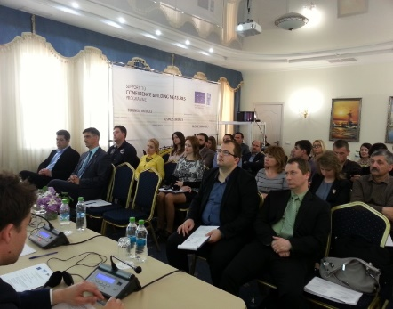
Main activities:
Final conference to present the Study of the BDS market
- The report provides a set of practical recommendations on further development of the business development services, based on interviews, questionnaires, focus group meetings and international experience.
- Main findings presented to key stakeholders during a public event attended by about 49 participants, including 14 from the Transnistrian region.

Sustainability: The study results were of much use when planning and launching further activities related to the development of consultancy market on both banks of the Nistru river.

Current Status: completed

Sub-project 7: Boosting the CCI capacity of offering sustainable consultancy services to the beneficiaries from both banks of the Nistru river
Implemented by: the Chamber of Commerce and Industry, Chisinau
Main Objectives: Development of business partnership between BSOs, promotion of business-to-business and organization-to-organization partnerships through the provision of joint training courses with the Chamber of Commerce and Industry from Tiraspol.
Budget: 134,657 EUR
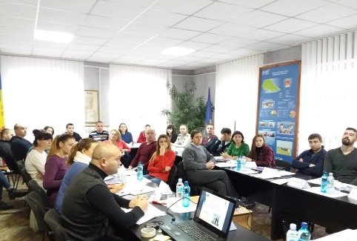
Implementation period: July 01, 2016 – November 30, 2017
Trainings organized by Tiraspol Business School
Beneficiaries: direct – 15 beneficiaries of baker course, 49 beneficiaries of Start-Up course, 15 beneficiaries of EUREM course. Indirect – companies and organizations which will improve their knowledge and skills.
Main activities:
- Training courses for 15 bakers (13 women and 2 men) started in Chisinau in partnership with a professional school from Chisinau.
- Start-Up courses for 49 persons (25 women) started in Ribnita and Tighina/Causeni.
- EUREM courses for 15 participants started in Chisinau. After the successful completion of the theoretical exam and practical project, the graduates of the program will receive the EUREM certificate (European Energy Manager) issued by the Nuremberg Chamber of Commerce and Industry and internationally recognized.

Sustainability: Through this project, both Chambers of Commerce and Industry cooperate in improving their services offered to the market, namely professional courses. The partners organized joint events and exchanged the best practices in the field of business development services. The established cooperation between the two BAs will ensure further durability of project results.

Current Status: ongoing

Sub-project 8: Measures to provide business education and staff development of business structures in order to enhance business activities in Transnistrian region
Implemented by: the Chamber of Commerce and Industry, Tiraspol
Main Objectives: further development of business education in the Transnistrian region, which allows creating and developing of new businesses, restraining the migration of young people, increasing economic activity and reducing the negative processes in the economy
Budget: 134,908 EUR
Implementation period: July 01, 2016 – December 10, 2017
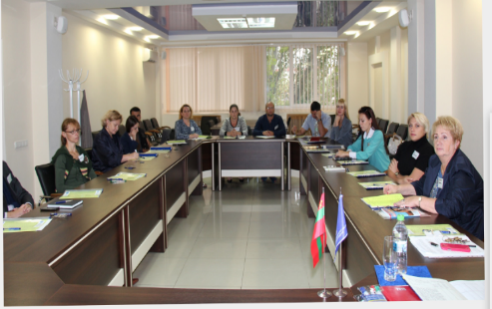
Beneficiaries: direct – 134 participants to courses and round tables; indirect - companies and organizations from the left bank
Trainings organized by Tiraspol Business School
Main activities:
- 118 beneficiaries from the left bank (67 women) are improving their skills on: brand development and management, control of entrepreneurship activity, internet trade as a new method of business development, methods of project management, basics of creating your own business and peculiarities of national cuisine.

Sustainability: while implementing the project activities, the Chamber of Commerce and Industry from Tiraspol cooperates with the Chamber of Commerce and Industry from Chisinau in the organization of events and exchanging experience. All these will contribute to the enhancement of cooperation and maintaining of a good partnership.
Current Status: ongoing

Sub-project 9: Developing capacities of export and internationalization consultants on both banks of the Nistru River
Implemented by: Alternative Internationale de Dezvoltare, AID, in consortium with Sigma Expert from the left bank and Institute of Export, United Kingdom
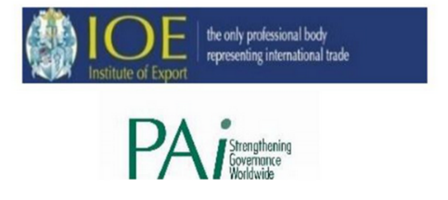
Main Objectives: To develop the business consultancy market by providing trainings and international certification of at least 15 export consultants
The partnership for the implementation of the project on training and certification of export consultants
Budget: 103,930 EUR
Implementation period: October 01, 2016 – July 31, 2017
Beneficiaries: direct – 20 participants to the training course. Indirect beneficiaries - companies in need of highly qualified experts to promote their exports
Main activities:
- The work plan and methodology of the courses were drafted by the Consortium and 20 beneficiaries from both banks were selected. The on-line training sessions will start in January 2017 and at least 15 of them will be certified.

Sustainability: The main target of this project is to create new business services to support the export of goods from both banks under the DCFTA terms. After the certification, the Consortium will enforce the cooperation between the experts on improving the export capabilities for the local companies.

Current Status: ongoing

Sub-project 10: Providing Consultancy Services for Competitiveness improvement through training and certification of Business Consultants
Implemented by: CPM Consulting, Austria in consortium with Business Consulting Institute and the Chamber of Commerce and Industry from Tiraspol
Main Objectives: To develop the business consultancy market by providing trainings and international certification of at least 16 business consultants
Budget: 175,770 EUR
Implementation period: November 17, 2016 – October 17, 2017
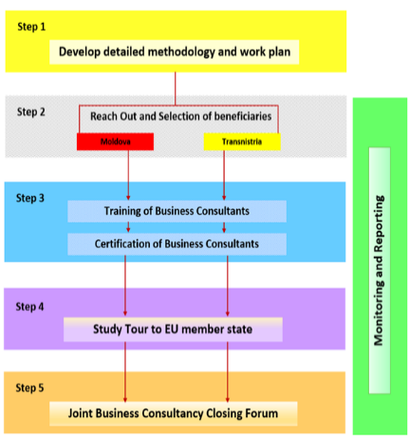
Beneficiaries: direct – 20 course participants. Indirect beneficiaries - companies and organizations that will improve their capacities as a result of the provided expertise by business consultants
Project methodology
Main activities:
- The work plan and methodology of the courses were drafted by the Consortium and 25 beneficiaries from both banks were selected. At least 16 of them will be certified. Introductory sessions were held in December 2016 in Chisinau and Tiraspol.

Sustainability: Joint training activities will support confidence building and will strengthen the local consultancy market by providing training of trainers. After the certification, the Consortium will enforce the cooperation between the experts on improving the business management for the local companies.
Current Status: ongoing
- Promote a Culture of Entrepreneurship and Support Young Entrepreneurs

Sub-project 11: Creation of Job Opportunities through Business Support for Youth on the Right bank
Implementer: Business Consulting Institute NGO
Main Objectives: Create job opportunities in the Security Zone (for people aged 18 to 35 years old) by providing the young entrepreneurs with support in starting and running effectively a business, as well as with opportunities to network and share knowledge and best practices
Budget: 331,725 EUR
Implementation period: July 2015 – April 2017
Beneficiaries: direct – 15 grant beneficiaries from targeted communities assisted, including 10 women, indirect – 152 people.
Main activities:
- 80 candidates (41 women, 40 men) additionally benefited from individual consultancy on business plan writing;
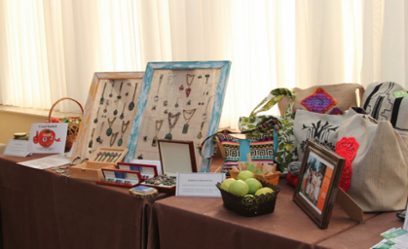
- 15 grant beneficiaries (including 10 women) from Anenii Noi, Causeni, Dubasari , Orhei , Rezina , Soldanesti and Stefan Voda were selected and received grants of up to 13,500 Euro, individual coaching and provision of business support services;
Exhibition of crafts produced by young entrepreneurs
- 62 new jobs were created (28 for women), with improved livelihoods for more than 150 people;
- 5 thematic seminars organized on Human Resources, Strategic management, Accounting and Finance and negotiation skills;
- A joint conference was organized in Vadul-lui-Voda (April 2016), attended by more than 100 participants from both banks. The event included an exhibition of young entrepreneurs’ products / services and short presentations of their success stories;
- A business platform for supporting collaboration between young entrepreneurs from both banks of the Nistru River has been updated and improved: www.business-bridges.net .
Sustainability: A network of young entrepreneurs has been created and as a result of implementation of two mirror projects it will ensure further continuity of project results. Several beneficiaries already identified the opportunity of further development trough economic exchanges and extension on the opposite bank.
Current Status: ongoing

Sub-project 12: Creation of Job Opportunities through Business Support for Youth in the Transnistrian region
Implementer: The Chamber of Commerce and Industry, Tiraspol
Main Objectives: Creation of job opportunities in the Transnistrian region (for people aged 18 to 35 years old) by providing young entrepreneurs with support in starting and running a business, getting opportunities to network, share their knowledge and best practices
Budget: 344,825 EUR
Implementation period: July 2015 – April 2017
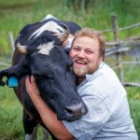
Beneficiaries: direct – 15 grant beneficiaries assisted in the Transnistrian region, including 9 women, indirect – 224 people
Vitalii Covali received a grant and established
a milk farm in Dubasari
Main activities:
- 146 applicants (51 women) benefitted from 4 one-day trainings on business plan writing (Tiraspol, Bendery, Rybnitsa) and 52 candidates (15 women) received more than 75 hours of individual consultancy on all aspects of business plan writing;
- 16 grant beneficiaries (9 women) from Tiraspol, Bendery, Grigoriopol, Ribnitsa, Slobozia, Dnestrovsc, Dubasari were selected and received grants of 9,400-13,500 Euro, continuous individual coaching and provision of business support services;
- 69 new jobs have been created and more than 220 people improved their livelihoods;
- 5 thematic seminars were organized on topics like: human resources, organizational management, accounting and fiscal regulations and negotiation skills.
- A Joint Conference, organized in Tiraspol in October 2016, was attended by more than 100 participants. During the event, the entrepreneurs had the opportunity to share their own products /services and their success story, as well as to network.

Sustainability: a network of young entrepreneurs created as a result of implementation of two mirror projects will ensure further durability of project results. Some of the beneficiaries have already identified new opportunities to extend their businesses on the right bank.

Current Status: ongoing

Sub-project 13: Study on entrepreneurship perception among youth on the left bank of the Nistru River
Implementer: CBS-AXA in cooperation with MiLab and Centre Resonance from the Left Bank
Main Objectives: to design and carry out a study among young women and men (aged 18 to 35) from the Transnistrian region, on their perceptions of entrepreneurship and come up with recommendations on promotion of a culture of entrepreneurship in the respective area.
Budget: 22,520 EUR
Implementation period: October 2015 - June 2016
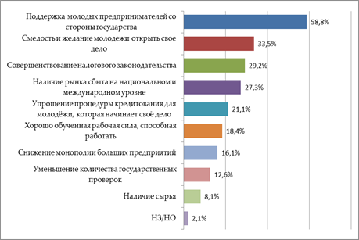
Beneficiaries: direct - 30 youth from both banks (16 women). Indirect beneficiaries - business communities, associations, analysts, researchers, entrepreneurs from both banks of Nistru River
The results of interviews on perception
of entrepreneurship
Main activities:
- The Study elaborated based on a public survey and in-depth interviews among youth on the left bank during March-April 2016.
- Discussions with 4 focus groups of 8-9 participants each (4 one-day meetings in total) were organized to secure the analysis and to validate the suggested recommendations on entrepreneurship culture promotion.
- The final report, containing recommendations delivered by CBS-AXA in June 2016 will further guide the implementation of business development activities.

Sustainability: the participants gained valuable experience and knowledge about the design thinking and culture of entrepreneurship and had the opportunity to network with their colleagues and experts and establish valuable liaisons for future cooperation. The training as well as extra-training activities were conceived to assure a large communication between the youth from both banks.
Current Status: completed
Sub-project 14: Feasibility research on the establishment of Business lab in the Taras Shevchenko University in Tiraspol
Implementer: Individual consultants Vlada Lisenco and Oleg Stiopca
Budget: 4,854 EUR
Implementation period: May-September, 2016
Beneficiaries: 121 participants, 59 women, including 8 from the Transnistrian region
Main activities:
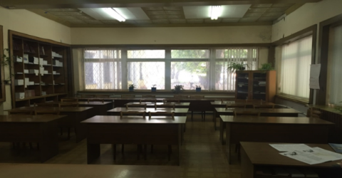
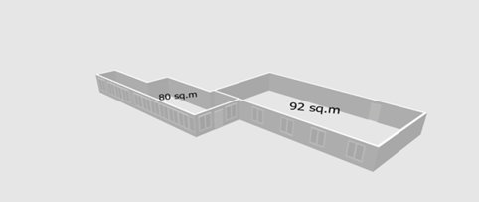
- The Study was conducted using diverse technics, e.g. applying questionnaires, organizing site visits, holding semi-structured interviews and meetings with different stakeholders: business representatives, university staff and managers, local authorities, representatives of business development organizations.
The recommended location of the future Business Lab
- Provided recommendations relate to the need for trainings for the Laboratory staff, suggestions for the physical location, a road-map for the Business Laboratory establishment and budget estimates.

Sustainability: The results of the study will be the basis for the decision on supporting the establishment of a Business Laboratory on the left bank.
Current Status: completed

Annex 4: List of Community Infrastructure Projects

Number of Sub-Projects: 25
Total budget committed for sub-projects: 3,886,631 EUR
Community contribution: 239,703 EUR
Other donors’ contributions: 25,000 EUR
Number of direct beneficiaries: 89,699 (women: 49,585 and men: 40,114)

Sub-Project 1: “Overall repair of the Child and Youth Creativity Hall” in the town of Dubasari (left bank)
Direct beneficiaries: 25,801 (town population): 12,939 women and 6,145 men
Budget: 149,060 EUR
Period of implementation: January 2016 – August 2016
Overall goals of the project: overall renovation of the Child and youth creativity hall, enhancing its capacity and generating opportunities for cross-river confidence building activities
Status: Completed
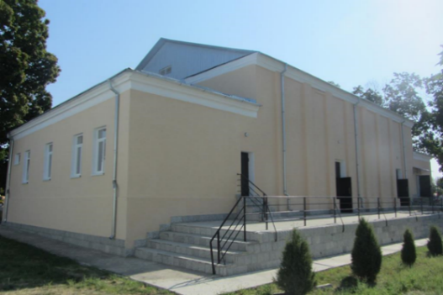
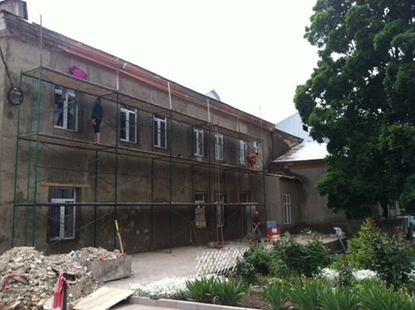
The works included capital repair of the previously leaking roof, total renovation of the building façade, construction of new separate toilettes for males and females (previously just one common restroom). In addition, the area surrounding the building was landscaped and the summer stage was renovated. Also the ceiling in the big concert hall was rehabilitated, new covers for the chairs and new wooden flooring for the stage were provided. All electricity networks were replaced and the heating system renovated (the previous one was non-functional and required maintenance works during the cold season). Old wooden windows were replaced and minor repairs for the rehearsal rooms and extra-curricular activity halls were conducted. Due to new wall padding, the acoustic features of the grand concert hall were greatly improved.

Results of the implemented project:
- Adequate conditions for existing after-school activity groups (both participants and staff) created;
- Modern premises available for the organization of cross-river and confidence building initiatives;
- Good EU-funded project visibility given the central location of the institution;
Sustainability and expected confidence building impact:
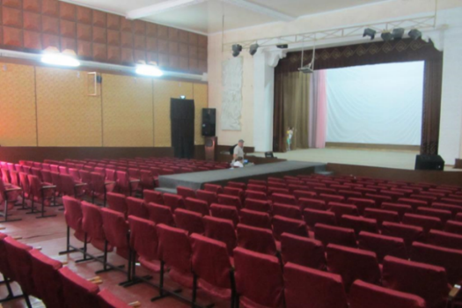
An MoU was signed with the local beneficiary institution prior to the initiation of the reconstruction. Given the fact that the Child and youth creativity hall is benefiting from continuous financial support of the Dubasari town administration, no risks regarding its further activity are foreseen. Considering the size of the town and the special status (focus on children and youth activity) of the institution, the local impact of the project is quite considerable. Improved conditions will make the centre more attractive, therefore increasing the number of future beneficiaries. Further, the Centre will be used as a platform for cross-river events which will involve people from both banks in culture related activities. The most recent example is the participation of Centres representatives in the joint cross-river collaboration event “Aho-aho rasuna Nistrul” which took place in Cosnita, December 24, 2016.
Sub-Project 2: “Reconstruction of general education school/kinder garden nr. 2” in Nezavertailovca village (left bank)
Direct beneficiaries: 746 (225 children+71 staff+450 parents): 395 women and 351 men
Budget: 175,942 EUR
Period of implementation: January 2016 – June 2016
Overall goals of the project: enhancing cross-river collaboration by improving the education and sanitary conditions at the general school and kindergarten nr.2 from Nezavertailovca village
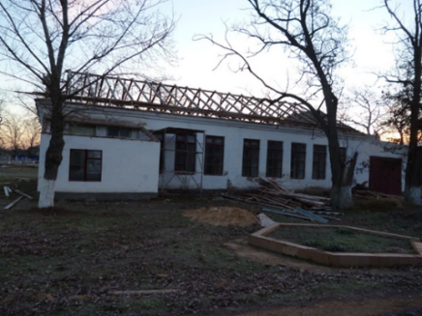
Status: Completed
Performed works included full renovation of the auxiliary block that now hosts a concert hall (previously the school did not have a concert hall because it hosted the kindergarten as well). The auxiliary block was consolidated according to current safety norms. The roof was changed and thermally insulated; all electrical and heating networks were replaced. Previously the school had no toilets; new restrooms were build inside the building. A cesspool was build and now the facility has a functional sewerage system. In the main block, the thermal system was completely renovated. In addition, the sports hall was renovated and equipped.

Results of the implemented project:
- Adequate learning conditions for pre-schoolers and pupils attending the institution (as well as hired personnel);
- Overall better energy efficiency leading to institutional budget savings;
- Improved standards for educational processes will attract more beneficiaries in the future;
Sustainability and expected confidence building impact:
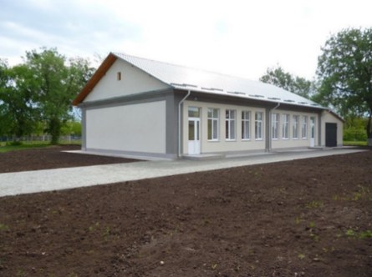
Experts from the implementing partner team (Interaction NGO) organized two trainings for the representatives of the community work group (topics: Basis of project planning and preparation, and Mobilizing community resources to solve social problems). In addition, representatives from Nezavertailovca attended the joint capacity building trainings organized in Chisinau. Improving the conditions of an institution where children begin their official education sets the foundation for a proper development and schooling processes in their lives, thus respecting their basic human right of access to education. The implemented project will become part of the thematic platform on education, therefore continuing to participate in specific capacity development as well as confidence building initiatives ensuring its sustainability beyond the duration of the project.

Sub-Project 3: “Renovation of School nr. 2” in Chitcani village (left bank)
Direct beneficiaries: 1,023 (420 pupils+550 parents+53 staff): 544 women and 479 men
Budget: 142,069 EUR
Period of implementation: January 2016 – October 2016
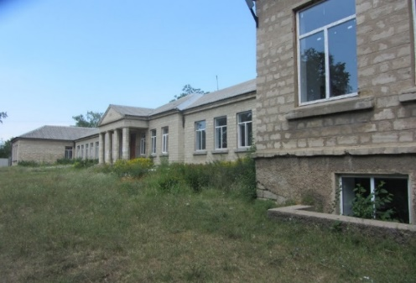
Overall goals of the project: enhancing cross-river collaboration through the creation of better education conditions within school nr.2 from Chitscani
Status: Completed
Performed works included replacing the roof for three school blocks. The heating network was replaced in the main block. General renovation of the block, which hosts the school cafeteria and full equipment of the lunchroom. All roofs have been equipped with rainwater collection and drainage systems to eliminate water collections previously leading to leakages and flooding in the school.

Results of the implemented project:
- Adequate learning conditions for pupils attending the institution (as well as hired personnel);
- Overall better energy efficiency leading to institutional budget savings;
- Improved standards for educational processes will attract more beneficiaries in the future;
Sustainability and expected confidence building impact:
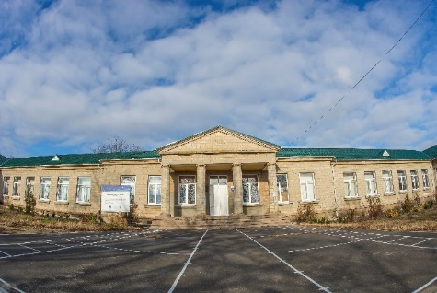
Experts from the implementing partner team (Interaction NGO) organized two trainings for the representatives of the community work group (topics: Basis of project planning and preparation, and Mobilizing community resources to solve social problems). In addition, representatives from Chitcani attended the joint capacity building trainings organized in Chisinau. As part of the soon to be established thematic platform on education, the school will benefit from further specialized trainings as well as will have the opportunity to be involved in cross-river collaboration initiatives with schools from Tanatari, Varnita Puhaceni, and Copanca (the right bank.) Additionally, the school from Chitcani will have the opportunity to access other funds for cross-river collaboration projects through the Small Grants programme.

Sub-Project 4: “Replacement of windows, repair of roof and cafeteria/festivity hall for general education school in Glinoe village (left bank)
Direct beneficiaries: 750 (250 pupils+500 parents): 380 women and 370 men
Budget: 129,935 EUR
Period of implementation: January 2016 – September 2016
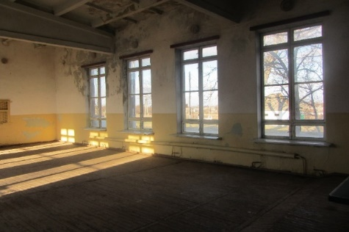
Overall goals of the project: enhancing cross-river collaboration through better education conditions within the general school from Glinoe village
Status: Completed
Performed works included capital renovation of the building where the sports and festivity halls (also used as the cafeteria) are located. The roof of the building was replaced. The façade and exterior finishing works were completed for the entire building. Inner yard of the school has a new pavement now. All electrical and heating networks were replaced. The sports hall was connected to hot water sources and shower facilities were installed. The kitchen (for the cafeteria) was renovated and old windows and doors were replaced for the entire edifice.
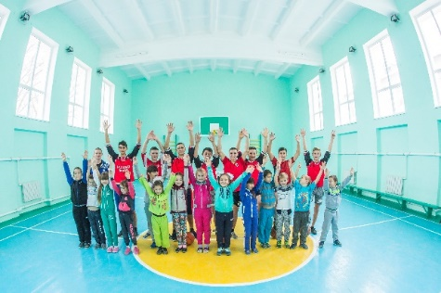
Results of the implemented project:
- Improved learning conditions for pupils attending the institution and hired staff;
- Overall better energy efficiency leading to institutional budget savings;
- Improved standards for educational processes will attract more beneficiaries in the future;
Sustainability and expected confidence building impact:
Experts from the implementing partner team (Interaction NGO) organized two trainings for the representatives of the community work group (topics: Basis of project planning and writing, and Mobilizing community resources to solve social problems). In addition, the community representatives were involved in joint training related to strategical planning. Starting from 2017, the renovated school will have the possibility to be involved in the thematic activities planned for the thematic collaboration platform on education. Currently, the renovated festivity hall could host events and serves as a premise for meetings of representatives from similar projects funded under the SCBM Programme framework. The projects that support educational institutions represent a great potential for strengthening confidence building, given that children, their parents and teaching personnel are directly benefitting from the EU-funded actions and can serve as future positive messengers of such initiatives.

Sub-Project 5: “Renovation of the town polyclinic” in Dnestrovsc (left bank)
Direct beneficiaries: 15,072 (15,000 yearly capacity of patients+72 staff): 7,868 women and 7,204 men
Budget: 160,793 EUR
Period of implementation: January 2016 – July 2016
Overall goals of the project: promoting confidence and enhancing cross-river collaboration by improving conditions for both, patients and staff (total of 72) of the polyclinic, as well as supporting exchange of experience in the medical services sphere.

Status: Completed
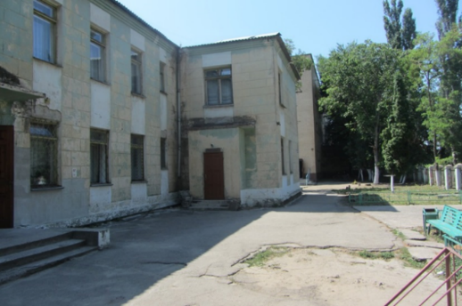
Performed works included roof replacement and renovation of all public areas. The polyclinic now has a new heating system and electricity networks, as well as a renovated water supply and sewerage system. The toilets were repaired and equipped. The flooring in all doctors’ offices was renovated. A number of specialized rooms were renovated according to safety and sanitary norms and standards (the procedure and testing facilities). The surgery, gynaecology and infectious diseases sections were fully refurbished. By combining the EU and SDC funds, a vaccination cabinet for new-borns and other children was established.

Results of the implemented project:
- Improved conditions for patients and medical personnel;
- Higher quality healthcare service;
- Decrease the number of hazards in the institution related to overall poor conditions and inadequate conditions;
Sustainability and expected confidence building impact:
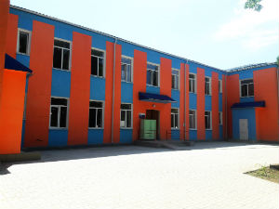
Experts from the implementing partner team (Interaction NGO) assessed the institution’s development needs and elaborated relevant recommendations and action plan for development. Furthermore, two trainings for the representatives of the community work group (topics: Basis of project planning and writing, and Mobilizing community resources to solve social problems) were organized. In addition, representatives from Dnestrovsc attended the joint capacity building trainings organized in Chisinau. As part of the thematic collaboration platform for healthcare, the needs of the institution will be identified and the polyclinic will further benefit from additional capacity building and specialized trainings, as well as study visits. The planned exchange of experience events between medical personnel from both banks will thus contribute to further strengthening of the confidence building potential also beyond the scope of the SCBM-implemented project.
As part of the confidence building promotion and visibility campaign an official inauguration of Dnestrovsk polyclinic was organized. Representatives of the EU Delegation, Swiss Agency for Development and Cooperation and local stakeholders attended the event that was shown in numerous TV stories, interviews, newspaper articles and radio news.

Sub-Project 6: “Improvement of educational, socio-cultural and sport services provided by the complex in Varnita village” (Anenii Noi district)
Direct beneficiaries: 2,365 (children, parents and staff): 1,170 women and 1,193 men
Budget: 162,184 EUR
Additional local contribution: 6,555 EUR
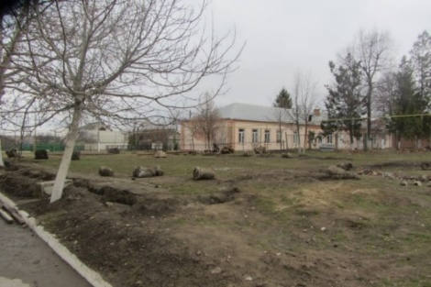
Period of implementation: January 2016 – June 2016
Overall goals of the project: create optimal conditions for the good functioning of the educational, socio-cultural and sports complex in Varnita village, leading to a growing number of cross-river collaboration initiatives and joint thematic events and activities
Status: Completed
Executed works included pavement of the basketball field, establishment of running tracks, as well as establishment and equipment of a fitness area (work out units). A little basketball field was provided for the kindergarten. The interior and exterior of Asclepio Centre was completely renovated. All thermal and electrical systems were replaced. In addition, all windows were renovated, and fences for the school and kindergarten were provided (to separate the school from the road and other private property).
Results of the implemented project:
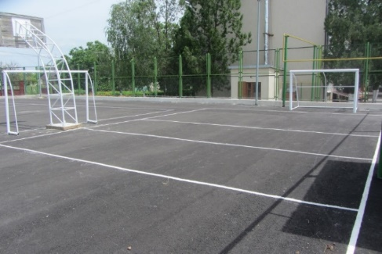
- Over 5000 beneficiaries from the village and surrounding communities will have access to modern sports and culture related facilities;
- Children from socially vulnerable backgrounds have access to extra-curricular activities;
- Elderly persons have a place to meet and celebrate diverse cultural holidays – activities otherwise not available in the community;
Sustainability and expected confidence building impact:
The local authorities have taken full responsibility for the maintenance of the renovated social infrastructure. Façade insulation as well as replacement of heating and internal networks diminished current maintenance costs.
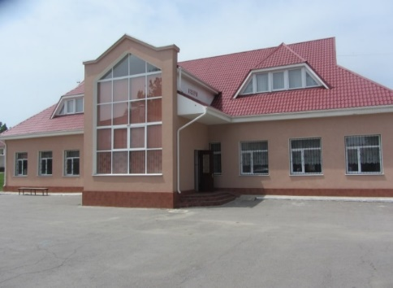
Experts from the implementing partner team (Contact NGO) assisted the local authorities in updating the community development strategy. Representatives from Varnita village attended the joint capacity building trainings organized in Chisinau. An exchange study visit to Varnita was organized in November 2016 and close to 30 participants were able to see all projects implemented in the community with the EU funding. The community of Varnita serves as a great example for representatives from other EU-funded projects (under the SCBM framework) since they managed to attract resources for a considerable number of social and community – focused initiatives. Sharing their experience with almost 30 persons from the nearby localities is a valuable contribution - passing on their experience, knowledge and offering tips to less experienced community initiative groups. The exchange visit also represented an opportunity for communities in search of cross-river collaboration ideas to establish contacts with potential partners and like-minded local leaders.
As part of the confidence building promotion and visibility campaign an official inauguration of Varnita sport and social-educational project was organized. The event was attended by representatives of the EU Delegation, the Prime Minister and local stakeholders from both banks of the Nistru River. The event was widely covered by local and national mass media.

Sub-Project 7: “Modernization of the regional community centre from Slobozia-Dusca village” (Criuleni district)
Direct beneficiaries: 3,200 (village population): 1,672 women and 1,528 men
Budget: 178,560 EUR
Additional local contribution: 22,930 EUR
Period of implementation: January 2016 – May 2016
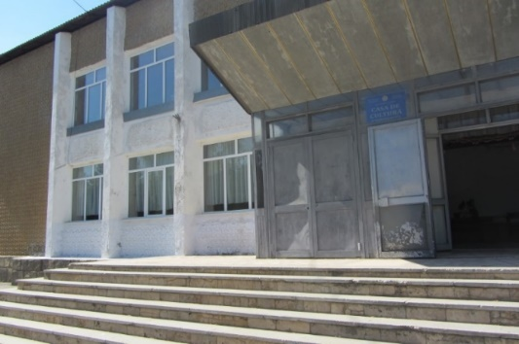
Overall goals of the project: promote and consolidate confidence, cultural and spiritual values, national traditions and customs, creating optimal conditions to organize joint cultural-artistic activities in the localities: Slobozia-Dusca, Criuleni and the villages Harmatca and Tibuleuca, Rascov, Nezavertailovca and Corotna from the Transnistrian region. Thus offering citizens qualitative services and diversified cultural activities as well as strengthening cross-river collaboration links.
Status: Completed
Performed works included total replacement of the roof, thermal insulation and total renovation of the building façade. The entrance to the community centre was renovated and is now being used as a stage for certain events (has a proper roof cover and stairs). Indoor restrooms were provided. The edifice was connected to water and sewerage systems. Repair works were performed in the grand concert hall, small concert hall and the rooms used for rehearsal and art activity. The entire stage lighting system from the grand concert hall was renewed. The mayoralty contributed by equipping the grand concert hall with chairs and the surrounding terrain was landscaped.
Results of the implemented project:
- Improved conditions for the organization of cultural and social events and activities;
- Preservation of the local cultural heritage;
- Access to modern and high quality cultural facilities at a local level;
Sustainability and expected confidence building impact:
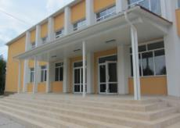
Experts from the implementing partner team (Contact NGO) assisted the local authorities in elaborating the community development strategy. Representatives from Slobozia-Dusca village attended the joint capacity building trainings organized in Chisinau. The community signed collaboration agreements with villages from the left bank of the Nistru river (Nezavertailovca and Corotna) and a joint Plan of activities is included in the document. The renovated premises of the Community Centre (full capacity: 330 spectators) can host the agreed upon activities and serve as a stomping grounds for representatives from both banks of the Nistru river interested in arts and culture also beyond the implementation timeframe of the project.

Sub-Project 8: “Renovation of the infectious diseases section of the Rezina district hospital
Direct beneficiaries: 500 (yearly capacity of section): 260 women and 240 men
Budget: 170,000 EUR
Additional local contribution: 21,345 EUR
Period of implementation: December 2015 – September 2016
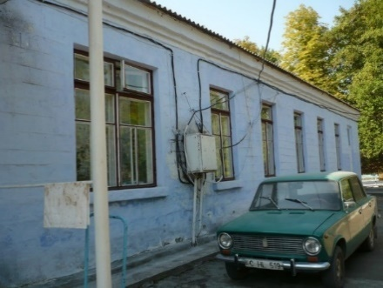
Overall goals of the project: improved quality of medical services and increased opportunities for cross-river communication for people from both banks of the Nistru river.
Status: Completed
Performed works included renovation of the entire infectious diseases section of the hospital (a separate block). The roof was replaced, thermally insulated and the entire façade was renovated. Windows and doors were replaced with new ones. A ventilation system was established. Heating, water, electricity and sewerage systems were all renovated. Every room was equipped with a separate closet, shower cabin and sinks. The space where the food is distributed was totally renovated. All public areas and patient rooms in the building were renovated and are now complying with relevant safety and sanitary norms. Currently the infectious diseases section from Rezina district is the most modern section from the country.

Results of the implemented project:
- Improved conditions for patient treatment, higher quality medical services;
- Modern work environment for medical personnel;
- One of the best infectious diseases sections from the entire country;
Sustainability and expected confidence building impact:
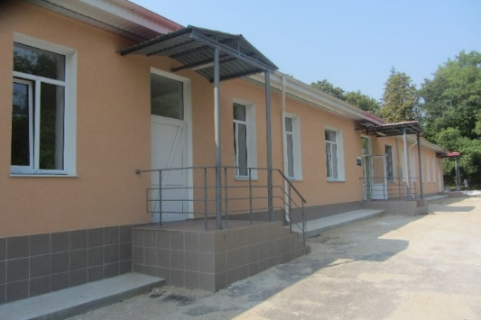
Experts from the implementing partner team (Contact NGO) elaborated capacity gaps assessment reports and capacity development action plans as well as confidence building action plans with the work group from Rezina. Representatives from Rezina attended the joint capacity building trainings organized in Chisinau. A high standard section like the one in the hospital from Rezina represents a great resource for specialized medical personnel on both banks of the Nistru river with great potential of sharing the expertise and know-how with other similar institutions from both banks of the Nistru River. Persons from the left bank also benefit directly from high quality medical services, while interacting and communicating with representatives from the right bank. As part of the thematic cooperation platform for healthcare, the project from Rezina could serve as a successful showcase of an effective collaboration between institutions and personnel from a specialized medical field – sharing their expertise with counterparts from the left bank of the Nistru river.

Sub-Project 9: “Capital renovation of the bridge on drumul Tirgului street” from Hirbovat village (Anenii Noi district)
Implemented by: local public authority of Hirbovat village
Direct beneficiaries: 8,690 (5,456 population of Hirbovat+3,234 population of Protegailovca): 4,466 women and 4,224 men
Budget: 135,984 EUR
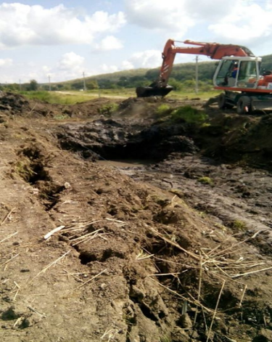
Additional local contribution: 8,258 EUR
Period of implementation: January 2016 – July 2016
Overall goals of the project: increased confidence building and cooperation between Hirbovat and Protegailovca (left bank) villages through improved accessibility and road safety conditions
Status: Completed
A Grant Agreement was signed with the local authorities from the community in December 2015. All works related to the bridge construction were successfully completed. Performed works included full demolishing of the previous bridge and clearing of the riverbed. New tubular elements for the construction of the bridge were brought and mounted. All access roads to the bridge were renovated and adjusted to the subsequent change in elevation (asphalted). Road signs and regulatory markings were provided and placed in relevant spaces. All reconstruction activities were successfully completed.

Results of the implemented project:
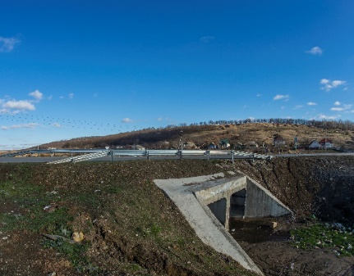
- Improved road safety for inhabitants from both banks of the Nistru river;
- Modern bridge and road portion between communities from the right and left banks of the river;
- Favourable conditions for the establishment of a regular transport connection between communities on the left and right banks of the Nistru river and additional economic opportunities for neighbouring villages;
Sustainability and expected confidence building impact:
Experts from the implementing partner team (Contact NGO) assisted the local authorities in updating the community development strategy. Representatives from Hirbovat village attended the joint capacity building trainings organized in Chisinau. An improved physical infrastructure facilitates the contact between communities from the opposite banks, increasing the frequency of travels from one side to the other. Also, given the location of Hirbovat village, the renovated bridge will facilitate upcoming cross-river thematic activities with representatives of neighbouring villages from the Transnistrian region.

Sub-Project 10: “Renovation of the Molovata village community centre” (Dubasari district)
Direct beneficiaries: 2,873 (village population): 1,443 women and 1,430 men
Budget: 172,800 EUR
Additional local contribution: 10,324 EUR
Period of implementation: January 2016 – December 2016
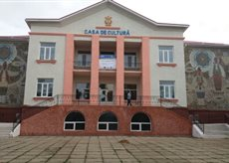
Overall goals of the project: development of culture related infrastructure from Molovata village, thus facilitating cross-river culture related interaction and collaboration.
Status: Completed
Performed works included a total roof replacement (from slate to tiles), as well as the overall rehabilitation of the building façade and establishment of indoor restrooms. The building was connected to water supply and sewerage systems. The hallway from the building was fully renovated. The ceiling from the grand concert hall was renewed keeping all original decorative elements and their colours. All decorative elements from the walls were fully renewed. The flooring in the grand concert hall was repaired and stuffed chairs were provided (400 in total). As a result, the beautiful façade of the building was renovated and all decorative elements were reconstructed according to the original.
Results of the implemented project:
- High standard conditions for the organization and hosting of cultural events;
- Increased number of planned concerts and performances meant to preserve the national heritage;
- Favourable rehearsal environment for the artistic and folk collectives from the community given the increase in the lifespan of the building by another 30 years;
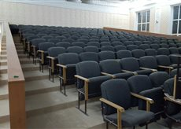
Sustainability and expected confidence building impact:
Experts from the implementing partner team (Contact NGO) assisted the local authorities in elaborating the community development strategy. Representatives from Molovata village attended the joint capacity building trainings organized in Chisinau. The Community Centre from Molovata is a beautiful building with two stories representing a valuable cultural trademark of the village. As part of the thematic collaboration platform for culture, it will represent a great example of preserved national heritage and will host many joint socio-cultural events.

Sub-Project 11: “Thermal insulation, replacement of windows and renovation of the stadium for the Cirnateni village lyceum” (Causeni district)
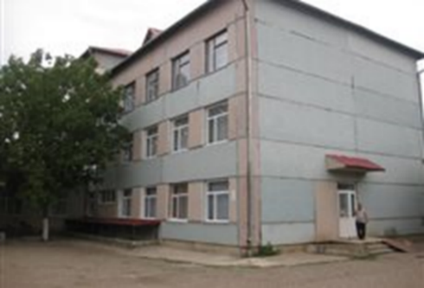
Direct beneficiaries: 1,111 (pupils, parents and staff): 555 women and 556 men
Budget: 158,500 EUR
Additional local contribution: 21,114 EUR
Period of implementation: January 2016 – November 2016
Overall goals of the project: enhancing the cross-river collaboration between schools from both banks of the Nistru River by creating of better education conditions within the village lyceum in Cirnateni
Status: Completed
Performed works included thermal insulation of two blocks and their roofing. All windows and doors were replaced and main access entrance to the building was renovated - new entrance stairs and roof cover for them. The stadium was equipped with running tracks and a new sandbox (for jumps). Volleyball, football and basketball fields were established. The sports hall showers and locker rooms are renovated and fully functional now.
Results of the implemented project:
- Overall better energy efficiency leading to institutional budget savings;
- Improved conditions for the education process of pupils;
- Better opportunities for outdoor activities aimed at promoting a healthy life style early on;
Sustainability and expected confidence building impact:
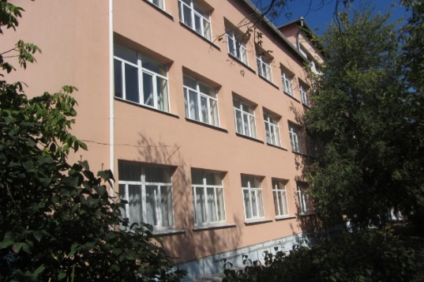
Experts from the implementing partner team (Contact NGO) assisted the local authorities in updating the community development strategy. Representatives from Cirnateni village attended the joint capacity building trainings organized in Chisinau. The lyceum from Cirnateni maintains good collaboration links with the sports school from Bender and Dubasari performing different joint activities. Therefore, its renovated premise can serve as meeting grounds for competitions and friendly sport retreats between representatives from the above-mentioned institutions. Once a member of the thematic collaboration platform for sports, the lyceum stadium can host outdoor activities and sports meet-ups for all surrounding communities well beyond the implementation timeframe of the project.

Sub-Project 12: “Renovation of the Dorotcaia village Community centre” (Dubasari district)
Direct beneficiaries: 3,547 (village population): 1,783 women and 1,764 men
Budget: 170,114 EUR
Additional local contribution: 12,050 EUR
Period of implementation: January 2016 – November 2016
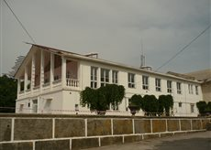
Overall goals of the project: promotion of social and cultural values aimed at increasing the trust between residents of Dubasarii Vechi village and Pirita, Cosnita, Dorotcaia, Delacau, Grigoriopol (town)
Status: Completed
Performed works included roof replacement, renovation of the façade as well as repair of access stairs and adjacent territory. The restrooms were renovated and connected to the water and sewerage systems. Interior repair works for the entire hall of the community centre were conducted. The public spaces were rehabilitated and the grand concert hall was refurbished. The stage in the grand concert hall was renewed and the curtains were changed.
Results of the implemented project:
- Improved conditions for the organization of festivals, concerts and exhibitions in the community;
- Conservation of local socio-cultural infrastructure;
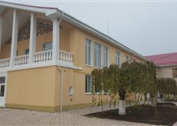
- Better conditions for two other institutions (public and children library) hosted by the renovation facility;
Sustainability and expected confidence building impact:
The local authorities cover all operational costs of the institution. Experts from the implementing partner team (Contact NGO) assisted the local authorities in elaborating the community development strategy. Representatives from Dorotcaia village attended the joint capacity building trainings organized in Chisinau. Further, the Community Centre from Dorotcaia village will host a very important cross-river festival “Nistrule pe malul tau” and renovating the premise will allow to observe this tradition in the future as well. As one of the most renowned regional festivals, “Nistrule pe malul tau” gathers folk, arts and craft representatives from different localities on both banks of the Nistru river. The EU-funded support for the renovation of the Community centre will allow keeping the tradition alive and serve as a great visibility instrument and positive community development example.

Sub-Project 13: “Renovation of the Office of Family Physicians and establishment of outpatient treatment section” in Gura Bicului village (Anenii Noi district)
Direct beneficiaries: 4,483 (3,600 Gura Bicului population+883 Bicioc population): 2,331 women and 2,152 men
Budget: 171,060 EUR
Additional local contribution: 2,223 EUR
Period of implementation: April 2016 – December 2016
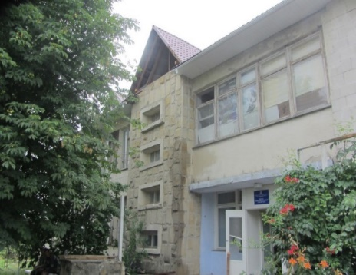
Overall goals of the project: Enhancing confidence building between people from Gura Bicului and Bicioc (left bank) villages by providing better health care services
Status: Completed
Performed works included renovation of the building façade (thermal insulation) and roof replacement. The facility was connected to the gas system and a boiler house was established and equipped with boilers. All doors and windows were replaced and indoor restrooms were constructed as well as connected to the water and sewerage systems. The electricity and heating systems along with the ventilation one were renovated. A space designed for procedures was established along with a registration desk/area. A Gynaecology cabinet and a laboratory/test room was included in the medical office.
Results of the implemented project:
- Improved conditions for medical assistance and establishment of an outpatient section;
- Better quality of locally available healthcare services;
- Increased number of beneficiaries from the left bank (Bicioc village) accessing services from right bank institutions;
Sustainability and expected confidence building impact:
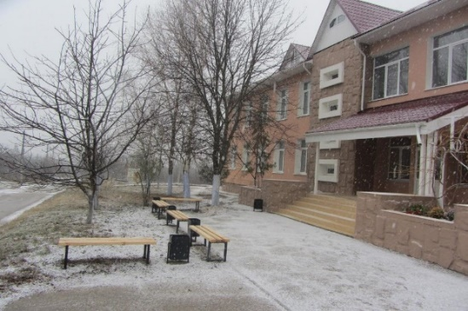
Experts from the implementing partner team (Contact NGO) assisted the local authorities in elaborating the community development strategy. Representatives from Gura Bicului village attended the joint capacity building trainings organized in Chisinau. Due to the geographical proximity to the left bank, the medical centre from Gura Bicului has been providing healthcare services to Bicioc community and improved conditions in the facility will attract even more representatives from the locality. This will lead to increased contacts between representatives from both banks, strengthening the regional confidence building potential. Throughout the project, the personnel from the institution will be involved in specialized seminars increasing their professionalism and overall training, thus further guaranteeing the sustainability of the renovated facility. Also as part of the thematic collaboration platform for healthcare, the Office of Family Physicians can provide space for specialized trainings and exchange of experience events for a period of time beyond the end date of the current phase of the SCBM Programme.

Sub-Project 14: “Overall renovation of the Rascov village Community Centre” (left bank)

Direct beneficiaries: 2,097 (village population): 1,085 women and 795 men
Budget: 205,486 EUR
Additional local contribution: 22,050 EUR
Embassy of Poland contribution: 25,000 EUR
Period of implementation: January 2016 – February 2017
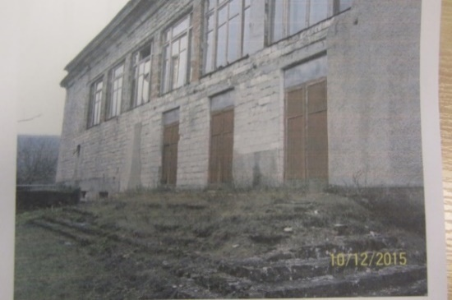
Overall goals of the project: improved conditions for socio-cultural activities in the community and promoting cross-river collaboration through cultural events between communities from both banks
Status: works almost completed
At the stage of project approval, the Community Centre from Rascov village was not operational due to multiple technical problems. Based on the approval of the SCBM Board and the MOUs signed with the local implementation partners the required technical expertise and relevant technical estimates were completed. A construction company has been selected through an open tender to run the works. The roof and façade were renovated and all external networks were completed, as well as the majority of internal works like the replacement of the floor, replacement of doors and windows, replacement of electrical, water supply, sewerage and heating systems. In addition, the chairs from the grand concert hall will be replaced. Final interior works are almost finished. Project-related works are expected to be completed in February 2017.
Expected results of the implemented project:
- Over 2000 people from Rascov and nearby villages from the left and right will benefit from a modern Community Centre with a total capacity of 600 places; banks
- Over 20 temporary and 2 permanent jobs were created;
- Due to the improved conditions in the Community Centre, cross-river cooperation and confidence building will be increased;
- The reconstruction of the Community Centre will make the community more attractive from the social, economic, as well as touristic perspective.

Sustainability and expected confidence building impact:
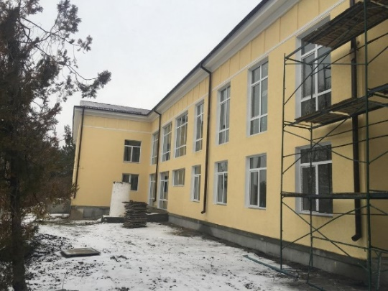
All trainings and experience transfer activities will involve similar entities from the right bank that have already worked in the field for a considerable amount of time. A continuous direct communication between the local implementation partners (NGOs and LPA) was ensured. In order to strengthen the project sustainability and increase the level of ownership, additional financial contribution was mobilized. In addition, the LPA representatives were actively involved in monitoring the entire reconstruction process.
Due to its thematic, geographical location and historical context, this project has a considerable confidence building potential. Following the reconstruction, a number of cross-river cultural events will be organized. Particularly a festival “We are from Rascov” is expected to take place in 2017. Based on thematic collaboration platform for culture soon to be established, the SCBM Program will support cross-river collaboration initiatives between communities and similar projects previously implemented on both banks of the Nistru River.

Sub-Project 15: “Reconstruction of the village sewer pipe” (Speia, Anenii Noi district)
Direct beneficiaries: 3,271 (village population): 1,720 women and 1,550 men
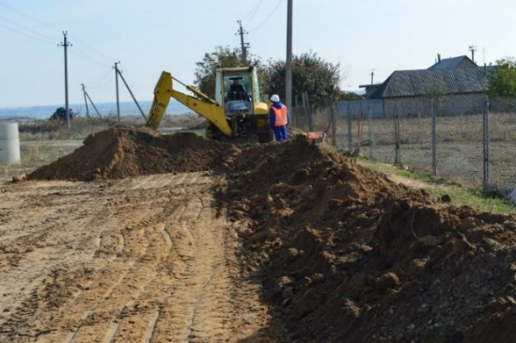
Budget: 165,095 EUR
Period of implementation: October 2016 – February 2017
Overall goals of the project: improved living conditions for Speia and neighbouring village residents by providing a renovated sewerage system (decreased pollution and higher quality social services)
Status: works almost completed
Performed works included connection of kindergarten, 5 floors-high buildings and the high school to the main pipeline of the sewerage system. It also included the construction of the sewerage pressure pipeline between pumping and waste treatment stations. The waste treatment station was purchased and is undergoing all necessary testing and verifications. The rehabilitation of the premises is expected to be completed in February 2017.
Expected results of the implemented project:
- A modern water provision and sewerage system;
- Improved environmental conditions in the village and surrounding communities;
- Better water management and decreased waste of this resource in the region;
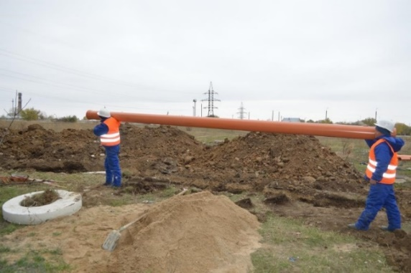
Sustainability and expected confidence building impact:
Experts from the implementing partner team (Contact NGO) assisted the local authorities in updating the community development strategy. Representatives from Speia village attended the joint capacity building trainings organized in Chisinau. The project from Speia is unique in its thematic compared to all other initiatives supported with EU funds in the fourth phase of the SCBM Programme. Upon its completion, it will serve as a valuable example of community development initiatives and the local work group will share their knowledge and experience of running such projects with interested counterparts.

Sub-Project 16: “Renovation of the centre for victims of human trafficking” in Tiraspol town (TN Region)
Direct beneficiaries: 129 (120 persons assisted during the year + 9 staff): 67 women and 62 men
Estimated Budget: 180,000 EUR
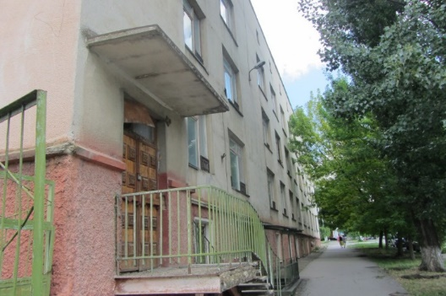
Period of implementation: January 2016 – September 2017
Overall goals of the project: renovate a part of a building formerly used as a children hospital and adapt it to accommodate the Centre for Victims of Human Trafficking; establish specialized psychological, social and legal counselling services for the beneficiaries of the centre and take over relevant expertise from similar organizations from the right bank.
Status: works in progress
A design company was selected through a public tender. The technical design documentation and bill of quantities were developed and is currently in the process of approval by relevant local institutions. Based on developed documentation an open tender for the selection of a construction company is to be launched at the beginning of 2017.
Expected results of the implemented project:
- A functional shelter for victims of domestic violence and/or human trafficking - first one of this kind on the left bank;
- Adequate conditions and trained personnel in offering social, legal and psychological assistance to beneficiaries;
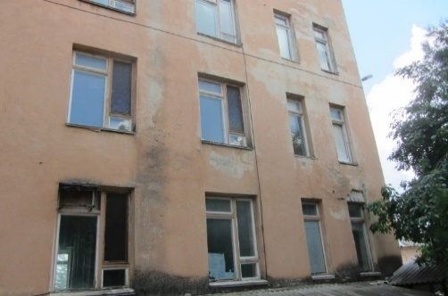
- Opportunities for transfer of expertise and know-how in the field from similar organizations on the right bank;
Sustainability and expected confidence building impact:
All trainings and experience transfer activities will involve similar entities from the right bank that have already worked in the field for a considerable amount of time. Specialized personnel from the centre already benefited from trainings and exchange visits on the right bank. Main areas of training are psychological counselling, social work with vulnerable persons, legal counselling and life skills development (for social reintegration). The established professional links will contribute to the sustainability of the project as well as the provided services, increasing the trust between the representatives of both banks.

Sub-Project 17: “Renovation of the Community centre in Corjova village” (Criuleni district)
Direct beneficiaries: 2,567 (village population): 1,335 women and 1,232 men
Budget: 175,260 EUR
Additional local contribution: 44,488 EUR
Period of implementation: October 2016 – May 2017
Overall goals of the project: renovation of the village Community centre that hosts socio-cultural and artistic meetings, with the scope to strengthen the relationships between both banks of Nistru (Criuleni on one side and Dubasari and Grigoriopol on the other side).
Status: works in progress
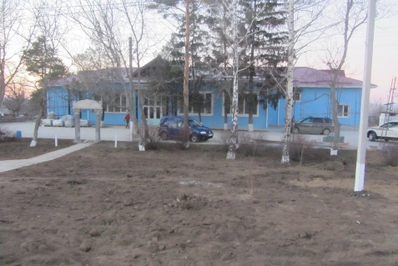
Works performed so far include construction of an annex to the community centre and construction of a boiler house and its equipment with boilers. The roof was renovated and reinforcement works for the entire roofing cast were performed. Interior works are being conducted now. The building façade has been renovated, the electricity network was replaced and indoor restrooms were established. Access to the building was ensured – new pavement installed around the facility. The mini-football field was also asphalted. Project-related works are expected to be completed in May 2017.

Expected results of the implemented project:
- A rehabilitated and modernized community centre available for all village inhabitants;
- Adequate rehearsal and performance conditions for the village folk dance and music groups;
- Given that the centre is the only one in the region with such a capacity it will serve as a host for cultural activities attended by representatives from regional communities from both banks of the Nistru river;
Sustainability and expected confidence building impact:
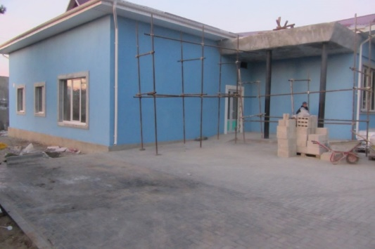
Experts from the implementing partner team (Contact NGO) assisted the local authorities in elaborating the community development strategy. Representatives from Corjova village attended the joint capacity building trainings organized in Chisinau. The village has an already traditional yearly contest “Miss elderly Corjova” that gathers contestants from both the right and left banks of the Nistru river and once the community centre is renovated more participants and spectators will be able to enjoy the humoristic show. In addition, once a member of the thematic specialized platform for culture, the community centre can host other regional festivals and share their experience of organizing yearly contests and events with other participants from the platform. Staff of the community centre will also attend specialized trainings and study visits/exchange of experience events increasing the local capacity and resourcefulness of the institution and contributing to its sustainability and that of the project beyond its completion.

Sub-Project 18: “Construction and equipment of the Office of Family Physicians from Hagimus village” (Causeni district)
Direct beneficiaries: 3,038 (1,550 women and 1,488 men)
Budget: 122,798 EUR
Additional local contribution: 6,673 EUR
Period of implementation: October 2016 – May 2017
Overall goals of the project: improve conditions for primary medical assistance; consolidate relationships and communication among local inhabitants from both banks through the construction of the Office of Family Physicians, Hagimus village.
Status: works in progress
The foundation was set, the walls were raised and a brand new edifice was build. The roof was completed and doors and windows were installed. Works are ongoing and the façade is under construction. Previous Office of Family Physicians was damaged and represented health and safety hazards given its location on watery foundation. The new premises comply with all safety norms and regulations and are expected to be completed in March 2017.
Expected results of the implemented project:
- A brand new local Office of Family Physicians;
- High quality healthcare services for the residents of Hagimus village as well as some from Bender (left bank);
- Potential part-time employment of medical personnel from Bender;
Sustainability and expected confidence building impact:
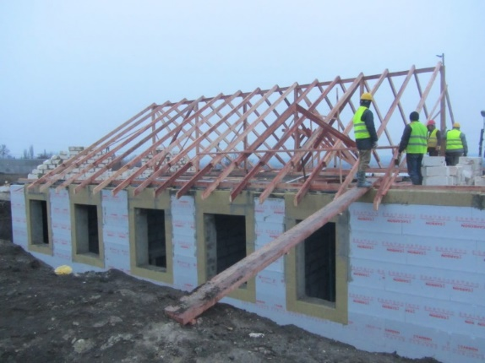
Experts from the implementing partner team (Contact NGO) assisted the local authorities in updating the community development strategy. Representatives from Hagimus village attended the joint capacity building trainings organized in Chisinau. A study visit to Hagimus was organized in November 2016 and close to 30 participants were able to see all projects implemented with EU funding in the community. Hagimus is one of the first communities visited by representatives from different communities where EU-funded projects are implemented and the local working group could share valuable lessons and experience with those less knowledgeable or first-time beneficiaries. The medical personal from the new Office of Family Physicians will be included in the thematic trainings provided within the healthcare thematic platform, thus becoming more qualified and passing on their expertise to future employees of the centre contributing to the overall sustainability of project and this establishment in particular.

Sub-Project 19: “Construction of and equipment provision for a sports field and playground at the Latin-script Theoretic Lyceum Evrika” from Ribnita town
Direct beneficiaries: 469 (pupils, parents and staff): 260 women and 209 men
Budget: 61,956 EUR
Period of implementation: January 2016 – TBD
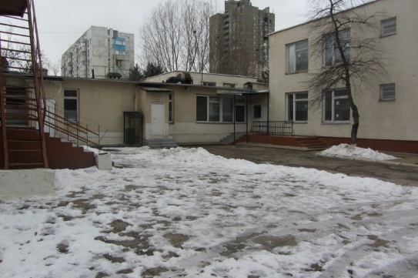
Overall goals of the project: construct and equip the sports field and the playground for children of the Theoretic Lyceum ‘Evrica’, ensure adequate compliance with the physical education curriculum
Status: works in progress
A design company was selected through a public tender. The technical design documentation and bill of quantities were developed and a construction company was identified through an open competition.
Expected results of the implemented project:
- A modern functional playground for pre-school children;
- A renovated and equipped sports field;
- Increased attractiveness of the school leading to growing number of enrolled pupils;
Sustainability and expected confidence building impact:
Experts from the implementing partner team (Contact NGO) elaborated capacity gaps assessment reports and capacity development action plans as well as confidence building action plans with the work group from Ribnita. Representatives from Ribnita attended the joint capacity building trainings organized in Chisinau. More in-depth capacity building will follow once the rehabilitation works start.

Sub-Project 20: “Renovation of the sports complex facility in Serpeni village” (Anenii Noi district)
Direct beneficiaries: 3,585 (village population): 1,865 women and 1,720 men
Budget: 167,990 EUR
Additional local contribution: 26,693 EUR
Period of implementation: January 2016 – September 2017
Overall goals of the project: development of sports and culture infrastructure of Serpeni village, thus creating conditions for cross-river collaboration initiatives and joints sports events and competitions.
Status: works in progress
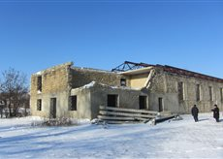
Construction works started in mid-December 2016. Performed works included reinforcement of roof beams and bearing walls. Project-related works are expected to be completed in July 2017.

Expected results of the implemented project:
- A modern area for leisure and sports activities in the village;
- Improved conditions for the organization of joint sports competitions and events;
- Overall increased attractiveness of the local community;
Sustainability and expected confidence building impact:
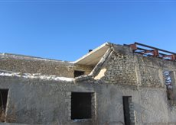
Experts from the implementing partner team (Contact NGO) assisted the local authorities in elaborating the community development strategy. Representatives from Serpeni village attended the joint capacity building trainings organized in Chisinau. A joint sports competition was already organized in Serpeni, bringing together football players from nearby communities including those from the left bank (Speia, Grigoriopol). Once a member of the sports platform, the complex will continue to host cross-river social and cultural activities with focus on sports competitions and retreats continuing well after the completion of the SCBM funded activities. The community already has a solid record of collaboration with localities from the left bank of the Nistru river and improving the sports and culture infrastructure of the village will only strengthen the existing links contributing to the sustainability of the initiative as a whole.

PROJECTS SELECTED IN 2016

Sub-Project 21: “Renovation of the village Community centre” in Carmanovo village (Grigoriopol district)
Direct beneficiaries: 2,128: 1,096 women and 1,032 men
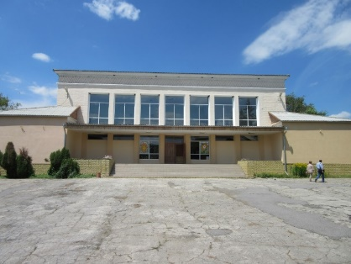
Estimated Budget: 141,300 EUR
Period of implementation: September 2016 – August 2017
Overall goals of the project: modern conditions for the organization and hosting of events in the local Community centre, facilitating cross-river cultural exchanges.
Status: works in progress
Works for the elaboration of the technical design have been initiated and relevant technical documentation was obtained from the Grigoriopol gas institutions. Project-related works are expected to be completed in August 2017.
Foreseen impact of the project:
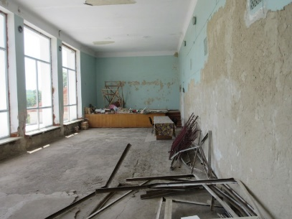
- A modern facility ready to host cultural, art and social enterprises;
- Improved performance of art groups;
- Increased number of participants in culture and art related events;
Sustainability and expected confidence building impact:
Experts from the implementing partner Interaction NGO visited the community and conducted three work sessions. Based on the results of the meetings with the local work group needs assessment and capacity gaps reports as well as capacity development and confidence building action plans are under development. The project will further be included in the list of members of the thematic collaboration platform for culture and continue to participate in capacity building and cross-river collaboration initiatives. As beneficiary of diverse trainings, study visits (including to EU countries) and other relevant events, the personnel of the community centre along with representatives from the local administration will increase their qualifications and develop skills to manage EU-funded projects contributing to project and overall institution activity sustainability.

Sub-Project 22: “Establishment of a Social Reintegration Centre for Youth from risk groups” in Tiraspol
Direct beneficiaries: orphan children from Tiraspol (413) and from the entire left bank (1,731): 917 girls and 814 boys
Estimated Budget: 180,000 EUR
Additional local contribution: 27,000 EUR
Period of implementation: October 2016 – September 2017
Overall goals of the project: creation of opportunities for vulnerable teenagers (risk group) to access social integration services (protection and temporary safe accommodation from 3 months up to 3 years) and for personnel to receive relevant training from partners on the right bank
Status: works in progress
A company responsible for the elaboration of the bills of quantities has been selected, thus the company is developing the technical estimates and bills of quantities. An invitation to bid will be launched to select the company responsible for the construction activities on the site. Project-related works are expected to be completed in September 2017.
Foreseen impact of the project:
- A renovated centre and developed methodology on social and psychological assistance;
- A trained team of specialists offering high quality social reintegration services;
- Assisted beneficiaries (equipped with relevant life skills) ready to be reintegrated into society;
Sustainability and expected confidence building impact:
Experts from the implementing partner Interaction NGO visited the community and conducted three work sessions. Based on the results of the meetings with the local work group needs assessment and capacity gaps reports as well as capacity development and confidence building action plans are under development. Capacity building activities for this particular project include specialized trainings for the centre personnel as well as transfer of experience and knowledge in the field of social assistance for troubled teenagers and youth from relevant counterparts on the right bank. The centre is already actively providing services to vulnerable youth from the left bank and improved conditions as well as further development of the skills of the employees will ensure that a greater number of beneficiaries can be assisted and supported.

Sub-Project 23: “Renovation of the school sports hall and cafeteria” in Protegailovca village (Bender district)
Direct beneficiaries: school pupils (65 girls and 75 boys) + school staff (25 women and 8 men)
Budget: 133,638 EUR
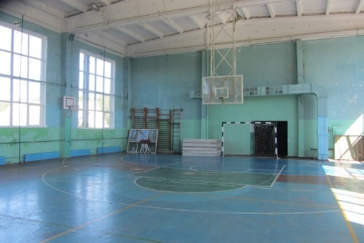
Period of implementation: October 2016 – September 2017
Overall goals of the project: ensure modern conditions for the organization of the educational process for young village residents and facilitate cross river collaboration between representatives of the primary and secondary education from both banks of the Nistru river.
Status: works in progress
A company responsible for the elaboration of the bills of quantities was selected, thus the company developed the technical estimates and bills of quantities. Also a construction company has been identified and will be contracted. Project-related works are expected to be completed in September 2017.
Foreseen impact of the project:
- Overall improved conditions for pupils and teachers in the school;
- Potential increase in the number of pupils enrolling in the school;
- Modern cafeteria and sports hall for the village school;
Sustainability and expected confidence building impact:
Experts from the implementing partner Interaction NGO visited the community and conducted three work sessions. Based on the results of the meetings with the local work group needs assessment and capacity gaps reports as well as capacity development and confidence building action plans are under development. The project work group will be included in all future joint and cross-river activities foreseen by the project action plan and will also become a member of the platform on education, thus receiving access to additional activities which can be funded through the Small Grants programme. A renovated sports hall and cafeteria will contribute directly to the improvement of the overall education process for primary and secondary levels. Children that receive education in good quality facilities register better results, thus the sustainability of the project is undeniable in this case.

Sub-Project 24: “Renovation of the village Sports Complex” in Blijnii Hutor village (Slobozia district)
Direct beneficiaries: village population (3,736 women and 3,313 men)
Estimated Budget: 180,000 EUR
Period of implementation: October 2016 – October 2017
Overall goals of the project: improved sports and education social infrastructure of the village by means of renovating the largest sports and wellness complex from the area
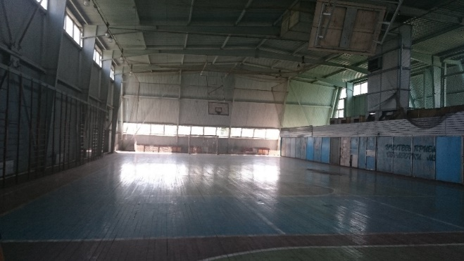
Status: works in progress
The company responsible for the elaboration of the bills of quantities has been selected, thus the company and developed the technical estimates and bills of quantities. An invitation to bid for construction companies will be launched. Project-related works are expected to be completed in October 2017.
Foreseen impact of the project:
- Improved conditions for practicing football, volleyball, basketball, climbing and table tennis;
- Establishment of new sports sections and increase the variety of service provided by the Sports centre;
- A modern facility to host joint sports events and other cross river initiatives;
Sustainability and expected confidence building impact:
Experts from the implementing partner Interaction NGO visited the community and conducted three work sessions. Based on the results of the meetings with the local work group needs assessment and capacity gaps reports as well as capacity development and confidence building action plans are under development. The facility represents a great space for the organization and development of diverse sports – focused activities and its geographical location if favourable for the involvement of institutions with similar interests from the right bank. As part of the sports platform, the complex could bring together representatives from different kinds of sports joining them in friendly retreats or full-fledged contests and championships. A facility of such size with modern conditions of training and sports practice will certainly attract an increased number of attendees ensuring the sports complex will be functional for a period way beyond the completion of the current phase of the SCBM Programme, serving as an efficient visibility tool for a longer time.

Sub-Project 25: “Renovation of the auxiliary block (sports hall and locker rooms)” for the “P. Erhan” school in Tanatari village (Causeni district)
Direct beneficiaries: pupils from the village school (160 girls and 110 boys) and pupils from sports school in Bender (150)
Budget: 96,107 EUR
Additional local contribution: 8,000 EUR
Period of implementation: November 2016 – May 2017
Overall goals of the project: support and consolidate confidence building measures between residents of Tanatari village and Bender (left bank) through promoting sports activities and a healthy life style.

Status: works in progress
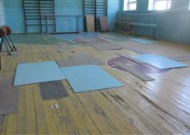
The Local Public Authority provided all relevant technical documentation, cost estimates and bills of quantities. A competition was organized, the construction company was selected, and the contract was signed. The required authorizations have been obtained and building reinforcement works are scheduled to start before the end of 2016. Project-related works are expected to be completed in May 2017.
Foreseen impact of the project:
- Renovated sports hall;
- Increased number of sports activities available in the school;
- A modern facility to host joint sports events and other cross river initiatives;
Sustainability and expected confidence building impact:
An expert from the implementing partner CONTACT NGO conducted two sessions with the community initiative group elaborating the confidence building and capacity development action plans also presenting them for local approval/validation. Another capacity building activity involved the update of the local development strategy of Tanatari village. Renovated sports facilities such as the one in Tanatari village motivate the younger generation to start practicing sports early on, thus developing their understanding of the importance of a healthy life style. Therefore, an intervention implemented now leads to considerable impacts that last much longer than the actual project ensuring long-term sustainability.

Sub-project 26: Assessment of data users’ capacities on both banks of the Nistru River
Implemented by: Magenta Consulting, Chisinau in cooperation with Sigma-Expert, Tiraspol
Main Objectives: to assess the data users’ capacities from both banks of Nistru River and their satisfaction with the available statistics
Budget: 46,319 EUR
Implementation period: November 2015 - August 2016
Beneficiaries: direct – statistical services from both banks; indirect – data users from both banks
Main activities:
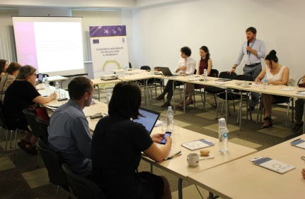
- A quantitative survey conducted, complemented by a qualitative analysis and an analytical report evaluating the existing capabilities of the data users, containing recommendations to overcome the identified gaps;
Presentation of the Data users’ satisfaction surveys
- The peculiarities and preferences of data users from both banks were analysed including: preferred types and means of information, data presentation form, frequency and periodicity, the way the data is being used by data users from both banks;
- Proposals for a training programme based on the identified needs have been produced.
Sustainability: Based on the recommendations provided in the report, the development of Training materials to build capacities of data producers and users was launched in November 2016. The materials are to be further used within learning activities.

Current Status: completed

Sub-project 27: Capacity development support for statisticians and data users on both banks of Nistru River
Implemented by: CERME, Romania in consortium with CIVICUS, Romania and ISDI, Moldova
Main Objectives: Improve the professional performance of statisticians from both banks and strengthen their capacities
Budget: 43,853 EUR
Implementation period: December 2016 - July 2017
Beneficiaries: Direct – statistical services on both banks. Indirect: data users from both banks
Main activities:
- A consortium was selected to elaborate the training materials to build capacities of data producers and users. Statistical services from both banks will benefit of the materials and trainings with similar content for both banks statistical services, which will promote the UN Fundamental Principles of official statistics.
Sustainability: The expected content of the courses for statisticians will be further digitalized and transformed into a e-learning platform to be used by both statistical offices.

Current Status: launched

Sub-project 28: Joint workshops and study visits for statistical practitioners from both banks
Implemented by: Statistical services from both banks
Main Objectives: Gain knowledge get acquainted with international standards, requirements and best European practices in the area of statistics
Budget: 22,854 EUR
Implementation period: May - December 2016
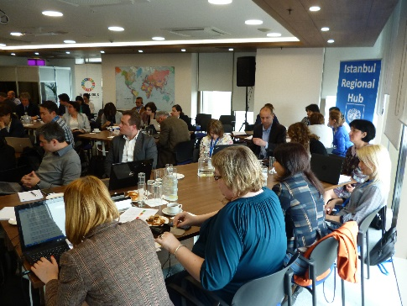
Beneficiaries: Direct – statistical services on both banks. Indirect: data users from both banks benefiting of better data produced by skilled statisticians
Statisticians from Georgia, Kyrgyzstan, Moldova, Montenegro, Turkey and Turkmenistan
Main activities:
Participation in a number of international events with the goal to enlarge the horizon on collecting data and producing official statistics:
- Regional workshop on 2030 Agenda, emerging practices and tools for SDGs nationalization and localization, lessons learned and good examples from the participating countries;
- UNECE Workshop on Gender Statistics;
- Work session on Gender Statistics: knowledge gained on international standards and practices by statisticians from both banks;
- UNECE High-level Seminar on Harmonization of Poverty Statistics in CIS. Challenges related to producing comparable / reliable poverty data have been defined, and inequality indicators to monitor sustainable development in CIS countries were proposed;
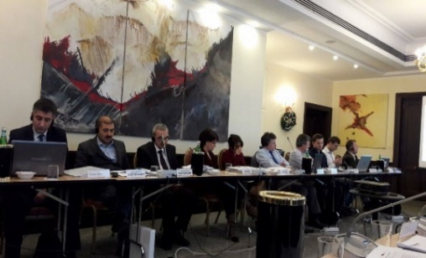
- 4th meeting of the Eastern Partnership’s Panel of Statistics, under the Platform 2: Economic Integration and Convergence with EU Policies;
Conference on Big Data
- Eurostat seminar on statistical metadata;
- Eurostat training course on Introduction to Big Data and its tools.
Sustainability: Statisticians from both banks gained technical skills, learned from international practices, shared opinions and experience with other countries representatives, got familiarized with the challenges faced by statisticians. An outstanding achievement is the participation of joint teams in the above-mentioned events.
Current Status: completed and to follow

Sub-project 29: Workshop aimed at familiarization with ILO international standards in areas of labour statistics (Tiraspol)
Implemented by: UNDP in collaboration with ILO-STAT, Geneva
Main Objectives: Familiarize the participants with the recent ILO concepts, definitions and indicators concerning statistics of work, employment and labour underutilization in labour force surveys.
Budget: 3,575 EUR
Implementation period: September 28-29, 2016
Beneficiaries: 15 statisticians from the statistical service in Tiraspol, Bender and other 5 rayon, 6 lectures from the T. Shevchenko University
Main activities:
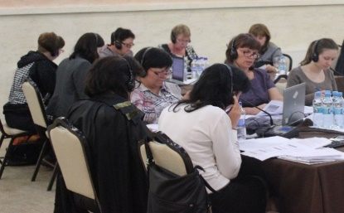
- The statisticians and data users from the left bank, got acquainted with the latest ILO and international concepts and employment statistics to the targeted data producers and users.
Workshop on ILO International standards
Sustainability: The statisticians from the left bank have the real possibility to implement in practice the knowledge gained during the seminar.

Current Status: completed

Sub-project 30: Organization of a seminar on statistical Household Surveys as the main data collection tool for social statistics (Tiraspol)
Implemented by: UNDP Moldova with the expert support from the Istanbul Regional Hub
Main Objectives: Familiarize participants with the concept and methodology of the Household Surveys, their advantages, as well as international best practices and experience on production of social statistics
Budget: 7,897 EUR
Implementation period: December 6-8, 2016
Beneficiaries: 12 statisticians from the statistical service in Tiraspol, Bender and 5 rayon, 4 specialists from the de-facto authority of social protection from Tiraspol and 4 specialists from the de-facto central bank, 4 lectures from the Shevchenko University
Main activities:
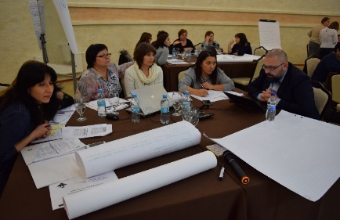
- The trainees improved their skills and got acquainted with the international concepts and definitions related to the statistical households’ surveys which are lacking on the left bank. The sessions were accompanied by practical activities and exercises related to the identification of social statistics’ needs, assessment of available data source, sampling design, planning of a survey and needed resources
International Expert Mihail Peleah leading the workshop on Household Surveys

Sustainability: The experts helped drafting a roadmap for the gradual implementation of household budget survey on the left bank, based on the model existing on the right bank.
Current Status: training completed, topic to be addressed in 2017

Sub-project 31: Organization of seminars on software for analysis of statistical data
Implemented by: UNDP Moldova
Main Objectives: Improve the skills of statisticians from both banks to operate with data processing tools
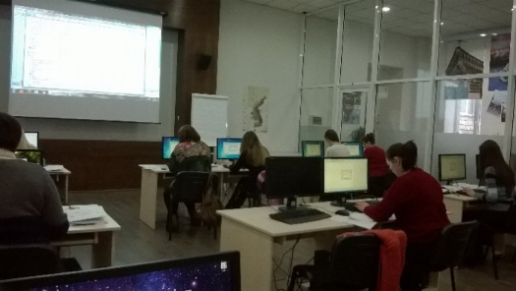
Budget: 5,617 EUR
Implementation period: December 20-23, 2016
Beneficiaries: 22 statisticians from the statistical service from both banks
Main activities:
Seminar on software for analysis of statistical data
- Two courses carried on the use of specialized data processing tools. The courses contributed to the development of theoretical knowledge and practical skills on using software for analysis of data.

Sustainability: The training was elaborated based on the attendees’ homework and their case studies, enabling statisticians to get all necessary practical abilities and apply them later on, in their daily activities.
Current Status: training completed

Sub-project 32: Grants competition for evidence-based analytical papers on sustainable development
Implemented by: UNDP Moldova
Main Objectives: Develop clear analytical reports, through the use of relevant data and available disaggregation, which describe the current status in the proposed SDG thematic areas
Budget: 17,973 EUR
Implementation period: September 2016 – February 2017
Beneficiaries: IPP (NGO) and an expert from T. Shevchenko University; Ecostrategii and Society for Bulgarian Culture Rodoliubec; Independent Institute of law and civil society (NGO) and an expert from the State University of Moldova; IDIS Viitorul and European Agency for Economic Research, Reconstruction and Development, Tiraspol
Main activities:
- 4 NGOs from both banks are currently developing evidence-based analytical papers on sustainable development, covering the following topics: [1] Evaluation of infrastructure of educational institutions with equal access to education (SDG9), [2] Eroded soils’ improvement in the wetland area of the Nistru river for organic farming and poverty reduction (SDG1), [3] Evaluation of the potential for sustainable development of small towns of Nistru valley (SDG11), [4] A comparative overview on labour market inequalities: key trends and perspectives (SDG8).The 4 papers will include: situational analysis, findings and recommendations on improvement measures, gaps in data/evidence availability.

Sustainability: This activity is to improve the dialogue and interaction between data analysts and researchers activating on both banks through common objectives on informing the population and stimulating public discussions on 2030 Agenda, and stimulating the use of available evidences and data gaps identification. The papers analysis will cover both banks of Nistru river.

Annex 4a: Capacity Building

Selection of infrastructure projects
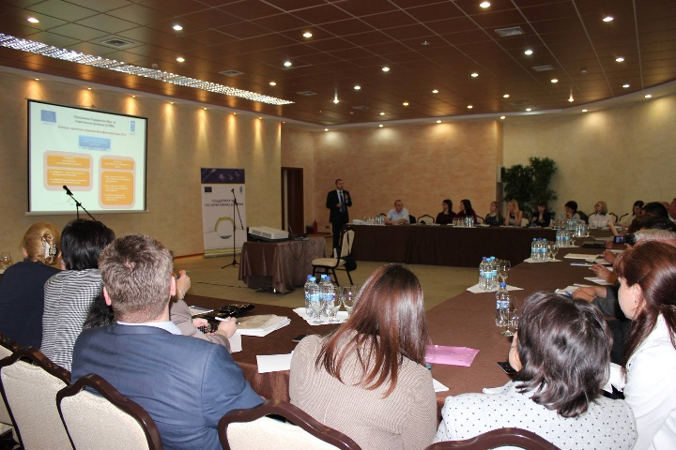
A joint call for proposals for infrastructure project ideas was launched in May 2016. As a first time experience, the competition had identical guidelines and procedures for applicants from the left and right banks of the Nistru river. Based on carried out competition, a total of 49 project proposals from 37 communities were received. Prior to the deadline, experts from the implementing partners Contact and Interaction NGOs offered support to 50 eligible communities (19 from the right bank and 31 from the left bank) in idea identification and project proposal compilation. As a result of the provided specialized assistance registered proposals had a better form, justification content and were overall of higher quality. Following a detailed evaluation 8 project proposals (6 from the left bank and 2 from the right bank of the Nistru river) were approved for funding, five out of which conditionally. Implementation works for five of the projects have been already initiated. The remaining three (Establishment of a Mobile hospice service for palliative assistance in Tiraspol, Installation of an Air Quality Monitoring Station on the left bank and Installation of an Air Quality Monitoring Station on the right bank) did not comply with the required conditions and thus have been put on a standby list by the programme Board.
To ensure the selection of the remaining 6 social infrastructure projects, the selection process has been adjusted and approved by the Board in August 2016. It consists of consultations with the main stakeholders from both banks of Nistru river, in order to come up with a list of new and strong ideas, to be analysed and proposed for approval to the Selection Committee. The final round of consultations materialized in a workshop where short-term and long-term project priorities have been brainstormed and a list of ideas in 5 areas has been generated.
As a result, a list of new potential project ideas was developed to be provided to Evaluation Committee for analysis.

Provision of capacity building activities to the target communities/stakeholders:
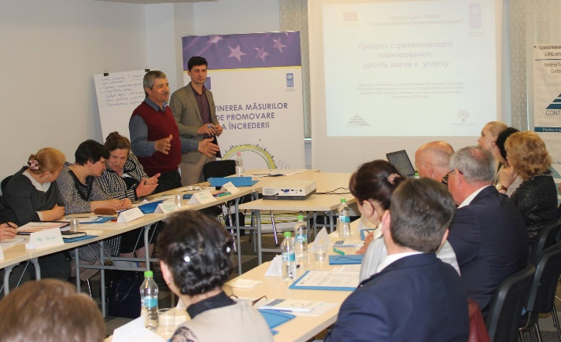
In April, May and June 2016 six joint capacity building trainings were organized by the implementing partners Contact and Interaction NGOs. The topics were: Strategic planning, Fundraising and Communication – planning and organizing information campaigns. Representatives from four communities on the left bank (Nezavertailovca, Chitcani, Glinoe, Dnestrovsc) attended local trainings on Basis of project preparation and planning and Mobilizing community resources to solve social problems organized by the specialists from Interaction NGO. In addition, experts from the implementing partner visited the four communities (Carmanovo, Tiraspol ‘Detstvo detyam’ NGO, Protegailovca and Blijnii Hutor) where projects were selected for funding in 2016 and conducted three work sessions in each one of them. Based on the results of the meetings with the local work group, needs assessment and capacity gaps reports as well as capacity development and confidence building action plans were developed.
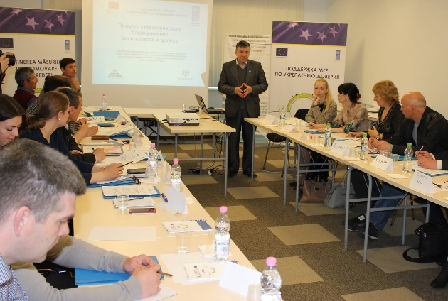
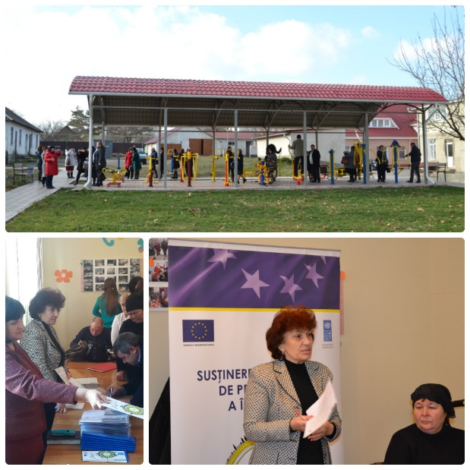
One study/exchange of experience visit in Varnita (Anenii Noi district) and Hagimus (Causeni district) villages was organized by Contact NGO, gathering close to 30 participants from 13 communities that were able to visit all projects implemented with EU funds in the community. Based on the opinions of guests the event was successful and participants were genuinely interested in learning good practices of fundraising and project implementation from the host communities. Excerpts from the evaluation forms showed that participants found the visit very informative and valuable for their activity. Although not all project implementation experience from Varnita and Hagimus villages is transferable to other projects supported by EU funds and implemented by SCBM, the main principles and lessons learned were extremely useful for the representatives 13 communities (projects) that took part in the activity. The list of participants and their contact information was disseminated to all attendees to facilitate future communication between them given that the event served as a means of initiating partnerships and finding communities willing to identify ideas for collaboration in the future (including initiatives that can be submitted to the Small Grants programme). Another example of good communication and information flow between projects supported by EU funds is sharing good local practices and experiences. Thus, an example of a banner used in Serpeni to mark the renovation site was shared with communities that can use it as a template and have similar information signs at the rehabilitated infrastructure objects from their communities. Another result of the study/exchange visit was the motivation of guests to hold a similar event in their community and talk about their experience as well as dos and don’ts of project implementation in their region.
Also as part of capacity building initiatives for the beneficiary communities, the specialists from Contact NGO organized workshops on the update (Varnita, Hirbovat, Speia, Cirnateni and Hagimus) and elaboration (Slobozia-Dusca, Corjova, Gura Bicului, Serpeni, Molovata and Dorotcaia) of the local development strategies. Experts from the implementing partner offered consultations on how to incorporate confidence building elements in the updated/elaborated local development strategies. Throughout the year, experts from Contact and Interaction NGOs provided consultations and mentoring on the implementation of the confidence building action plans developed by the community.

Support for cross-river collaboration and confidence building activities:
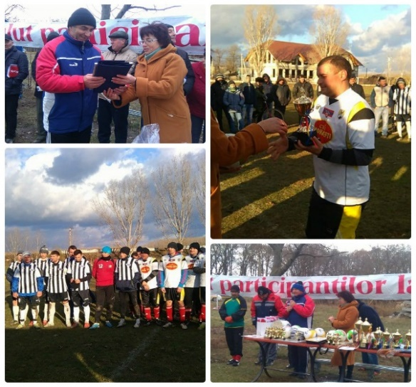
Given that all social infrastructure projects funded under the SCBM framework could be divided into five major activity fields – education, healthcare, sports, culture and environment protection – it was decided that the cross-river collaboration platforms will be organized around these particular domains as well. A concept on platforms and the mechanism of their activity was elaborated and coordinated with Project leaders. The rationale behind the establishment of a thematic collaboration platform is to ensure an organized structure that will allow members to stay in contact, exchange news, post announcements, take part in capacity development initiatives and invite guests and participants from opposite banks of the Nistru river to thematic events and activities.
In this regard, an open competition for the creation of thematic collaboration platforms was successfully carried out at the end of 2016 and three organizations were selected to complete the task. Contracts have been signed with the entities selected for the education platform – ProDidactica; culture – ICOM (International Council of Museums in Moldova) and environment - EcoContact. According to the signed contracts, the main responsibilities of the identified platform leaders are the development of an implementation methodology and work plan for each platform, the actual establishment of the platform and elaboration of needs assessment reports for each member of the initiated structure. In addition, each leader will be responsible for the development and strengthening of the platform through capacity building activities and study/exchange visits within the country as well as abroad. A final task for the contracted organizations will be to elaborate a sustainability plan for each platform, which will expand beyond the timeframe of the current SCBM phase.
A new competition for the selection of the remaining two organizations was organized and the evaluation of the submitted applications is ongoing.
Small grants documentation package is developed and adjusted to the current Programme realities.
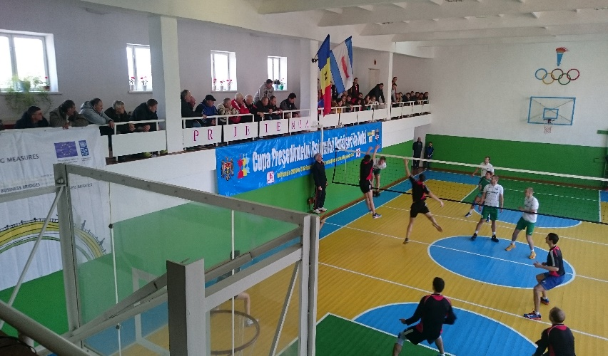
Several cross-river sports and cultural events took place with SCBM support in Varnita, Serpeni, Pirita and Cosnita villages. In Serpeni six teams (15 members per team) competed in the football tournament and 50 children were involved in celebration activities. Together with invited community veterans and spectators, the ceremony gathered close to 200 persons from both banks of the Nistru river.
A similar cross-river sports event was organized on December 17-18 in Pirita-Cosnita villages – the volleyball championship. A total of15 volleyball teams participated, out of which 5 were from TN region (Dnestrovsc, Dubasari, Tibuleuca, Grigoriopol and Butor) and one team from Ukraine (Crijopoli). The event represented a successful celebration of the 2016-year season closure. Another joint event was the cultural festival “Aho-Aho rasuna Nistrul” that took place in Cosnita Community Centre. Participants from Carmanovo, Butor, Grigoriopol, and Garmatskaya (left bank) were invited.

Contract number: ENPI/2014/354-587, Annex I, Description of the Action, Support to Confidence Building Measures
Costs of the Transnistrian conflict and benefits of its resolution”, www.cisr-md.org.
http://www.gov.md/ro/advanced-page-type/programul-de-activitate-guvernului
Programul de activitate al Guvernului Republicii Moldova 2016- 2018, http://gov.md/sites/default/files/document/attachments/guvernul_republicii_moldova_-_programul_de_activitate_al_guvernului_republicii_moldova_2016-2018.pdf
The declaration calls for non-politicization in the context of AA signature, EU‘s increasing role in conflict settlement is welcomed, context in which CBM are mentioned.
http://expert-grup.org/media/k2/attachments/Realitatea_Economica_Transnistreana_septembrie2016_EN.pdf
EU Joint Analysis
http://www.registru.md/date-statistice/in-profil-administrativ-teritorial
http://www.worldbank.org/en/country/moldova/overview .
http://imf.md/press/pressw/press-161107.html
http://www.worldbank.org/en/news/press-release/2016/12/16/moldova-increases-transparency-with-world-bank-support
http://www.expert-grup.org/en/biblioteca/item/1333-realitatea-economic%C4%83-transnistreana-septembrie-2016&category=7 .

